UNITED STATES

SECURITIES AND EXCHANGE COMMISSION

Washington, D.C. 20549

FORM 10-Q

- QUARTERLY REPORT PURSUANT TO SECTION 13 OR 15(d) OF THE SECURITIES EXCHANGE ACT OF 1934

For the quarterly period ended December 31, 2025

or

- TRANSITION REPORT PURSUANT TO SECTION 13 OR 15(d) OF THE SECURITIES EXCHANGE ACT OF 1934

For the transition period from _______________________ to ___________________________

Commission file number 001-39510

STEPSTONE GROUP INC.

(Exact name of Registrant as specified in its charter)
Delaware |  |  |  |  |  | 84-3868757
(State or other jurisdiction of |  |  |  |  |  | (I.R.S. Employer
incorporation or organization) |  |  |  |  |  | Identification No.)
277 Park Avenue, 45th Floor
New York, NY |  |  |  |  |  | 10172
(Address of principal executive offices) |  |  |  |  |  | (Zip Code)
 | (212) 351-6100
 | (Registrant’s telephone number, including area code)
Securities registered pursuant to Section 12(b) of the Act:
Title of each class |  |  | Trading Symbol(s) |  |  | Name of each exchange on which registered
Class A Common Stock, $0.001 par value per share |  |  | STEP |  |  | The Nasdaq Stock Market LLC

Indicate by check mark whether the registrant (1) has filed all reports required to be filed by Section 13 or 15(d) of the Securities Exchange Act of 1934 during the preceding 12 months (or for such shorter period that the registrant was required to file such reports), and (2) has been subject to such filing requirements for the past 90 days. Yes ☒ No ☐

Indicate by check mark whether the registrant has submitted electronically every Interactive Data File required to be submitted pursuant to Rule 405 of Regulation S-T (§ 232.405 of this chapter) during the preceding 12 months (or for such shorter period that the registrant was required to submit such files). Yes ☒ No ☐

Indicate by check mark whether the registrant is a large accelerated filer, an accelerated filer, a non-accelerated filer, a smaller reporting company, or an emerging growth company. See the definitions of “large accelerated filer,” “accelerated filer,” “smaller reporting company” and “emerging growth company” in Rule 12b-2 of the Exchange Act.

Large accelerated filer | ☒ | Accelerated filer | ☐
Non-accelerated filer | ☐ | Smaller reporting company | ☐
Emerging growth company | ☐

If an emerging growth company, indicate by check mark if the registrant has elected not to use the extended transition period for complying with any new or revised financial accounting standards provided pursuant to Section 13(a) of the Exchange Act. ☐

Indicate by check mark whether the registrant is a shell company (as defined in Rule 12b-2 of the Exchange Act). Yes ☐ No ☒

Indicate the number of shares outstanding of each of the registrant’s classes of common stock, as of the latest practicable date: As of February 3, 2026, there were 80,143,962 shares of the registrant’s Class A common stock, par value $0.001, and 39,017,716 shares of the registrant’s Class B common stock, par value $0.001, outstanding.

Table of Contents

 |  |  |  |  |  |  |  |  |  |  |  |  |  |  |  |  | Page
 |  |  |  |  |  |  |  |  |  |  | PART I - FINANCIAL INFORMATION
 | Item 1. Financial Statements
 |  | Condensed Consolidated Balance Sheets as of December 31, 2025 and March 31, 2025 |  |  |  |  |  |  |  |  |  |  |  |  |  |  | 6
 |  | Condensed Consolidated Statements of Loss for the Three and Nine Months Ended December 31, 2025 and 2024 |  |  |  |  |  |  |  |  |  |  |  |  |  |  | 8
 |  | Condensed Consolidated Statements of Comprehensive Loss for the Three and Nine Months Ended December 31, 2025 and 2024 |  |  |  |  |  |  |  |  |  |  |  |  |  |  | 9
 |  | Condensed Consolidated Statements of Stockholders’ Equity for the Three and Nine Months Ended December 31, 2025 and 2024 |  |  |  |  |  |  |  |  |  |  |  |  |  |  | 10
 |  | Condensed Consolidated Statements of Cash Flows for the Nine Months Ended December 31, 2025 and 2024 |  |  |  |  |  |  |  |  |  |  |  |  |  |  |  | 12
 |  | Notes to Condensed Consolidated Financial Statements |  |  |  |  |  |  |  |  |  |  |  |  |  |  |  | 14
 | Item 2. Management’s Discussion and Analysis of Financial Condition and Results of Operations |  |  |  |  |  |  |  |  |  |  |  |  |  |  |  | 49
 | Item 3. Qualitative and Quantitative Disclosures about Market Risk |  |  |  |  |  |  |  |  |  |  |  |  |  |  |  |  | 88
 | Item 4. Controls and Procedures |  |  |  |  |  |  |  |  |  |  |  |  |  |  |  |  | 90
 |  |  |  |  |  |  |  |  |  |  | PART II - OTHER INFORMATION
 | Item 1. Legal Proceedings |  |  |  |  |  |  |  |  |  |  |  |  |  |  |  | 90
 | Item 1A. Risk Factors |  |  |  |  |  |  |  |  |  |  |  |  |  |  |  |  | 91
 | Item 2. Unregistered Sales of Equity Securities and Use of Proceeds |  |  |  |  |  |  |  |  |  |  |  |  |  |  |  |  | 91
 | Item 3. Defaults Upon Senior Securities |  |  |  |  |  |  |  |  |  |  |  |  |  |  |  |  | 91
 | Item 4. Mine Safety Disclosures |  |  |  |  |  |  |  |  |  |  |  |  |  |  |  |  | 91
 | Item 5. Other Information |  |  |  |  |  |  |  |  |  |  |  |  |  |  |  |  | 91
 | Item 6. Exhibits |  |  |  |  |  |  |  |  |  |  |  |  |  |  |  |  | 92
 | Signatures |  |  |  |  |  |  |  |  |  |  |  |  |  |  |  |  | 93

3

This quarterly report on Form 10-Q (“Form 10-Q”) includes certain information regarding the historical investment performance of our focused commingled funds and separately managed accounts. An investment in shares of our Class A common stock is not an investment in any StepStone Fund (as defined below). The StepStone Funds are separate, distinct legal entities that are not our subsidiaries. In the event of our bankruptcy or liquidation, you will have no claim against the StepStone Funds. In considering the performance information relating to the StepStone Funds contained herein, current and prospective Class A common stockholders should bear in mind that the performance of the StepStone Funds is not indicative of the possible performance of shares of our Class A common stock and also is not necessarily indicative of the future results of the StepStone Funds, even if fund investments were in fact liquidated on the dates indicated, and we cannot assure you that the StepStone Funds will continue to achieve, or that future StepStone Funds will achieve, comparable results.

Unless otherwise indicated or the context otherwise requires:

- “StepStone Group Inc.” or “SSG” refers solely to StepStone Group Inc., a Delaware corporation, and not to any of its subsidiaries;

- the “Partnership” refers solely to StepStone Group LP, a Delaware limited partnership, and not to any of its subsidiaries;

- “General Partner” refers to StepStone Group Holdings LLC, a Delaware limited liability company, and the sole general partner of the Partnership;

- “we,” “us,” “our,” the “Company,” “our company,” “StepStone” and similar terms refer to SSG and its consolidated subsidiaries, including the Partnership;

- “StepStone Funds” or “our funds” refer to our focused commingled funds and our separately managed accounts for which we act as both investment adviser and general partner or managing member;

- references to the “Greenspring acquisition” refer to the acquisition of Greenspring Associates, Inc. and certain of its affiliates (“Greenspring”) that was completed on September 20, 2021;

- references to “FY,” “fiscal” or “fiscal year” are to the fiscal year ended March 31 of the applicable year;

- references to the “Reorganization” refer to the series of transactions immediately before the Company’s initial public offering (“IPO”), which was completed on September 18, 2020;

- references to “private markets allocations” or “total capital responsibility” refer to the aggregate amount of our assets under management (“AUM”) and our assets under advisement (“AUA”);

- references to “high-net-worth” individuals refer to individuals with net worth of over $5 million, excluding primary residence;

- references to “mass affluent” individuals refer to individuals with annual income over $200,000 or net worth between $1 million and $5 million, excluding primary residence;

- references to “Consolidated Funds” refer to the StepStone Funds that we are required to consolidate as of the applicable reporting period; and

- references to “SRA” refer to StepStone Group Real Assets LP, references to “SRE” refer to StepStone Group Real Estate LP, references to “SPD” refer to StepStone Group Private Debt AG, and references to “SPW” refer to StepStone Group Private Wealth LLC.

4

TRADEMARKS, SERVICE MARKS AND TRADE NAMES

We own or have rights to trademarks, service marks or trade names that we use in connection with the operation of our business. In addition, our names, logos and website names and addresses are owned by us or licensed by us. We also own or have the rights to copyrights that protect the content of our solutions. Solely for convenience, the trademarks, service marks, trade names and copyrights referred to in this Form 10-Q are listed without the ©, ® and ™ symbols, but we will assert, to the fullest extent under applicable law, our rights or the rights of the applicable licensors to these trademarks, service marks, trade names and copyrights.

FORWARD-LOOKING STATEMENTS

This Form 10-Q contains forward-looking statements within the meaning of Section 27A of the Securities Act of 1933, as amended (the “Securities Act”), and Section 21E of the Securities Exchange Act of 1934, as amended (the “Exchange Act”). All statements other than statements of historical fact, including statements regarding guidance, industry prospects or future results of operations or financial position made in this Form 10-Q are forward-looking. We use words such as “anticipate,” “believe,” “continue,” “estimate,” “expect,” “future,” “intend,” “may,” “plan” and “will” and similar expressions to identify forward-looking statements. Forward-looking statements reflect management’s current plans, estimates and expectations and are inherently uncertain. The inclusion of any forward-looking information should not be regarded as a representation by us or any other person that the future plans, estimates or expectations contemplated will be achieved. Forward-looking statements are subject to various risks, uncertainties and assumptions. Important factors that could cause actual results to differ materially from those in forward-looking statements include, but are not limited to, global and domestic market and business conditions, our successful execution of business and growth strategies, the favorability of the private markets fundraising environment, successful integration of acquired businesses and regulatory factors relevant to our business, as well as assumptions relating to our operations, financial results, financial condition, business prospects, growth strategy and liquidity and the risks and uncertainties described in greater detail under “Risk Factors” in Part I, Item 1A of our annual report on Form 10-K for the fiscal year ended March 31, 2025 and in our subsequent reports filed from time to time with the U.S. Securities and Exchange Commission (“SEC”), which are accessible on the SEC’s website at www.sec.gov. These factors should not be construed as exhaustive and should be read in conjunction with the other cautionary statements that are included in this Form 10-Q and in our other periodic filings. We undertake no obligation to revise or update any forward-looking statements, whether as a result of new information, future events or otherwise, except as may be required by law.

5

Part I. FINANCIAL INFORMATION

Item 1. Financial Statements

StepStone Group Inc.

Condensed Consolidated Balance Sheets (Unaudited)

(in thousands, except share and per share amounts)

 |  |  |  | As of
 |  |  | December 31, 2025 |  |  | March 31, 2025
Assets
Cash and cash equivalents |  | $ | 266,075 | $ |  | 244,791
Restricted cash |  |  | 564 |  |  | 502
Fees and accounts receivable |  |  | 79,669 |  |  | 80,871
Due from affiliates |  |  | 334,942 |  |  | 92,723
Investments:
 | Investments in funds |  | 292,994 |  |  | 183,694
 | Accrued carried interest allocations |  | 1,835,862 |  |  | 1,495,664
 | Legacy Greenspring investments in funds and accrued carried interest allocations⁽¹⁾ |  | 670,631 |  |  | 629,228
Deferred income tax assets |  |  | 583,565 |  |  | 382,886
Lease right-of-use assets, net |  |  | 84,016 |  |  | 91,841
Other assets and receivables |  |  | 61,058 |  |  | 62,869
Intangibles, net |  |  | 233,251 |  |  | 263,872
Goodwill |  |  | 580,542 |  |  | 580,542
Assets of Consolidated Funds:
 | Cash and cash equivalents |  | 111,377 |  |  | 44,511
 | Investments, at fair value |  | 105,150 |  |  | 415,011
 | Other assets |  | 1,758 |  |  | 17,688
Total assets |  | $ | 5,241,454 |  | $ | 4,586,693
Liabilities and stockholders’ equity
Accounts payable, accrued expenses and other liabilities |  | $ | 87,118 | $ |  | 89,731
Accrued compensation and benefits |  |  | 2,404,228 |  |  | 736,695
Accrued carried interest-related compensation |  |  | 960,513 |  |  | 757,968
Legacy Greenspring accrued carried interest-related compensation⁽¹⁾ |  |  | 536,484 |  |  | 495,739
Due to affiliates |  |  | 354,610 |  |  | 331,821
Lease liabilities |  |  | 106,497 |  |  | 113,519
Debt obligations |  |  | 270,246 |  |  | 269,268
Liabilities of Consolidated Funds:
 | Other liabilities |  | 2,305 |  |  | 17,580
 | Total liabilities |  | 4,722,001 |  |  | 2,812,321
Commitments and contingencies (Note 14)
Redeemable non-controlling interests in Consolidated Funds |  |  | 171,870 |  |  | 377,897
Redeemable non-controlling interests in subsidiaries |  |  | 7,914 |  |  | 6,327
Stockholders’ equity:
Class A common stock, $0.001 par value, 650,000,000 authorized; 80,135,346 and 76,761,399 issued and outstanding as of December 31, 2025 and March 31, 2025, respectively |  |  | 80 |  |  | 77
Class B common stock, $0.001 par value, 125,000,000 authorized; 39,017,716 and 39,656,954 issued and outstanding as of December 31, 2025 and March 31, 2025, respectively |  |  | 39 |  |  | 40
Additional paid-in capital |  |  | 486,542 |  |  | 421,057
Accumulated deficit |  |  | (866,331) |  |  | (242,546)
Accumulated other comprehensive income |  |  | 876 |  |  | 728
Total StepStone Group Inc. stockholders’ equity |  |  | (378,794) |  |  | 179,356
Non-controlling interests in subsidiaries |  |  | 948,365 |  |  | 1,056,510
Non-controlling interests in legacy Greenspring entities⁽¹⁾ |  |  | 134,147 |  |  | 133,489
Non-controlling interests in the Partnership |  |  | (364,049) |  |  | 20,793
Total stockholders’ equity |  |  | 339,669 |  |  | 1,390,148
 | Total liabilities and stockholders’ equity | $ | 5,241,454 |  | $ | 4,586,693
(1) | Reflects amounts attributable to consolidated VIEs for which the Company did not acquire any direct economic interests. See notes 2 and 5 for more information.
See accompanying notes to condensed consolidated financial statements.

6

StepStone Group Inc.

Condensed Consolidated Balance Sheets (Unaudited)

(in thousands)

The following presents the portion of the condensed consolidated balances presented above attributable to consolidated variable interest entities.

 |  |  | As of
 |  | December 31, 2025 |  |  |  | March 31, 2025
Assets
Cash and cash equivalents | $ | 97,495 | $ |  |  | 75,769
Restricted cash |  | 564 |  |  |  | 502
Fees and accounts receivable |  | 68,821 |  |  |  | 66,692
Due from affiliates |  | 279,840 |  |  |  | 43,830
Investments in funds |  | 72,517 |  |  |  | 47,362
Legacy Greenspring investments in funds and accrued carried interest allocations |  | 670,631 |  |  |  | 629,228
Deferred income tax assets |  | 275 |  |  |  | 275
Lease right-of-use assets, net |  | 16,406 |  |  |  | 18,307
Other assets and receivables |  | 15,976 |  |  |  | 16,859
Assets of Consolidated Funds:
Cash and cash equivalents |  | 111,377 |  |  |  | 44,511
Investments, at fair value |  | 105,150 |  |  |  | 415,011
Other assets |  | 1,758 |  |  |  | 17,688
Total assets | $ | 1,440,810 |  |  | $ | 1,376,034
Liabilities
Accounts payable, accrued expenses and other liabilities | $ | 33,049 | $ |  |  | 29,484
Accrued compensation and benefits |  | 2,230,033 |  |  |  | 699,015
Legacy Greenspring accrued carried interest-related compensation |  | 536,484 |  |  |  | 495,739
Due to affiliates |  | 20,782 |  |  |  | 18,072
Lease liabilities |  | 17,332 |  |  |  | 18,814
Liabilities of Consolidated Funds:
Other liabilities |  | 2,305 |  |  |  | 17,580
Total liabilities | $ | 2,839,985 |  |  | $ | 1,278,704

See accompanying notes to condensed consolidated financial statements.

7

StepStone Group Inc.

Condensed Consolidated Statements of Loss (Unaudited)

(in thousands, except share and per share amounts)

 | Three Months Ended December 31, |  |  |  |  |  |  | Nine Months Ended December 31,
 | 2025 |  |  | 2024 |  |  |  | 2025 |  |  | 2024
Revenues
Management and advisory fees, net | $ | 239,932 |  | $ | 190,840 |  | $ | 666,594 |  | $ | 553,613
Performance fees:
Incentive fees |  | 207,954 |  |  | 22,369 |  |  | 213,046 |  |  | 26,365
Carried interest allocations:
Realized |  | 46,703 |  |  | 24,282 |  |  | 129,985 |  |  | 83,718
Unrealized |  | 101,985 |  |  | 93,325 |  |  | 338,681 |  |  | 120,370
Total carried interest allocations |  | 148,688 |  |  | 117,607 |  |  | 468,666 |  |  | 204,088
Legacy Greenspring carried interest allocations⁽¹⁾ |  | (10,063) |  |  | 8,207 |  |  | 56,717 |  |  | 13,035
Total performance fees |  | 346,579 |  |  | 148,183 |  |  | 738,429 |  |  | 243,488
Total revenues |  | 586,511 |  |  | 339,023 |  |  | 1,405,023 |  |  | 797,101
Expenses
Compensation and benefits:
Cash-based compensation |  | 107,114 |  |  | 85,203 |  |  | 303,447 |  |  | 246,298
Equity-based compensation |  | 468,808 |  |  | 486,418 |  |  | 1,541,996 |  |  | 542,929
Performance fee-related compensation:
Realized |  | 122,215 |  |  | 25,477 |  |  | 164,915 |  |  | 55,092
Unrealized |  | 69,050 |  |  | 49,670 |  |  | 202,134 |  |  | 66,495
Total performance fee-related compensation |  | 191,265 |  |  | 75,147 |  |  | 367,049 |  |  | 121,587
Legacy Greenspring performance fee-related compensation⁽¹⁾ |  | (10,063) |  |  | 8,207 |  |  | 56,717 |  |  | 13,035
Total compensation and benefits |  | 757,124 |  |  | 654,975 |  |  | 2,269,209 |  |  | 923,849
General, administrative and other |  | 50,640 |  |  | 43,130 |  |  | 138,846 |  |  | 134,202
Total expenses |  | 807,764 |  |  | 698,105 |  |  | 2,408,055 |  |  | 1,058,051
Other income (expense)
Investment income |  | 9,829 |  |  | 1,064 |  |  | 19,131 |  |  | 5,710
Legacy Greenspring investment income (loss)⁽¹⁾ |  | (527) |  |  | 1,167 |  |  | 4,168 |  |  | (4,119)
Investment income of Consolidated Funds |  | 21,282 |  |  | 15,037 |  |  | 88,997 |  |  | 30,878
Interest income |  | 2,455 |  |  | 2,559 |  |  | 8,175 |  |  | 7,632
Interest expense |  | (5,123) |  |  | (3,008) |  |  | (14,082) |  |  | (9,510)
Other income (loss) |  | (1,312) |  |  | (2,452) |  |  | 5,818 |  |  | (1,626)
Total other income |  | 26,604 |  |  | 14,367 |  |  | 112,207 |  |  | 28,965
Loss before income tax |  | (194,649) |  |  | (344,715) |  |  | (890,825) |  |  | (231,985)
Income tax benefit |  | (32,214) |  |  | (57,552) |  |  | (140,889) |  |  | (46,005)
Net loss |  | (162,435) |  |  | (287,163) |  |  | (749,936) |  |  | (185,980)
Less: Net income attributable to non-controlling interests in subsidiaries |  | 24,562 |  |  | 27,226 |  |  | 62,421 |  |  | 62,966
Less: Net income (loss) attributable to non-controlling interests in legacy Greenspring entities⁽¹⁾ |  | (527) |  |  | 1,167 |  |  | 4,168 |  |  | (4,119)
Less: Net loss attributable to non-controlling interests in the Partnership |  | (82,207) |  |  | (134,760) |  |  | (369,275) |  |  | (107,856)
Less: Net income attributable to redeemable non-controlling interests in Consolidated Funds |  | 18,564 |  |  | 10,905 |  |  | 79,180 |  |  | 23,101
Less: Net income attributable to redeemable non-controlling interests in subsidiaries |  | 624 |  |  | 314 |  |  | 1,587 |  |  | 983
Net loss attributable to StepStone Group Inc. | $ | (123,451) |  | $ | (192,015) |  | $ | (528,017) |  | $ | (161,055)
Net loss per share of Class A common stock:
Basic | $ | (1.55) |  | $ | (2.61) |  | $ | (6.72) |  | $ | (2.32)
Diluted | $ | (1.55) |  | $ | (2.61) |  | $ | (6.72) |  | $ | (2.32)
Weighted-average shares of Class A common stock:
Basic |  | 79,465,039 |  |  | 73,687,289 |  |  | 78,627,273 |  |  | 69,561,254
Diluted |  | 79,465,039 |  |  | 73,687,289 |  |  | 78,627,273 |  |  | 69,561,254

- Reflects amounts attributable to consolidated VIEs for which the Company did not acquire any direct economic interests. See notes 2, 3 and 5 for more information. See accompanying notes to condensed consolidated financial statements.

8

StepStone Group Inc.

Condensed Consolidated Statements of Comprehensive Loss (Unaudited)

(in thousands)

 |  | Three Months Ended December 31, |  |  |  |  |  | Nine Months Ended December 31,
 |  | 2025 |  |  | 2024 |  |  | 2025 |  |  | 2024
Net loss | $ | (162,435) |  | $ | (287,163) |  | $ | (749,936) |  | $ | (185,980)
Other comprehensive income (loss):
Foreign currency translation adjustment |  | (153) |  |  | 210 |  |  | (953) |  |  | 3
Total other comprehensive income (loss) |  | (153) |  |  | 210 |  |  | (953) |  |  | 3
Comprehensive loss before non-controlling interests |  | (162,588) |  |  | (286,953) |  |  | (750,889) |  |  | (185,977)
Less: Comprehensive income attributable to non-controlling interests in subsidiaries |  | 24,500 |  |  | 27,268 |  |  | 62,034 |  |  | 62,913
Less: Comprehensive income (loss) attributable to non-controlling interests in legacy
Greenspring entities |  | (527) |  |  | 1,167 |  |  | 4,168 |  |  | (4,119)
Less: Comprehensive loss attributable to non-controlling interests in the Partnership |  | (82,239) |  |  | (134,697) |  |  | (369,479) |  |  | (107,837)
Less: Comprehensive income attributable to redeemable non-controlling interests in
Consolidated Funds |  | 18,564 |  |  | 10,905 |  |  | 79,180 |  |  | 23,101
Less: Comprehensive income attributable to redeemable non-controlling interests in subsidiaries |  | 624 |  |  | 314 |  |  | 1,587 |  |  | 983
Comprehensive loss attributable to StepStone Group Inc. | $ | (123,510) |  | $ | (191,910) |  | $ | (528,379) |  | $ | (161,018)

See accompanying notes to condensed consolidated financial statements.

9

StepStone Group Inc.

Condensed Consolidated Statements of Stockholders’ Equity (Unaudited)

(in thousands)

 |  | Class A Common |  |  | Class B Common |  |  | Additional Paid-in |  |  |  |  |  | Accumulated Other |  |  | Non-Controlling |  |  | Non-Controlling |  |  | Non-Controlling |  |  | Total Stockholders’
 |  |  |  |  |  |  |  |  |  |  | Accumulated Deficit |  |  |  |  |  | Interests in |  |  | Interests in Legacy |  |  | Interests in the |  |  | Total Stockholders’
 |  | Stock |  |  | Stock |  |  | Capital |  |  |  |  |  | Comprehensive Income |  |  | Subsidiaries |  |  | Greenspring Entities |  |  | Partnership |  |  | Equity
Balance at September 30, 2025 | $ | 79 |  | $ | 39 |  | $ | 485,919 |  | $ | (720,431) |  | $ | 935 |  | $ | 927,728 |  | $ | 134,551 |  | $ | (282,029) |  | $ | 546,791
Net income (loss) |  | — |  |  | — |  |  | — |  |  | (123,451) |  |  | — |  |  | 24,562 |  |  | (527) |  |  | (82,207) |  |  | (181,623)
Other comprehensive loss |  | — |  |  | — |  |  | — |  |  | — |  |  | (59) |  |  | (62) |  |  | — |  |  | (32) |  |  | (153)
Contributed capital |  | — |  |  | — |  |  | — |  |  | — |  |  | — |  |  | 614 |  |  | 338 |  |  | — |  |  | 952
Equity-based compensation |  | — |  |  | — |  |  | 3,230 |  |  | — |  |  | — |  |  | 179 |  |  | — |  |  | 1,728 |  |  | 5,137
Distributions |  | — |  |  | — |  |  | — |  |  | — |  |  | — |  |  | (4,656) |  |  | (215) |  |  | (7,853) |  |  | (12,724)
Dividends declared |  | — |  |  | — |  |  | — |  |  | (22,449) |  |  | — |  |  | — |  |  | — |  |  | — |  |  | (22,449)
Exchange of Class B, Class C and Class D units for Class A common stock |  | 1 |  |  | — |  |  | (1) |  |  | — |  |  | — |  |  | — |  |  | — |  |  | — |  |  | —
and redemption of corresponding Class B common stock |  | 1 |  |  |  |  |  | (1) |  |  |  |  |  |  |  |  |  |  |  |  |  |  |  |  |  | —
Purchase of non-controlling interests |  | — |  |  | — |  |  | 13 |  |  | — |  |  | — |  |  | — |  |  | — |  |  | 7 |  |  | 20
Equity reallocation between controlling and non-controlling interests |  | — |  |  | — |  |  | (6,337) |  |  | — |  |  | — |  |  | — |  |  | — |  |  | 6,337 |  |  | —
Deferred tax effect resulting from equity transactions affecting ownership in |  | — |  |  | — |  |  | 3,718 |  |  | — |  |  | — |  |  | — |  |  | — |  |  | — |  |  | 3,718
the Partnership⁽¹⁾ |  |  |  |  |  |  |  | 3,718 |  |  |  |  |  |  |  |  |  |  |  |  |  |  |  |  |  | 3,718
Balance at December 31, 2025 | $ | 80 |  | $ | 39 |  | $ | 486,542 |  | $ | (866,331) |  | $ | 876 |  | $ | 948,365 |  | $ | 134,147 |  | $ | (364,049) |  | $ | 339,669
Balance at March 31, 2025 | $ | 77 |  | $ | 40 |  | $ | 421,057 |  | $ | (242,546) |  | $ | 728 |  | $ | 1,056,510 |  | $ | 133,489 |  | $ | 20,793 |  | $ | 1,390,148
Net income (loss) |  | — |  |  | — |  |  | — |  |  | (528,017) |  |  | — |  |  | 62,421 |  |  | 4,168 |  |  | (369,275) |  |  | (830,703)
Other comprehensive loss |  | — |  |  | — |  |  | — |  |  | — |  |  | (362) |  |  | (387) |  |  | — |  |  | (204) |  |  | (953)
Contributed capital |  | — |  |  | — |  |  | — |  |  | — |  |  | — |  |  | 2,194 |  |  | 1,148 |  |  | 1 |  |  | 3,343
Equity-based compensation |  | — |  |  | — |  |  | 9,056 |  |  | — |  |  | — |  |  | 543 |  |  | — |  |  | 4,984 |  |  | 14,583
Distributions |  | — |  |  | — |  |  | — |  |  | — |  |  | — |  |  | (55,942) |  |  | (4,658) |  |  | (69,421) |  |  | (130,021)
Dividends declared |  | — |  |  | — |  |  | — |  |  | (95,768) |  |  | — |  |  | — |  |  | — |  |  | — |  |  | (95,768)
Class A common stock issued under ESPP |  | — |  |  | — |  |  | 1,113 |  |  | — |  |  | — |  |  | — |  |  | — |  |  | 615 |  |  | 1,728
Exchange of Class B, Class C and Class D units for Class A common stock |  | 2 |  |  | (1) |  |  | (2) |  |  | — |  |  | — |  |  | — |  |  | — |  |  | — |  |  | (1)
and redemption of corresponding Class B common stock |  | 2 |  |  | (1) |  |  | (2) |  |  |  |  |  |  |  |  |  |  |  |  |  |  |  |  |  | (1)
Purchase of non-controlling interests |  | — |  |  | — |  |  | (6,553) |  |  | — |  |  | — |  |  | — |  |  | — |  |  | (3,766) |  |  | (10,319)
Class A common stock issued for purchase of asset class non-controlling |  | 1 |  |  | — |  |  | (1) |  |  | — |  |  | — |  |  | — |  |  | — |  |  |  |  |  | —
interests |  | 1 |  |  |  |  |  | (1) |  |  |  |  |  |  |  |  |  |  |  |  |  |  |  |  |  | —
Equity reallocation between controlling and non-controlling interests |  | — |  |  | — |  |  | 64,240 |  |  | — |  |  | 510 |  |  | (116,974) |  |  | — |  |  | 52,224 |  |  | —
Deferred tax effect resulting from equity transactions affecting ownership in |  | — |  |  | — |  |  | (2,368) |  |  | — |  |  | — |  |  | — |  |  | — |  |  | — |  |  | (2,368)
the Partnership⁽¹⁾ |  |  |  |  |  |  |  | (2,368) |  |  |  |  |  |  |  |  |  |  |  |  |  |  |  |  |  | (2,368)
Balance at December 31, 2025 | $ | 80 |  | $ | 39 |  | $ | 486,542 |  | $ | (866,331) |  | $ | 876 |  | $ | 948,365 |  | $ | 134,147 |  | $ | (364,049) |  | $ | 339,669

- See notes 10 and 13 for more information.

See accompanying notes to condensed consolidated financial statements.

10

StepStone Group Inc.

Condensed Consolidated Statements of Stockholders’ Equity (Unaudited)

(in thousands)

 |  | Class A Common |  |  | Class B Common |  |  | Additional Paid-in |  |  | Retained Earnings |  |  | Accumulated Other |  |  | Non-Controlling |  |  | Non-Controlling |  |  | Non-Controlling |  |  | Total Stockholders’
 |  |  |  |  |  |  |  |  |  |  |  |  |  |  |  |  | Interests in |  |  | Interests in Legacy |  |  | Interests in the |  |  | Total Stockholders’
 |  | Stock |  |  | Stock |  |  | Capital |  | (Accumulated Deficit) |  |  |  | Comprehensive Income |  |  | Subsidiaries |  |  | Greenspring Entities |  |  | Partnership |  |  | Equity
Balance at September 30, 2024 | $ | 73 |  | $ | 43 |  | $ | 393,115 |  | $ | 3,992 |  | $ | 236 |  | $ | 1,021,775 |  | $ | 150,852 |  | $ | 218,391 |  | $ | 1,788,477
Net income (loss) |  | — |  |  | — |  |  | — |  |  | (192,015) |  |  | — |  |  | 27,226 |  |  | 1,167 |  |  | (134,760) |  |  | (298,382)
Other comprehensive income |  | — |  |  | — |  |  | — |  |  | — |  |  | 105 |  |  | 42 |  |  | — |  |  | 63 |  |  | 210
Contributed capital |  | — |  |  | — |  |  | — |  |  | — |  |  | — |  |  | 7,078 |  |  | 501 |  |  | — |  |  | 7,579
Equity-based compensation |  | — |  |  | — |  |  | 1,690 |  |  | — |  |  | — |  |  | 204 |  |  | — |  |  | 1,026 |  |  | 2,920
Distributions |  | — |  |  | — |  |  | — |  |  | — |  |  | — |  |  | (4,406) |  |  | (19,959) |  |  | (14,099) |  |  | (38,464)
Dividends declared |  | — |  |  | — |  |  | — |  |  | (17,651) |  |  | — |  |  | — |  |  | — |  |  | — |  |  | (17,651)
Exchange of Class B, Class C and Class D units for Class A common stock |  | 3 |  |  | (3) |  |  | (3) |  |  | — |  |  | — |  |  | — |  |  | — |  |  | — |  |  | (3)
and redemption of corresponding Class B common stock |  | 3 |  |  | (3) |  |  | (3) |  |  |  |  |  |  |  |  |  |  |  |  |  |  |  |  |  | (3)
Equity reallocation between controlling and non-controlling interests |  | — |  |  | — |  |  | 14,891 |  |  | — |  |  | — |  |  | — |  |  | — |  |  | (14,891) |  |  | —
Deferred tax effect resulting from equity transactions affecting ownership in |  | — |  |  | — |  |  | 5,366 |  |  | — |  |  | — |  |  | — |  |  | — |  |  | — |  |  | 5,366
the Partnership⁽¹⁾ |  |  |  |  |  |  |  | 5,366 |  |  |  |  |  |  |  |  |  |  |  |  |  |  |  |  |  | 5,366
Balance at December 31, 2024 | $ | 76 |  | $ | 40 |  | $ | 415,059 |  | $ | (205,674) |  | $ | 341 |  | $ | 1,051,919 |  | $ | 132,561 |  | $ | 55,730 |  | $ | 1,450,052
Balance at March 31, 2024 | $ | 66 |  | $ | 45 |  | $ | 310,293 |  | $ | 13,768 |  | $ | 304 |  | $ | 974,559 |  | $ | 147,042 |  | $ | 208,514 |  | $ | 1,654,591
Net income (loss) |  | — |  |  | — |  |  | — |  |  | (161,055) |  |  | — |  |  | 62,966 |  |  | (4,119) |  |  | (107,856) |  |  | (210,064)
Other comprehensive income (loss) |  | — |  |  | — |  |  | — |  |  | — |  |  | 37 |  |  | (53) |  |  | — |  |  | 19 |  |  | 3
Contributed capital |  | — |  |  | — |  |  | — |  |  | — |  |  | — |  |  | 7,078 |  |  | 19,247 |  |  | — |  |  | 26,325
Equity-based compensation |  | — |  |  | — |  |  | 7,803 |  |  | — |  |  | — |  |  | 612 |  |  | — |  |  | 5,513 |  |  | 13,928
Distributions |  | — |  |  | — |  |  | — |  |  | — |  |  | — |  |  | (35,554) |  |  | (29,609) |  |  | (61,374) |  |  | (126,537)
Dividends declared |  | — |  |  | — |  |  | — |  |  | (58,387) |  |  | — |  |  | — |  |  | — |  |  | — |  |  | (58,387)
Vesting of RSUs, net of shares withheld for taxes |  | 1 |  |  | — |  |  | (673) |  |  | — |  |  | — |  |  | — |  |  | — |  |  | (451) |  |  | (1,123)
Class A common stock issued under ESPP |  | — |  |  | — |  |  | 684 |  |  | — |  |  | — |  |  | — |  |  | — |  |  | 431 |  |  | 1,115
Exchange of Class B, Class C and Class D units for Class A common stock |  | 9 |  |  | (8) |  |  | (9) |  |  | — |  |  | — |  |  | — |  |  | — |  |  | — |  |  | (8)
and redemption of corresponding Class B common stock |  | 9 |  |  | (8) |  |  | (9) |  |  |  |  |  |  |  |  |  |  |  |  |  |  |  |  |  | (8)
Vesting of Class B2 units and issuance of corresponding Class B common |  | — |  |  | 3 |  |  | — |  |  | — |  |  | — |  |  | — |  |  | — |  |  | — |  |  | 3
stock at par value |  |  |  |  | 3 |  |  |  |  |  |  |  |  |  |  |  |  |  |  |  |  |  |  |  |  | 3
Purchase of non-controlling interests |  | — |  |  | — |  |  | (3,149) |  |  | — |  |  | — |  |  | — |  |  | — |  |  | (2,249) |  |  | (5,398)
Settlement of non-controlling interests related to awards of carried interest |  | — |  |  | — |  |  | — |  |  | — |  |  | — |  |  | 54,977 |  |  | — |  |  | — |  |  | 54,977
allocations |  |  |  |  |  |  |  |  |  |  |  |  |  |  |  |  | 54,977 |  |  |  |  |  |  |  |  | 54,977
Redemption of redeemable non-controlling interests in subsidiaries |  | — |  |  | — |  |  | 55,879 |  |  | — |  |  | — |  |  | — |  |  | — |  |  | 41,504 |  |  | 97,383
Equity reallocation between controlling and non-controlling interests |  | — |  |  | — |  |  | 40,987 |  |  | — |  |  | — |  |  | (12,666) |  |  | — |  |  | (28,321) |  |  | —
Deferred tax effect resulting from equity transactions affecting ownership in |  | — |  |  | — |  |  | 3,244 |  |  | — |  |  | — |  |  | — |  |  | — |  |  | — |  |  | 3,244
the Partnership⁽¹⁾ |  |  |  |  |  |  |  | 3,244 |  |  |  |  |  |  |  |  |  |  |  |  |  |  |  |  |  | 3,244
Balance at December 31, 2024 | $ | 76 |  | $ | 40 |  | $ | 415,059 |  | $ | (205,674) |  | $ | 341 |  | $ | 1,051,919 |  | $ | 132,561 |  | $ | 55,730 |  | $ | 1,450,052

- See notes 10 and 13 for more information.

See accompanying notes to condensed consolidated financial statements.

11

StepStone Group Inc.

Condensed Consolidated Statements of Cash Flows (Unaudited)

(in thousands)

 | Nine Months Ended December 31,
 | 2025 |  |  | 2024
Cash flows from operating activities
Net loss | $ | (749,936) |  | $ | (185,980)
Adjustments to reconcile net loss to net cash provided by operating activities:
Depreciation and amortization |  | 34,292 |  |  | 34,087
Unrealized carried interest allocations and investment income |  | (366,386) |  |  | (121,324)
Unrealized legacy Greenspring carried interest allocations and investment (income) loss |  | (39,860) |  |  | 54,718
Unrealized performance fee-related compensation |  | 201,826 |  |  | 66,495
Unrealized legacy Greenspring performance fee-related compensation |  | 38,271 |  |  | (43,793)
Amortization of deferred financing costs |  | 978 |  |  | 521
Equity-based compensation |  | 1,437,539 |  |  | 529,788
Change in deferred income taxes |  | (168,607) |  |  | (57,563)
Fair value adjustment for acquisition-related contingent consideration |  | — |  |  | 16,062
Adjustments to reconcile net loss to net cash used in operating activities of Consolidated Funds:
Unrealized investment income of Consolidated Funds |  | (87,538) |  |  | (28,149)
Purchases of investments of Consolidated Funds |  | (229,273) |  |  | (165,967)
Proceeds from sale of investments of Consolidated Funds |  | 3,397 |  |  | 5,492
Changes in operating assets and liabilities:
Fees and accounts receivable |  | (10,782) |  |  | (6,752)
Due from affiliates |  | (239,616) |  |  | (29,059)
Other assets and receivables |  | 14,287 |  |  | (6,575)
Accounts payable, accrued expenses and other liabilities |  | (1,728) |  |  | (4,714)
Accrued compensation and benefits |  | 244,577 |  |  | 72,980
Due to affiliates |  | 2,266 |  |  | 1,797
Lease right-of-use assets, net and lease liabilities |  | 803 |  |  | (368)
Changes in operating assets and liabilities of Consolidated Funds:
Other assets and receivables |  | 16,175 |  |  | (588)
Other liabilities and payables |  | (11,004) |  |  | 343
Net cash provided by operating activities |  | 89,681 |  |  | 131,451
Cash flows from investing activities
Contributions to investments |  | (47,182) |  |  | (47,011)
Distributions received from investments |  | 11,635 |  |  | 9,218
Contributions to investments in legacy Greenspring entities |  | (1,148) |  |  | (19,247)
Distributions received from investments in legacy Greenspring entities |  | 2,078 |  |  | 22,803
Net cash derecognized from deconsolidation of fund |  | (52,365) |  |  | —
Purchases of property and equipment |  | (1,858) |  |  | (2,435)
Other investing activities |  | — |  |  | 1
Net cash used in investing activities |  | (88,840) |  |  | (36,671)

See accompanying notes to condensed consolidated financial statements.

12

StepStone Group Inc.

Condensed Consolidated Statements of Cash Flows (Unaudited)

(in thousands)

 |  | Nine Months Ended December 31,
 |  | 2025 |  |  | 2024
Cash flows from financing activities
Proceeds from capital contributions from non-controlling interests | $ | 2,195 |  | $ | 7,078
Purchase of non-controlling interests |  | (10,319) |  |  | (5,398)
Redemption of redeemable non-controlling interests |  | — |  |  | (12,968)
Proceeds from revolving credit facility |  | 75,000 |  |  | 25,000
Proceeds from issuance of Class A common stock of shares under ESPP |  | 1,728 |  |  | 1,115
Proceeds from issuance of notes payable |  | — |  |  | 175,000
Deferred financing costs |  | — |  |  | (5,401)
Payments on revolving credit facility |  | (75,000) |  |  | (175,000)
Distributions to non-controlling interests |  | (125,363) |  |  | (96,928)
Proceeds from capital contributions to legacy Greenspring entities |  | 1,148 |  |  | 19,247
Distributions to non-controlling interests in legacy Greenspring entities |  | (4,658) |  |  | (29,609)
Dividends paid to common stockholders |  | (94,423) |  |  | (57,579)
Payments for taxes related to net settlement of RSUs |  | — |  |  | (1,123)
Payments to related parties under Tax Receivable Agreements |  | (12,565) |  |  | (9,819)
Other financing activities |  | (1) |  |  | (5)
Cash flows from financing activities of Consolidated Funds:
Proceeds from borrowings on fund credit facility |  | 17,500 |  |  | 7,872
Payments on fund credit facility |  | (17,500) |  |  | —
Contributions from redeemable non-controlling interests in Consolidated Funds |  | 391,250 |  |  | 169,943
Redemptions of redeemable non-controlling interests in Consolidated Funds |  | (53,793) |  |  | (8,845)
Net cash provided by financing activities |  | 95,199 |  |  | 2,580
Effect of foreign currency exchange rate changes |  | (7,828) |  |  | (168)
Net increase in cash, cash equivalents and restricted cash |  | 88,212 |  |  | 97,192
Cash, cash equivalents and restricted cash at beginning of period |  | 289,804 |  |  | 182,312
Cash, cash equivalents and restricted cash at end of period | $ | 378,016 |  | $ | 279,504
Supplemental disclosures:
Non-cash operating, investing, and financing activities:
Accrued dividends | $ | 1,345 |  | $ | 808
Deferred tax effect resulting from transactions affecting ownership in the Partnership, including net amounts payable under Tax Receivable |  | (2,368) |  |  | 3,244
Agreements |  | (2,368) |  |  | 3,244
Settlement of non-controlling interests related to awards of carried interest allocations |  | — |  |  | 54,977
Equity issued for redemption of redeemable non-controlling interests |  | — |  |  | 97,383
Equity issued for purchase of non-controlling interests |  | 160,876 |  |  | —
Reconciliation of cash, cash equivalents and restricted cash:
Cash and cash equivalents | $ | 266,075 |  | $ | 223,103
Restricted cash |  | 564 |  |  | 720
Cash and cash equivalents of Consolidated Funds |  | 111,377 |  |  | 55,681
Total cash, cash equivalents and restricted cash | $ | 378,016 |  | $ | 279,504

See accompanying notes to condensed consolidated financial statements.

13

StepStone Group Inc.

Notes to Condensed Consolidated Financial Statements (Unaudited)

(in thousands, except share and per share amounts and where noted)

1. Organization

StepStone Group Inc. (“SSG”) was incorporated in the state of Delaware on November 20, 2019 and, following its initial public offering in 2020, acts as a holding company for StepStone Group LP (the “Partnership”). SSG is the sole managing member of StepStone Group Holdings LLC (the “General Partner”), the general partner of the Partnership. Unless otherwise specified, “StepStone” or the “Company” refers to SSG and its consolidated subsidiaries, including the Partnership, throughout the remainder of these notes to the condensed consolidated financial statements.

The Company is a global private markets investment firm focused on providing customized investment solutions and advisory and data services to its clients. The Company’s clients include some of the world’s largest public and private defined benefit and defined contribution pension funds, sovereign wealth funds and insurance companies, as well as prominent endowments, foundations, family offices and private wealth clients, including high-net-worth and mass affluent individuals. The Company partners with its clients to develop and build private markets portfolios designed to meet their specific objectives across the private equity, infrastructure, private debt and real estate asset classes. These portfolios utilize several types of synergistic investment strategies with third-party fund managers, including commitments to funds (“primaries”), acquiring stakes in existing funds on the secondary market (“secondaries”) and investing directly into companies (“co-investments”).

The Company, through its subsidiaries, acts as the investment advisor and general partner or managing member to separately managed accounts (“SMAs”) and focused commingled funds (collectively, the “StepStone Funds”).

SSG is a holding company whose principal asset is a controlling financial interest in the Partnership through its ownership of all of the Partnership’s Class A units and 100% of the membership interests in the General Partner of the Partnership. SSG acts as the sole managing member of the General Partner of the Partnership and, as a result, indirectly operates and controls all of the Partnership’s business and affairs. As a result, SSG consolidates the financial results of the Partnership and reports non-controlling interests related to the Class B, Class C and Class D units of the Partnership which are not owned by SSG. The assets and liabilities of the Partnership represent substantially all of SSG’s consolidated assets and liabilities, with the exception of certain deferred income taxes and payables due to affiliates pursuant to tax receivable agreements (see note 10). Each share of Class A common stock and Class B common stock is entitled to one vote. As of December 31, 2025, SSG held approximately 65.7% of the economic interest in the Partnership. As the Partnership’s limited partners exchange their Class B, Class C and Class D units into SSG’s Class A common stock in the future, SSG’s economic interest in the Partnership will increase relative to that of the Class B, Class C and Class D unitholders.

14

StepStone Group Inc.

Notes to Condensed Consolidated Financial Statements (Unaudited)

(in thousands, except share and per share amounts and where noted)

2. Summary of Significant Accounting Policies

Basis of Presentation

The accompanying unaudited condensed consolidated financial statements are prepared in accordance with accounting principles generally accepted in the United States (“GAAP”) for interim financial information. Management believes it has made all necessary adjustments (consisting of only normal recurring items) such that the condensed consolidated financial statements are presented fairly and that estimates made in preparing the condensed consolidated financial statements are reasonable and prudent. The operating results presented for interim periods are not necessarily indicative of the results that may be expected for any other interim period or for the entire year. The condensed consolidated financial statements include the accounts of the Company, its wholly-owned or majority-owned subsidiaries and entities in which the Company is deemed to have a direct or indirect controlling financial interest based on either a variable interest model or voting interest model. All intercompany balances and transactions have been eliminated in consolidation. These unaudited condensed consolidated financial statements should be read in conjunction with the Company’s audited consolidated financial statements included in its annual report on Form 10-K for the fiscal year ended March 31, 2025 filed with the Securities and Exchange Commission (“SEC”).

Certain of the StepStone Funds are investment companies that follow specialized accounting under GAAP and reflect their investments at estimated fair value. Accordingly, the carrying value of the Company’s equity method investments in such entities retains the specialized accounting.

Consolidation

The Company consolidates all entities that it controls through a majority voting interest or as the primary beneficiary of a variable interest entity (“VIE”). Under the VIE model, management first assesses whether the Company has a variable interest in an entity. In evaluating whether the Company holds a variable interest, fees received as a decision maker or in exchange for services (including management fees, incentive fees and carried interest allocations) that are customary and commensurate with the level of services provided, and where the Company does not hold other economic interests in the entity that would absorb more than an insignificant amount of the expected losses or returns of the entity, are not considered variable interests. If the Company has a variable interest in an entity, management further assesses whether that entity is a VIE, and if so, whether the Company is the primary beneficiary under the VIE model. Entities that do not qualify as VIEs are assessed for consolidation under the voting interest model. The consolidation analysis can generally be performed qualitatively; however, in certain situations a quantitative analysis may also be performed. Investments and redemptions (either by the Company, affiliates of the Company or third parties) or amendments to the governing documents of the respective StepStone Funds that are VIEs could affect the entity’s status as a VIE or the determination of the primary beneficiary.

Under the VIE model, an entity is deemed to be the primary beneficiary of a VIE if it holds a controlling financial interest. A controlling financial interest is defined as (a) the power to direct the activities of a VIE that most significantly affect the entity’s economic performance and (b) the obligation to absorb losses of the entity or the right to receive benefits from the entity that could potentially be significant to the VIE. Management determines whether the Company is the primary beneficiary of a VIE at the time it becomes involved with a VIE and reconsiders that conclusion at each reporting date. When assessing whether the Company is the primary beneficiary of a VIE, management evaluates whether the Company’s involvement, through holding interests directly or indirectly in an entity or contractually through other variable interests, would give the Company a controlling financial interest. This analysis includes an evaluation of the Company’s control rights, as well as the economic interests that the Company holds in the VIE, including indirectly through related parties.

15

StepStone Group Inc.

Notes to Condensed Consolidated Financial Statements (Unaudited)

(in thousands, except share and per share amounts and where noted)

The Company provides investment advisory services to the StepStone Funds, which have third-party clients. These funds are investment companies and are typically organized as limited partnerships or limited liability companies for which the Company, through its operating subsidiaries, acts as the general partner or managing member. A limited partnership or similar entity is a VIE if the unaffiliated limited partners or members do not have substantive rights to terminate or liquidate the fund or remove the general partner or substantive rights to participate. Certain StepStone Funds are VIEs because they have not granted unaffiliated limited partners or members substantive rights to terminate the fund or remove the general partner or substantive rights to participate. The Company does not consolidate these StepStone Funds because it is not the primary beneficiary of those funds, primarily because it does not hold an interest in those funds that is considered more than insignificant and its fee arrangements are considered customary and commensurate.

The Company has determined that certain of its operating subsidiaries, including StepStone Group Real Assets LP (“SRA”), StepStone Group Real Estate LP (“SRE”), StepStone Group Private Debt AG (“SPD”), and StepStone Group Private Wealth LLC (“SPW”) and certain StepStone Funds are VIEs, and that the Company is the primary beneficiary of each entity because it has a controlling financial interest in each entity; accordingly, the Company consolidates these entities. The assets and liabilities of the consolidated VIEs are presented gross in the condensed consolidated balance sheets. The assets of the consolidated VIEs may only be used to settle obligations of the consolidated VIEs. See note 4 for more information on both consolidated and unconsolidated VIEs.

In connection with the acquisition of Greenspring Associates Inc. and certain of its affiliates (“Greenspring”) that was completed on September 20, 2021 (the “Greenspring acquisition”), the Company, indirectly through its subsidiaries, became the sole and/or managing member of certain entities, each of which is the general partner of an investment fund (“legacy Greenspring general partner entities”). The Company did not acquire any direct economic interests attributable to the legacy Greenspring general partner entities, including legacy Greenspring investments in funds and carried interest allocations. However, certain arrangements negotiated as part of the acquisition represent variable interests that could be significant. The Company determined that the legacy Greenspring general partner entities are VIEs and it is the primary beneficiary of each such entity because it has a controlling financial interest in each entity. As a result, the Company consolidates these entities.

The Company and its subsidiaries manages or controls certain entities that constitute client investment funds that have been consolidated in the accompanying condensed consolidated financial statements (“Consolidated Funds”). Including the results of the Consolidated Funds increases the reported amounts of the assets, liabilities, expenses and cash flows in the accompanying condensed consolidated financial statements, and amounts related to economic interests held by third-party investors are reflected as redeemable non-controlling interests in Consolidated Funds. The revenues earned by the Company as investment manager of the Consolidated Funds are eliminated in consolidation and generally have no direct effect on the net income attributable to SSG or to Stockholders’ Equity.

Non-Controlling Interests

Non-controlling interests (“NCI”) reflect the portion of income or loss and the corresponding equity attributable to third-party equity holders and employees in certain consolidated subsidiaries that are not 100% owned by the Company. Non-controlling interests are presented as separate components of stockholders’ equity on the Company’s condensed consolidated balance sheets to clearly distinguish between the Company’s interests and the economic interests of third parties and employees in those entities. Net income (loss) attributable to SSG, as reported in the condensed consolidated statements of income (loss), is presented net of the portion of net income (loss) attributable to holders of non-controlling interests. See note 13 for more information on ownership interests in the Company.

16

StepStone Group Inc.

Notes to Condensed Consolidated Financial Statements (Unaudited)

(in thousands, except share and per share amounts and where noted)

Non-controlling interests in subsidiaries represent the economic interests in the consolidated subsidiaries of the Partnership held by third parties and employees. Non-controlling interests in subsidiaries are allocated a share of income or loss in the respective consolidated subsidiary in proportion to their relative ownership interests, after consideration of contractual arrangements that govern allocations of income or loss.

Non-controlling interests in legacy Greenspring entities represent the economic interests in the legacy Greenspring general partner entities. The Company did not acquire any direct economic interests in the legacy Greenspring general partner entities. As a result, all of the net income (loss) attributable to the legacy Greenspring general partner entities is allocated to non-controlling interests in legacy Greenspring entities.

Non-controlling interests in the Partnership represent the economic interests related to the Class B, Class C and Class D units of the Partnership which are not owned by SSG. Non-controlling interests in the Partnership are allocated a share of income or loss in the Partnership in proportion to their relative ownership interests, after consideration of contractual arrangements that govern allocations of income or loss.

Redeemable non-controlling interests in Consolidated Funds represent the economic interests in the Consolidated Funds which are not held by SSG, but are held by the client investors in the funds. These interests are presented as redeemable non-controlling interests in Consolidated Funds within the condensed consolidated balance sheets, outside of permanent capital as the investors in these funds generally have the right to withdraw their capital, subject to the terms of the respective contractual agreements. Redeemable non-controlling interests in Consolidated Funds are allocated a share of income or loss in the respective fund in proportion to their relative ownership interests, after consideration of contractual arrangements that govern allocations of income or loss.

Redeemable non-controlling interests in subsidiaries represent the redeemable economic interests in the consolidated subsidiaries of the Partnership held by third parties and employees in those entities that were established in connection with the Transaction Agreements as described in note 13. Redeemable non-controlling interests in subsidiaries are allocated a share of income or loss in the respective consolidated subsidiary in proportion to their relative ownership interests, after consideration of contractual arrangements that govern allocations of income or loss.

Accounting for Differing Fiscal Periods

The StepStone Funds primarily have a fiscal year end as of December 31. The Company accounts for its investments in the StepStone Funds on a three-month lag due to the timing of receipt of financial information from the investments held by the StepStone Funds. The StepStone Funds primarily invest in private markets funds that generally require at least 90 days following the calendar year end to provide audited financial statements. As a result, the Company uses the December 31 audited financial statements of the StepStone Funds, which reflect the underlying private markets funds as of December 31, to record its investments (including any carried interest allocated by those investments) for its fiscal year-end consolidated financial statements as of March 31. The Company further adjusts the reported carrying values of its investments in the StepStone Funds for its share of capital contributions to and distributions from the StepStone Funds during the three-month lag period. For this interim period ended December 31, 2025, the Company used the September 30, 2025 unaudited financial statements of the StepStone Funds, which reflect the underlying private market funds as of September 30, 2025, to record its investments (including any carried interest allocated from those investments), as adjusted for capital contributions and distributions during the three-month lag period ended December 31, 2025.

The Company does not account for management and advisory fees or incentive fees on a three-month lag.

To the extent that management becomes aware of any material events that affect the StepStone Funds during the three-month lag period, the effect of the events would be disclosed in the notes to the condensed consolidated financial statements.

17

StepStone Group Inc.

Notes to Condensed Consolidated Financial Statements (Unaudited)

(in thousands, except share and per share amounts and where noted)

Current Events

In the second half of 2025, financial markets continued to experience significant volatility in response to the uncertainty of the economic impact from U.S. trade policy developments including the announcement and implementation of increases on tariffs charged by the U.S. on certain imports and the weakening of the U.S. dollar against several major foreign currencies. Despite elevated levels of inflation, slowing global growth and elevated long-term rates, unemployment has remained low, and the U.S. economy has continued to grow throughout calendar year 2025.

On July 4, 2025, the One Big Beautiful Bill Act was enacted in the United States, which includes extensive amendments to existing tax laws applicable to businesses. The relevant provisions were included in the Company’s income tax provision for the three and nine months ended December 31, 2025 and did not have a significant impact on the Company’s condensed consolidated financial statements. The Company will continue to evaluate the effect of the new legislation but does not expect the legislation to have a significant effect on the condensed consolidated financial statements for the full year ending March 31, 2026.

The Company is continuing to closely monitor developments related to inflation, decreasing but still elevated interest rates, trade, regulatory and other governmental policy, fluctuations in foreign currency exchange rates, banking system volatility, geopolitical tension, unrest or conflicts, including in or with China, Russia, Ukraine, Europe and the Middle East, and assess the impact on financial markets and the Company’s business. The Company’s results and the overall industry results have been, and may continue to be, adversely affected by slowdowns in fundraising activity and the pace of capital deployment, which have resulted in, and may continue to result in, delayed or decreased management fees. Further, fund managers have been unable or less able to exit existing investments profitably. Such conditions have resulted in, and may continue to result in, delayed or decreased performance fee revenues. It is currently not possible to predict the ultimate effects of these events on the financial markets, the overall economy and the Company’s condensed consolidated financial statements.

Fair Value Measurements

GAAP establishes a hierarchical disclosure framework, which prioritizes and ranks the level of market price observability used in measuring financial instruments at fair value. Market price observability is affected by a number of factors, including the type of financial instrument, the characteristics specific to the financial instrument and the state of the marketplace – including the existence and transparency of transactions between market participants. Financial instruments with readily available quoted prices in active markets generally will have a higher degree of market price observability and therefore a lesser degree of judgment is used in measuring their fair value.

Financial instruments measured and reported at fair value are classified and disclosed based on the observability of inputs used in the determination of their fair values, as follows:

- Level I – Pricing inputs are unadjusted, quoted prices in active markets for identical assets or liabilities as of the measurement date.

- Level II – Pricing inputs are other than quoted prices in active markets, which are either directly or indirectly observable as of the measurement date, and fair value is determined through the use of models or other valuation methodologies. The types of financial instruments classified in this category include less liquid securities traded in active markets and securities traded in other than active markets.

- Level III – Pricing inputs are unobservable for the financial instruments and include situations where there is little, if any, market activity for the financial instrument. The inputs into the determination of fair value require significant management judgment or estimation.

18

StepStone Group Inc.

Notes to Condensed Consolidated Financial Statements (Unaudited)

(in thousands, except share and per share amounts and where noted)

In certain cases, the inputs used to measure fair value may fall into different levels of the fair value hierarchy. In such cases, the level in the fair value hierarchy within which the fair value measurement in its entirety falls has been determined based on the lowest level input that is significant to the fair value measurement in its entirety. The Company’s assessment of the significance of a particular input to the fair value measurement in its entirety requires judgment and consideration of factors specific to the financial instrument.

The availability of observable inputs can vary depending on the financial asset or liability and is affected by a wide variety of factors including, for example, the type of instrument, whether the instrument has recently been issued, whether the instrument is traded on an active exchange or in the secondary market, and current market conditions. To the extent that valuation is based on models or inputs that are less observable or unobservable in the market, the determination of fair value requires more judgment. Accordingly, the degree of judgment exercised in determining fair value is greatest for financial instruments categorized in Level III. The variability and availability of the observable inputs affected by the factors described above may result in transfers between Levels I, II, and III.

The Company considers its cash, cash equivalents, restricted cash, fees and accounts receivable, accounts payable, investments, notes payable, and revolving credit facility to be financial instruments. The carrying amounts of cash, cash equivalents, restricted cash, fees and accounts receivable and accounts payable equal or approximate their fair values due to their nature and/or the relatively short period over which they are held. See note 8 for additional details regarding the fair value of the Company’s notes payable and revolving credit facility balances.

Restricted Cash

Restricted cash consists of cash that the Company is contractually obligated to maintain to secure its letters of credit used primarily related to its office facilities and other obligations.

Investments

Investments primarily include the Company’s ownership interests in the StepStone Funds, as general partner or managing member of such funds. The Company accounts for all investments in which it has or is otherwise presumed to have significant influence, but not control, including the StepStone Funds, using the equity method of accounting. The carrying value of these equity method investments is determined based on amounts invested by the Company, adjusted for the Company’s share in the earnings or losses of each investee, after consideration of contractual arrangements that govern allocations of income or loss (including carried interest allocations), less distributions received. Investments include the Company’s cumulative accrued carried interest allocations from the StepStone Funds, which primarily represent performance-based capital allocations, assuming the StepStone Funds were liquidated as of each reporting date in accordance with the funds’ governing documents. Legacy Greenspring investments in funds and accrued carried interest allocations represent the economic interests held by the legacy Greenspring general partner entities in certain funds for which the Company does not have any direct economic interests. All of the economics in respect of such interests are payable to employees and are therefore reflected as non-controlling interests in legacy Greenspring entities and legacy Greenspring performance fee-related compensation. The Company evaluates its equity method investments for impairment whenever events or changes in circumstances indicate that the carrying amounts of such investments may not be recoverable.

Management’s determination of fair value for investments in the underlying funds includes various valuation techniques. These techniques may include a market approach, recent transaction price, net asset value approach, or discounted cash flows, and may use one or more significant unobservable inputs such as EBITDA, revenue multiples, discount rates, weighted average cost of capital, exit multiples, or terminal growth rates.

19

StepStone Group Inc.

Notes to Condensed Consolidated Financial Statements (Unaudited)

(in thousands, except share and per share amounts and where noted)

Investments of Consolidated Funds

The Company’s Consolidated Funds are investment companies under GAAP and reflect their investments at estimated fair value. The Company has retained the specialized investment company accounting for the Consolidated Funds under GAAP. Investments of the Consolidated Funds are recorded at fair value and the unrealized appreciation (depreciation) in fair value is recognized in the condensed consolidated statements of income (loss). In addition, the Consolidated Funds do not consolidate their majority-owned and controlled investments in underlying portfolio companies.

Leases

The Company determines whether an arrangement contains a lease at inception of the arrangement. A lease is a contract that provides the right to control an identified asset for a period of time in exchange for consideration. For identified leases, the Company determines the classification as either an operating or finance lease. The Company’s identified leases primarily consist of operating lease agreements for office space and certain equipment, as the lessee. Operating leases are included in lease right-of-use-assets, net and lease liabilities in the condensed consolidated balance sheets. Certain leases include lease and non-lease components, which the Company accounts for as a single lease component. Lease right-of-use (“ROU”) assets and lease liabilities are measured based on the present value of future minimum lease payments over the lease term at the commencement date. Lease ROU assets include initial direct costs incurred by the Company and are presented net of deferred rent and lease incentives. The Company uses its incremental borrowing rate in determining the present value of future minimum lease payments. The Company’s lease terms may include options to extend or terminate the lease, which are included in the measurement of ROU assets and lease liabilities when it is reasonably certain that the Company will exercise those options.

Operating lease expense associated with minimum lease payments is recognized on a straight-line basis over the lease term in general, administrative and other expenses in the condensed consolidated statements of income (loss). Minimum lease payments for leases with an initial term of twelve months or less are not recorded in the condensed consolidated balance sheets. See note 14 for more information.

Intangibles and Goodwill

The Company’s finite-lived intangible assets consist of acquired contractual rights to earn future management and advisory fee income and client relationships. Finite-lived intangible assets are amortized over their estimated useful lives, which is 10 years. The Company did not have any intangible assets that were deemed to have an indefinite life as of December 31, 2025.

Finite-lived intangible assets are reviewed for impairment whenever events or changes in circumstances indicate that the carrying amount of the asset may not be recoverable. There were no impairment charges related to the Company’s finite-lived intangible assets during the three and nine months ended December 31, 2025 and 2024.

20

StepStone Group Inc.

Notes to Condensed Consolidated Financial Statements (Unaudited)

(in thousands, except share and per share amounts and where noted)

Goodwill represents the excess amount of consideration transferred in a business combination above the fair value of the identifiable net assets. Goodwill is assessed for impairment at least annually using a qualitative and, if necessary, a quantitative approach. The Company performs its annual goodwill impairment test as of January 1, or more frequently, if events and circumstances indicate that an impairment may exist. Goodwill is tested for impairment at the reporting unit level. The initial assessment for impairment under the qualitative approach is to determine whether it is more likely than not that the fair value of a reporting unit is less than its carrying amount, including goodwill. If the qualitative assessment indicates that it is more likely than not that the fair value of a reporting unit is less than the carrying amount, a quantitative assessment is performed to measure the amount of impairment loss, if any. The quantitative assessment includes comparing the fair value of a reporting unit with its carrying amount, including goodwill. If the carrying amount of the reporting unit exceeds its fair value, an impairment loss is recognized equal to the lesser of (a) the difference between the carrying amount of the reporting unit and its fair value and (b) the total carrying amount of the reporting unit’s goodwill.

Revenues

The Company recognizes revenue in accordance with Accounting Standards Codification Topic 606 (“ASC 606”), Revenue from Contracts with Customers. Revenue is recognized in a manner that depicts the transfer of promised goods or services to customers and for an amount that reflects the consideration to which the Company expects to be entitled in exchange for those goods or services. The application of ASC 606 requires an entity to identify its contract(s) with a customer, identify the performance obligations in a contract, determine the transaction price, allocate the transaction price to the performance obligations in the contract and recognize revenue when (or as) the entity satisfies a performance obligation. In determining the transaction price, variable consideration is included only to the extent that it is probable that a significant reversal in the amount of cumulative revenue recognized would not occur when the uncertainty associated with the variable consideration is resolved. The Company has elected to apply the variable consideration allocation exception for its fee arrangements with its customers.

Management and Advisory Fees, Net

The Company earns management fees for services provided to its SMAs and focused commingled funds. The Company earns advisory fees for services provided to

advisory clients where the Company does not have discretion over investment decisions. The Company considers its performance obligations in its customer contracts from which it earns management and advisory fees to be one or more of the following, based on the services promised: asset management services, advisory services and/or the arrangement of administrative services. Management fees include income-based incentive fees, which are based on net investment income of certain funds.

The Company recognizes revenues from asset management services and advisory services when control of the promised services is transferred to customers, in an amount that reflects the consideration that the Company expects to receive in exchange for those services. SMAs are generally contractual arrangements involving an investment management agreement between the Company and a single client, and are typically structured as a partnership or limited liability company for which a subsidiary of SSG serves as the general partner or managing member. Focused commingled funds are structured as limited partnerships or limited liability companies with multiple clients, for which a subsidiary of the Company serves as the general partner or managing member. The Company determined that the individual client or single limited partner or member is the customer with respect to SMAs and advisory clients. Based on certain facts and circumstances specific to each individual fund structure, the Company has determined that for accounting purposes, either the StepStone Fund or the individual investors in the fund may be considered to be the customer for arrangements with focused commingled funds.

21

StepStone Group Inc.

Notes to Condensed Consolidated Financial Statements (Unaudited)

(in thousands, except share and per share amounts and where noted)

When asset management services and the arrangement of administrative services are the performance obligations promised in a contract, the Company satisfies these performance obligations over time because the customer simultaneously receives and consumes the benefits of the services as they are performed. The transaction price is the amount of consideration to which the Company expects to be entitled in exchange for transferring the promised services to the customer. Management fees earned from these contracts where the Company has discretion over investment decisions are generally calculated based on a percentage of unaffiliated committed capital or net invested capital, and these amounts are typically billed quarterly. For certain investment funds, management fees are initially based on committed capital during the investment period and on net invested capital through the remainder of the fund’s term. In addition, the management fee rate charged may also be reduced for certain investment funds depending on the contractual arrangement. The management fee basis is subject to factors outside of the Company’s control. Therefore, estimates of future period management fees are not included in the transaction price because those estimates would be considered constrained. Advisory fees from contracts where the Company does not have discretion over investment decisions are generally based on fixed amounts and typically billed quarterly.

Management fees generally exclude reimbursements for expenses paid by the Company on behalf of its customers, including amounts related to certain professional fees and other fund administrative expenses pursuant to the fund’s governing documents. For professional and administrative services that the Company arranges to be performed by third parties on behalf of investment funds, management has concluded that the nature of its promise is to arrange for the services to be provided and, accordingly, the Company does not control the services provided by the third parties before they are transferred to the customer. Therefore, the Company is acting as an agent, and the reimbursements for these professional fees paid on behalf of the investment funds are generally presented on a net basis.

The Company and certain investment funds that it manages have distribution and service agreements with third-party financial institutions, whereby the Company pays a portion of the fees it receives to such institutions for ongoing distribution and servicing of customer accounts. Management has concluded that the Company does not act as principal for the third-party services, as the Company does not control the services provided by the third parties before they are transferred to the customer. Therefore, the Company is acting as an agent, and the management fees are recorded net of these service fees.

The Company may incur certain costs in connection with satisfying its performance obligations for investment management services – primarily employee travel costs – for which it receives reimbursements from its customers. For reimbursable employee travel costs, the Company concluded it controls the services provided by its employees and, therefore, is acting as principal. Accordingly, the Company records the reimbursement for these costs incurred on a gross basis – that is, as revenue in management and advisory fees, net and expense in general, administrative and other expenses in the condensed consolidated statements of income (loss). For reimbursable costs incurred in connection with satisfying its performance obligations for administration services, the Company concluded it does not control the services provided by other third parties and, therefore, is acting as agent. Accordingly, the Company records the reimbursement for these costs incurred on a net basis.

Performance Fees

The Company earns two types of performance fee revenues: incentive fees and carried interest allocations, as described below.

22

StepStone Group Inc.

Notes to Condensed Consolidated Financial Statements (Unaudited)

(in thousands, except share and per share amounts and where noted)

Incentive fees are generally calculated as a percentage of the profits (up to 15%) earned in respect of certain accounts, including certain permanent capital vehicles, for which the Company is the investment adviser, subject to the achievement of minimum return levels or performance benchmarks. Incentive fees are a form of variable consideration and represent contractual fee arrangements in the Company’s contracts with its customers. Incentive fees are typically subject to reversal until the end of a defined performance period, as these fees are affected by changes in the fair value of the assets under management or advisement over such performance period. Moreover, incentive fees that are received prior to the end of the defined performance period are typically subject to clawback, net of tax.

The Company recognizes incentive fee revenue only when these amounts are realized and no longer subject to significant risk of reversal, which is typically at the end of a defined performance period and/or upon expiration of the associated clawback period (i.e., crystallization). However, clawback terms for incentive fees received prior to crystallization only require the return of amounts on a net of tax basis. Accordingly, the tax-related portion of incentive fees received in advance of crystallization is not subject to clawback and is therefore recognized as revenue immediately upon receipt. Incentive fees received in advance of crystallization that remain subject to clawback are recorded as deferred incentive fee revenue and included in accounts payable, accrued expenses and other liabilities in the condensed consolidated balance sheets.

Carried interest allocations include the allocation of performance-based fees, commonly referred to as carried interest, to the Company from unaffiliated limited partners in the StepStone Funds in which the Company holds an equity interest. The Company is entitled to a carried interest allocation (typically 5% to 20%) based on cumulative fund or account performance to date, irrespective of whether such amounts have been realized. These carried interest allocations are subject to the achievement of minimum return levels (typically 5% to 10%) in accordance with the terms set forth in each respective fund’s governing documents. The Company accounts for its investment balances in the StepStone Funds, including carried interest allocations, under the equity method of accounting because it is presumed to have significant influence as the general partner or managing member. Accordingly, carried interest allocations are not deemed to be within the scope of ASC 606.

Legacy Greenspring carried interest allocations reflect the allocation of carried interest to legacy Greenspring general partner entities from limited partners in certain legacy Greenspring funds in which the legacy Greenspring general partner entities hold an equity interest. The legacy Greenspring general partner entities are entitled to a carried interest allocation (typically 5% to 20%) based on cumulative fund or account performance to date, irrespective of whether such amounts have been realized. The Company accounts for the investment balances in the legacy Greenspring funds, including carried interest allocations, under the equity method of accounting because it is presumed to have significant influence as the general partner or managing member. Accordingly, legacy Greenspring carried interest allocations are not deemed to be within the scope of ASC 606. The Company does not hold any direct economic interests in the legacy Greenspring general partner entities and thus is not entitled to any carried interest allocation from the legacy funds. All of the carried interest allocations in respect of the legacy Greenspring funds are payable to employees who are considered affiliates of the Company and are therefore reflected as legacy Greenspring performance fee-related compensation in the condensed consolidated statements of income (loss).

23

StepStone Group Inc.

Notes to Condensed Consolidated Financial Statements (Unaudited)

(in thousands, except share and per share amounts and where noted)

The Company recognizes revenue attributable to carried interest allocations from a fund based on the amount that would be due to the Company pursuant to the fund’s governing documents, assuming the fund was liquidated based on the current fair value of its underlying investments as of that date. Accordingly, the amount recognized as carried interest allocation revenue reflects the Company’s share of the gains and losses of the associated fund’s underlying investments measured at their then-fair values, relative to the fair values as of the end of the prior period. The Company records the amount of carried interest allocated to the Company as of each period end as accrued carried interest allocations receivable, which is included as a component of investments in the condensed consolidated balance sheets. Management’s determination of fair value for investments in the underlying funds includes various valuation techniques. These techniques may include a market approach, recent transaction price, net asset value approach, or discounted cash flows, and may use one or more significant unobservable inputs such as EBITDA, revenue multiples, discount rates, weighted average cost of capital, exit multiples, or terminal growth rates.

Carried interest is realized when an underlying investment is profitably disposed of and the fund’s cumulative returns are in excess of the specific hurdle rates, as defined in the applicable governing documents. Carried interest is subject to reversal to the extent that the amount received to date exceeds the amount due to the Company based on cumulative results. As such, a liability is accrued for potential clawback obligations if amounts previously distributed to the Company would require repayment to a fund if such fund were to be liquidated based on the current fair value of their underlying investments as of the reporting date. Actual repayment obligations generally do not become realized until the end of a fund’s life. As of December 31, 2025 and March 31, 2025, no material amounts for potential clawback obligations had been accrued.

Compensation and Benefits

Cash-based compensation expense primarily includes salaries, bonuses, employee benefits, cash-based incentive awards and employer-related payroll taxes. Bonuses are accrued over the service period in which they are earned. Expense for cash-based incentive awards granted to employees is recognized and adjusted to fair value over the vesting period to track the performance for one of the Company’s designated investment funds. During fiscal 2025, the Company adopted the StepStone Group LP Evergreen Fund Incentive Plan, under which grants of share unit (“Evergreen Fund Units”) awards entitle the holder to receive shares of one of the Company’s evergreen investment funds, or the cash value thereof, following vesting. The Evergreen Fund Units are accounted for as cash-based incentive awards. During the year ended March 31, 2025, the Company granted Evergreen Fund Unit awards valued at $2.0 million to certain employees of the Company which vest over four years in equal installments subject to continued service through the vesting date. The Company recognized $0.1 million and $0.4 million of expense related to cash-based incentive awards for the three and nine months ended December 31, 2025, respectively. There was no expense recognized related to cash-based incentive awards for the three and nine months ended December 31, 2024.

Equity-based compensation represents grants of equity-based awards or arrangements to certain employees and directors. The Company accounts for grants of equity-based awards, including service-based restricted stock units (“RSUs”) and performance-based RSUs (or “PRSUs”), to certain employees and directors at fair value as of the grant date. The Company recognizes non-cash compensation expense attributable to these grants on a straight-line basis over the requisite service and performance period, which is generally the vesting period. Expense related to grants of PRSUs is recognized if it is probable that the performance condition will be satisfied. Expense related to grants of equity-based awards is recognized as equity-based compensation expense in the condensed consolidated statements of income (loss). The fair value of RSUs and PRSUs is determined by the closing stock price on the grant date. Forfeitures of equity-based awards are recognized as they occur. Awards classified as liabilities are remeasured at the end of each reporting period until settlement. Equity-based compensation cost for the employee stock purchase plan (“ESPP”) is measured as the discount the employee receives upon purchase of shares and the option value of a share when the offering contains a look-back option feature. See note 9 for additional information regarding the Company’s accounting for equity-based awards.

24

StepStone Group Inc.

Notes to Condensed Consolidated Financial Statements (Unaudited)

(in thousands, except share and per share amounts and where noted)

Income Taxes

SSG is a corporation for U.S. federal income tax purposes and therefore is subject to U.S. federal and state income taxes on its share of taxable income generated by the Partnership. The Partnership is treated as a pass-through entity for U.S. federal and state income tax purposes. As such, income generated by the Partnership flows through to its limited partners, including SSG, and is generally not subject to U.S. federal or state income tax at the Partnership level. The Partnership’s non-U.S. subsidiaries generally operate as corporate entities in non-U.S. jurisdictions, with certain of these entities subject to non-U.S. income taxes. Additionally, certain subsidiaries are subject to local jurisdiction taxes at the entity level, which are reflected within income tax expense in the condensed consolidated statements of income (loss). As a result, the Partnership does not record U.S. federal and state income taxes on income in the Partnership or its subsidiaries, except for certain local and foreign income taxes discussed above.

Taxes are accounted for using the asset and liability method of accounting. Under this method, deferred tax assets and liabilities are recognized for the expected future tax consequences of differences between the carrying amounts of assets and liabilities and their respective tax bases, using tax rates in effect for the year in which the differences are expected to reverse. The effect of a change in tax rates on deferred tax assets and liabilities is recognized in income in the period when the change is enacted. Deferred tax liabilities are included within accounts payable, accrued expenses and other liabilities in the condensed consolidated balance sheets. The principal items giving rise to temporary differences are certain basis differences resulting from exchanges of Partnership units. See Tax Receivable Agreements below.

Deferred tax assets are reduced by a valuation allowance when it is more-likely-than-not that some portion or all of the deferred tax assets will not be realized. The realization of deferred tax assets is dependent on the amount, timing and character of the Company’s future taxable income. When evaluating the realizability of deferred tax assets, all evidence – both positive and negative – is considered. This evidence includes, but is not limited to, expectations regarding future earnings, future reversals of existing temporary tax differences and tax planning strategies.

The Company is subject to the provisions of ASC Subtopic 740-10, Accounting for Uncertainty in Income Taxes. This standard establishes consistent thresholds as it relates to accounting for income taxes. It defines the threshold for recognizing the benefits of tax return positions in the financial statements as more-likely-than-not to be sustained by the relevant taxing authority and requires measurement of a tax position meeting the more-likely-than-not criterion, based on the largest benefit that is more than 50% likely to be realized. If upon performance of an assessment pursuant to this subtopic, management determines that uncertainties in tax positions exist that do not meet the minimum threshold for recognition of the related tax benefit, a liability is recorded in the condensed consolidated financial statements. The Company recognizes interest and penalties, if any, related to unrecognized tax benefits as interest expense and general, administrative and other expenses, respectively, in the condensed consolidated statements of income (loss). See note 10 for more information.

The Company has elected to account for global intangible low-taxed income (“GILTI”) earned by foreign subsidiaries in the period the tax is incurred.

Tax laws are complex and subject to different interpretations by the taxpayer and respective governmental taxing authorities. Significant judgment is required in determining tax expense and in evaluating tax positions, including evaluating uncertainties under GAAP. The Company reviews its tax positions quarterly and adjusts its tax balances as new information becomes available.

25

StepStone Group Inc.

Notes to Condensed Consolidated Financial Statements (Unaudited)

(in thousands, except share and per share amounts and where noted)

Tax Receivable Agreements

The Tax Receivable Agreements provide for payment by SSG to the Class B limited partners, Class C limited partners, Class D limited partners and pre-IPO institutional investors of the Partnership of 85% of the amount of the net cash tax savings, if any, that SSG realizes (or, under certain circumstances, is deemed to realize) as a result of increases in tax basis (and utilization of certain other tax benefits) resulting from (i) SSG’s acquisition of such partners’ and institutional investors’ Partnership units and (ii) in the case of the Exchanges Tax Receivable Agreement, any payments SSG makes under the Exchanges Tax Receivable Agreement (including tax benefits related to imputed interest). SSG will retain the benefit of the remaining 15% of these net cash tax savings under the Tax Receivable Agreements. See note 13 for more information.

Accumulated Other Comprehensive Income

The Company’s accumulated other comprehensive income consists of foreign currency translation adjustments and unrealized gains and losses on the defined benefit plan sponsored by one of its subsidiaries. The components of accumulated other comprehensive income were as follows:

 |  |  | As of
 | December 31, 2025 |  |  |  |  | March 31, 2025
Foreign currency translation adjustments | $ | 208 |  |  | $ | 92
Unrealized gain on defined benefit plan, net |  | 668 |  |  |  | 636
Accumulated other comprehensive income | $ | 876 |  |  | $ | 728

Segments

The Company operates as one business, a fully-integrated private markets solution provider. The Company’s chief operating decision maker (“CODM”), who is the Company’s chief executive officer, utilizes a consolidated approach to assess the performance of and allocate resources to the business. Accordingly, management has concluded that the Company consists of a single operating segment and single reportable segment for accounting and financial reporting purposes. See note 15 for more information.

Recent Accounting Pronouncements

The Company considers the applicability and impact of all Accounting Standards Updates (“ASU”) issued by the Financial Accounting Standards Board (“FASB”). ASUs issued during the current period not listed below were assessed and determined to either be not applicable to the Company, or not expected to have a material impact on the condensed consolidated financial statements.

In November 2023, the FASB issued ASU 2023-09, Income Taxes (Topic 740): Improvements to Income Tax Disclosures, which amends current guidance to provide expanded disclosure for the rate reconciliation with information about specific categories and reconciling items that meet a specific threshold, and to provide additional information about income taxes paid disaggregated by jurisdiction. The amendments are effective for annual periods beginning after December 15, 2024, with early adoption permitted. The Company does not expect the adoption of this guidance to have a material effect on the condensed consolidated financial statements.

26

StepStone Group Inc.

Notes to Condensed Consolidated Financial Statements (Unaudited)

(in thousands, except share and per share amounts and where noted)

In November 2024, the FASB issued ASU 2024-03, Income Statement - Reporting Comprehensive Income - Expense Disaggregation Disclosures (Subtopic 220-40): Disaggregation of Income Statement Expenses, which amends current guidance to add requirements for disaggregation of certain costs and expenses included within relevant expense captions. The update also requires the separate disclosure of total selling costs. The amendments are effective for annual reporting periods beginning after December 15, 2026, and interim reporting periods beginning after December 15, 2027, with early adoption permitted. The Company is currently evaluating the impact on the condensed consolidated financial statements.

In May 2025, the FASB issued ASU 2025-03, Business Combinations (Topic 805) and Consolidation (Topic 810): Determining the Accounting Acquirer in the Acquisition of a Variable Interest Entity, which amends current guidance to improve how entities determine the accounting acquirer in business combinations involving a VIE, particularly when the transaction is primarily executed though the exchange of equity interests. It aligns the criteria for determining the acquirer for accounting purposes in transactions in which the acquiree is a VIE with those used in other acquisition transactions. The amendments are effective for annual periods beginning after December 15, 2026, with early adoption permitted. The Company does not expect the adoption of this guidance to have a material effect on the condensed consolidated financial statements.

3. Revenues

The following presents revenues disaggregated by product offering, which aligns with the Company’s performance obligations and the basis for calculating each amount:

Management and Advisory Fees, Net |  | Three Months Ended December 31, |  |  |  |  |  | Nine Months Ended December 31,
Management and Advisory Fees, Net |  | 2025 |  |  | 2024 |  |  | 2025 |  |  | 2024
Focused commingled funds⁽¹⁾ | $ | 143,298 |  | $ | 104,891 |  | $ | 387,310 |  | $ | 316,598
SMAs |  | 75,226 |  |  | 66,245 |  |  | 217,290 |  |  | 185,014
Advisory and other services |  | 18,295 |  |  | 17,458 |  |  | 54,493 |  |  | 47,134
Fund reimbursement revenues |  | 3,113 |  |  | 2,246 |  |  | 7,501 |  |  | 4,867
Total management and advisory fees, net | $ | 239,932 |  | $ | 190,840 |  | $ | 666,594 |  | $ | 553,613

_______________________________

- Includes income-based incentive fees of $6.0 million and $2.1 million for the three months ended December 31, 2025 and 2024, respectively, and $15.7 million and $4.6 million for the nine months ended December 31, 2025 and 2024, respectively.

Incentive Fees |  | Three Months Ended December 31, |  |  |  |  |  | Nine Months Ended December 31,
Incentive Fees |  | 2025 |  |  | 2024 |  |  | 2025 |  |  | 2024
SMAs | $ | — |  | $ | — |  | $ | 4,853 |  | $ | 3,675
Focused commingled funds |  | 207,954 |  |  | 22,369 |  |  | 208,193 |  |  | 22,690
Total incentive fees | $ | 207,954 |  | $ | 22,369 |  | $ | 213,046 |  | $ | 26,365
Carried Interest Allocations |  | Three Months Ended December 31, |  |  |  |  |  | Nine Months Ended December 31,
Carried Interest Allocations |  | 2025 |  |  | 2024 |  |  | 2025 |  |  | 2024
SMAs | $ | 63,558 |  | $ | 74,419 |  | $ | 283,735 |  | $ | 133,705
Focused commingled funds |  | 85,130 |  |  | 43,188 |  |  | 184,931 |  |  | 70,383
Total carried interest allocations | $ | 148,688 |  | $ | 117,607 |  | $ | 468,666 |  | $ | 204,088

27

StepStone Group Inc.

Notes to Condensed Consolidated Financial Statements (Unaudited)

(in thousands, except share and per share amounts and where noted)

Legacy Greenspring Carried Interest Allocations |  | Three Months Ended December 31, |  |  |  |  | Nine Months Ended December 31,
Legacy Greenspring Carried Interest Allocations |  | 2025 |  | 2024 |  |  | 2025 |  |  |  | 2024
SMAs | $ | 213 |  | $ | 198 |  | $ | 641 |  | $ | 468
Focused commingled funds |  | (10,276) |  |  | 8,009 |  |  | 56,076 |  |  | 12,567
Total legacy Greenspring carried interest allocations⁽¹⁾ | $ | (10,063) |  | $ | 8,207 |  | $ | 56,717 |  | $ | 13,035

_______________________________

- The three months ended December 31, 2025 and 2024 reflect the net effect of gross realized carried interest allocations of $0.3 million and $38.3 million, respectively, and the nine months ended December 31, 2025 and 2024 reflect the net effect of gross realized carried interest allocations of $18.4 million and $56.8 million, respectively, and the reversal of such amounts in unrealized carried interest allocations for such periods.

See note 5 for a discussion of changes in carried interest allocations and legacy Greenspring carried interest allocations.

For the three and nine months ended December 31, 2025, the increase in incentive fees was primarily driven by higher incentive fees generated by StepStone’s Private Venture and Growth Fund.

The Company derives revenues from clients located in both the United States and other countries. The table below presents the Company’s revenues by geographic location:

Revenues⁽¹⁾ |  | Three Months Ended December 31, |  |  |  |  |  | Nine Months Ended December 31,
Revenues⁽¹⁾ |  | 2025 |  |  | 2024 |  |  | 2025 |  |  | 2024
United States | $ | 370,743 |  | $ | 142,367 |  | $ | 703,809 |  | $ | 312,178
Non-U.S. countries |  | 215,768 |  |  | 196,656 |  |  | 701,214 |  |  | 484,923
Total revenues | $ | 586,511 |  | $ | 339,023 |  | $ | 1,405,023 |  | $ | 797,101

_______________________________

- Revenues are attributed to countries based on client location for SMAs and advisory and other services, or location of investment vehicle for focused commingled funds.

For the three and nine months ended December 31, 2025 and 2024, no individual client represented 10% or more of the Company’s net management and advisory fees. For the three and nine months ended December 31, 2025, two commingled funds represented 10% or more of the Company’s incentive fees. For the three and nine months ended December 31, 2024, one commingled fund represented 10% or more of the Company’s incentive fees.

For the three and nine months ended December 31, 2025, the Company had management and advisory fee revenues attributable to the United States, which represented 10% or more of the Company’s net management and advisory fees. The Company had incentive fees attributable to the United States and Luxembourg, which represented 10% or more of the Company’s incentive fees. For the three months ended December 31, 2024, the Company had management and advisory fee revenues attributable to the United States and Luxembourg, each of which represented 10% or more of the Company’s net management and advisory fees. For the nine months ended December 31, 2024, the Company had management and advisory fee revenues attributable to the United States and Cayman Islands, each of which represented 10% or more of the Company’s net management and advisory fees. For the three and nine months ended December 31, 2024, the Company had incentive fees attributable to the United States, which represented 10% or more of the Company’s incentive fees.

28

StepStone Group Inc.

Notes to Condensed Consolidated Financial Statements (Unaudited)

(in thousands, except share and per share amounts and where noted)

As of December 31, 2025 and March 31, 2025, the Company had $24.6 million and $26.8 million, respectively, of deferred revenues, which is included in accounts payable, accrued expenses and other liabilities in the condensed consolidated balance sheets. During the nine months ended December 31, 2025, the Company had recognized $4.5 million as revenue from amounts included in the deferred revenue balance as of March 31, 2025.

- Variable Interest Entities Consolidated VIEs
The Company consolidates certain VIEs for which it is the primary beneficiary. Such VIEs consist of certain operating entities not wholly-owned by the Company (e.g., SPD, SRA and SRE), SPW, legacy Greenspring general partner entities and certain StepStone Funds. See note 2 for more information on the Company’s accounting policies related to the consolidation of VIEs. The assets of the consolidated VIEs totaled $1,440.8 million and $1,376.0 million as of December 31, 2025 and March 31, 2025, respectively. The liabilities of the consolidated VIEs totaled $2,840.0 million and $1,278.7 million as of December 31, 2025 and March 31, 2025, respectively. The assets of the consolidated VIEs may only be used to settle obligations of the same VIE. In addition, there is no recourse to the Company for the consolidated VIEs’ liabilities, except for certain entities in which there could be a clawback of previously distributed carried interest. As of December 31, 2025 and March 31, 2025, no material amounts previously distributed have been accrued for clawback liabilities.

Unconsolidated VIEs

The Company holds variable interests in the form of direct equity interests in certain VIEs that are not consolidated because the Company is not the primary beneficiary. The Company’s maximum exposure to loss is limited to the potential loss of assets recognized by the Company relating to these unconsolidated entities. The carrying value of the assets and liabilities recognized in the condensed consolidated balance sheets with respect to the Company’s interests in VIEs that were not consolidated is set forth below:

 |  |  | As of
 |  | December 31, 2025 |  |  |  | March 31, 2025
Investments in funds | $ | 280,840 |  |  | $ | 176,339
Legacy Greenspring investments in funds |  | 134,147 |  |  |  | 133,489
Due from affiliates, net |  | 56,058 |  |  |  | 47,693
Less: Amounts attributable to non-controlling interests in subsidiaries |  | 29,625 |  |  |  | 26,465
Less: Amounts attributable to non-controlling interests in legacy Greenspring entities |  | 134,147 |  |  |  | 133,489
Maximum exposure to loss | $ | 307,273 |  |  | $ | 197,567

5. Investments

The Company’s investments consist of equity method investments primarily related to (i) investments in the StepStone Funds for which it serves as general partner or managing member but does not have a controlling financial interest and (ii) investments of Consolidated Funds. The Company’s equity interest in its equity method investments in the StepStone Funds typically does not exceed 1% in each fund. The Company’s share of the underlying net income or loss attributable to its equity interest in the funds is recorded in investment income (loss) in the condensed consolidated statements of income (loss). Investment income attributable to the Consolidated Funds is recorded in investment income of Consolidated Funds. Investment income attributable to investments in certain legacy Greenspring funds for which the Company has no direct economic interests is recorded in legacy Greenspring investment income (loss) in the condensed consolidated statements of income (loss).

29

StepStone Group Inc.

Notes to Condensed Consolidated Financial Statements (Unaudited)

(in thousands, except share and per share amounts and where noted)

Equity Method Investments

The Company’s equity method investments consist of the following:

 |  |  | As of
 |  | December 31, 2025 |  |  |  | March 31, 2025
Investments in funds⁽¹⁾ | $ | 292,994 |  |  | $ | 183,694
Accrued carried interest allocations |  | 1,835,862 |  |  |  | 1,495,664
Legacy Greenspring investments in funds and accrued carried interest allocations⁽²⁾ |  | 670,631 |  |  |  | 629,228
Total equity method investments | $ | 2,799,487 |  |  | $ | 2,308,586

_______________________________

- The Company’s investments in funds were $338.2 million and $275.7 million as of December 31, 2025 and March 31, 2025, respectively. The consolidation of the Consolidated Funds results in the elimination of the Company’s investments in such funds.
- Reflects investments in funds of $134.1 million and $133.5 million and carried interest allocations of $536.5 million and $495.7 million as of December 31, 2025 and March 31, 2025, respectively.

The Company recognized equity method income of the following:

 |  | Three Months Ended December 31, |  |  |  |  |  | Nine Months Ended December 31,
 |  | 2025 |  |  | 2024 |  |  | 2025 |  |  | 2024
Carried interest allocations | $ | 148,688 |  | $ | 117,607 |  | $ | 468,666 |  | $ | 204,088
Investment income |  | 9,829 |  |  | 1,064 |  |  | 19,131 |  |  | 5,710
Legacy Greenspring carried interest allocations |  | (10,063) |  |  | 8,207 |  |  | 56,717 |  |  | 13,035
Legacy Greenspring investment income (loss) |  | (527) |  |  | 1,167 |  |  | 4,168 |  |  | (4,119)
Total equity method income | $ | 147,927 |  | $ | 128,045 |  | $ | 548,682 |  | $ | 218,714

The increase in carried interest allocations for the three months ended December 31, 2025 as compared to the three months ended December 31, 2024 was primarily attributable to higher net unrealized appreciation in the fair value of certain underlying fund investments in the Company’s private equity and infrastructure funds. The increase in carried interest allocations for the nine months ended December 31, 2025 as compared to the nine months ended December 31, 2024 was primarily attributable to higher net unrealized appreciation in the fair value of certain underlying fund investments in the Company’s private equity funds. The decrease in legacy Greenspring carried interest allocations for the three months ended December 31, 2025 as compared to the three months ended December 31, 2024 was primarily attributable to net unrealized depreciation in the fair value of certain underlying fund investments in the current year period as compared to net unrealized appreciation in the prior year period. The increase in legacy Greenspring carried interest allocations for the nine months ended December 31, 2025 as compared to the nine months ended December 31, 2024 was primarily attributable to higher net unrealized appreciation in the fair value of certain underlying fund investments in the current year period as compared to the prior year period. See note 2 for a discussion of the Company’s accounting policy for investments on a three-month lag.

30

StepStone Group Inc.

Notes to Condensed Consolidated Financial Statements (Unaudited)

(in thousands, except share and per share amounts and where noted)

As of December 31, 2025 and March 31, 2025, the Company’s investment in one SMA represented 10% or more of the total accrued carried interest allocations balance, and in the aggregate represented approximately 13% and 15%, respectively, of the total accrued carried interest allocations balance as of those dates. As of December 31, 2025 and March 31, 2025, the Company’s investments in each of three commingled funds individually represented 10% or more of the total legacy Greenspring accrued carried interest allocations balance, and in the aggregate represented approximately 53% and 47%, respectively, of the total legacy Greenspring accrued carried interest allocations balances as of those dates.

Of the total accrued carried interest allocations balance as of December 31, 2025 and March 31, 2025, $960.5 million and $758.0 million, respectively, were payable to affiliates and are included in accrued carried interest-related compensation in the condensed consolidated balance sheets. Of the total legacy Greenspring investments in funds and accrued carried interest allocations balance as of December 31, 2025 and March 31, 2025, $536.5 million and $495.7 million, respectively, were payable to employees who are considered affiliates of the Company and are included in legacy Greenspring accrued carried interest-related compensation in the condensed consolidated balance sheets and $134.1 million and $133.5 million, respectively, are reflected as non-controlling interests in legacy Greenspring entities in the condensed consolidated balance sheets.

The Company evaluates each of its equity method investments to determine if any are considered significant as defined by the SEC. As of December 31, 2025 and March 31, 2025, no individual equity method investment held by the Company met the significance criteria. As a result, the Company is not required to provide separate financial statements for any of its equity method investments.

Investments of Consolidated Funds

The Company consolidates funds and entities when it is deemed to hold a controlling financial interest. The activity of the Consolidated Funds is reflected within the condensed consolidated financial statements.

Investments held by the Consolidated Funds are summarized below:

 |  | Fair Value as of |  |  |  |  | Percentage of Total Investments as of
 |  | December 31, 2025 |  |  | March 31, 2025 |  | December 31, 2025 |  | March 31, 2025
Investments of Consolidated Funds:
Debt securities (cost of $1.9 million and $0 million as of December 31, 2025 and March 31,
2025, respectively) | $ | 1,915 |  | $ | — | 2 % |  |  | — %
Equity securities (cost of $0 million and $60.0 million as of December 31, 2025 and March 31,
2025, respectively) |  | — |  |  | 70,178 |  | — % |  | 17 %
Partnership and LLC interests (cost of $85.3 million and $257.0 million as of December 31, 2025
and March 31, 2025, respectively) |  | 103,235 |  |  | 344,833 | 98 % |  |  | 83 %
Total investments of Consolidated Funds | $ | 105,150 |  | $ | 415,011 | 100 % |  |  | 100 %

As of December 31, 2025 and March 31, 2025, no individual investment had a fair value greater than 5% of the Company’s total assets. During the three months ended December 31, 2025, the Company deconsolidated an investment fund that was previously consolidated in the Company’s results as it was determined that the Company no longer held a controlling financial interest. As the Company continues to hold financial interests in the fund, the investment is accounted for under the equity method and is classified as a related party transaction. See note 12 for more information.

31

StepStone Group Inc.

Notes to Condensed Consolidated Financial Statements (Unaudited)

(in thousands, except share and per share amounts and where noted)

The following table summarizes the net realized and unrealized gains from investment activities of the Consolidated Funds:

 | Three Months Ended December 31, |  |  |  |  |  |  | Nine Months Ended December 31,
 | 2025 |  |  |  | 2024 |  |  | 2025 |  |  | 2024
Investment Income of Consolidated Funds:
Net realized gains on investments | $ | 61 |  | $ | 2,458 |  | $ | 1,458 |  | $ | 2,729
Net unrealized gains on investments |  | 21,221 |  |  | 12,579 |  |  | 87,539 |  |  | 28,149
Total investment income of Consolidated Funds | $ | 21,282 |  | $ | 15,037 |  | $ | 88,997 |  | $ | 30,878

6. Fair Value Measurements

The Company measures certain assets and liabilities at fair value on a recurring basis.

Financial Instruments of the Company

As of December 31, 2025 and March 31, 2025, respectively, the Company held no financial instruments within the fair value hierarchy measured at fair value on a recurring

basis.

Contingent Consideration

The Company previously held a contingent consideration obligation liability that was measured at fair value on a recurring basis. The fair value of the contingent consideration obligation was based on a discounted cash flow analysis using a probability-weighted average estimate of certain performance targets, including revenue levels. The significant unobservable inputs required to value the contingent consideration obligation primarily related to the future expected revenues and the discount rate applied to the expected future revenues and payments of obligations. The management fee revenue target for calendar year 2024 was achieved resulting in the full earn-out amount of

$75.0 million, which was fully paid during the three months ended March 31, 2025. In accordance with the contingent consideration arrangement, a portion of the contingent earn-out liability otherwise payable to the sellers included amounts paid to certain of the Company’s employees and former employees during the year ended March 31, 2025. As a result, the contingent consideration liability was settled net of $5.8 million paid. Changes in the fair value of the liabilities are included in general, administrative and other expenses in the condensed consolidated statements of income (loss).

Financial Instruments of Consolidated Funds

 |  |  |  |  | As of December 31, 2025
 |  | Level I |  |  | Level II |  |  | Level III |  |  | Total
Assets
Debt securities | $ | — |  | $ | — |  | $ | 1,915 |  | $ | 1,915
Total assets | $ | — |  | $ | — |  | $ | 1,915 |  | $ | 1,915

32

StepStone Group Inc.

Notes to Condensed Consolidated Financial Statements (Unaudited)

(in thousands, except share and per share amounts and where noted)

 |  |  |  | As of March 31, 2025
 | Level I |  |  | Level II |  |  | Level III |  |  |  | Total
Assets
Equity securities | $ | — |  | $ | — |  | $ | 63,664 |  | $ | 63,664
Partnership and LLC interests |  | — |  |  | — |  |  | 866 |  |  | 866
Total assets | $ | — |  | $ | — |  | $ | 64,530 |  | $ | 64,530

For the financial instruments presented in the tables above, there were no changes in fair value hierarchy levels during the three and nine months ended December 31, 2025 and 2024.

During the three months ended December 31, 2025, the Company deconsolidated an investment fund that was previously consolidated in the Company’s results as it was determined that the Company no longer held a controlling financial interest. The related investments previously presented as Level III were derecognized due to the deconsolidation of the fund.

The Company generally values its investment funds, which are generally organized as partnership and LLC interests, using the NAV per share equivalent calculated by the investment manager as a practical expedient in determining an independent fair value. The Company does not categorize within the fair value hierarchy investments where fair value is measured using the net asset value per share practical expedient. As of December 31, 2025 and March 31, 2025, investments with a combined fair value of $103.2 million and $350.5 million, respectively, are excluded from presentation in the fair value hierarchy as the fair value of these investments were measured at net asset value. As of December 31, 2025 and March 31, 2025, investments with a combined fair value of $1.9 million and $64.5 million, respectively, were classified as Level III investments. Depending on the valuation methodology applied, the significant unobservable input used to value these investments classified as Level III investments may include the enterprise value to revenue multiple, discounts to recent transaction prices or recent round of financing, or the yield method.

A reconciliation from the beginning balance to the closing balance of Level III financial instruments of Consolidated Funds are set forth below:

 |  | Three Months Ended December 31, |  |  |  |  |  | Nine Months Ended December 31,
 |  | 2025 |  |  | 2024 |  |  | 2025 |  |  | 2024
Financial Instruments of Consolidated Funds
Balance, beginning of period: | $ | 79,776 |  | $ | 27,471 |  | $ | 64,530 |  | $ | 13,694
Transfers into Level III |  | — |  |  | — |  |  | — |  |  | 9,289
Transfers out of Level III |  | — |  |  | — |  |  | — |  |  | (4,332)
Purchases |  | — |  |  | 14,543 |  |  | 10,805 |  |  | 23,363
Change in fair value |  | — |  |  | 421 |  |  | 4,441 |  |  | 421
Deconsolidation of fund - Level III derecognition |  | (77,861) |  |  | — |  |  | (77,861) |  |  | —
Balance, end of period: | $ | 1,915 |  | $ | 42,435 |  | $ | 1,915 |  | $ | 42,435
Changes in unrealized gains included in earnings related to financial assets still held at the reporting | $ | — |  | $ | 421 |  | $ | 4,441 |  | $ | 421
date |  |  |  |  |  |  | $ | 4,441 |  | $ | 421

33

StepStone Group Inc.

Notes to Condensed Consolidated Financial Statements (Unaudited)

(in thousands, except share and per share amounts and where noted)

7. Intangibles and Goodwill

Intangible assets consist of management contracts providing economic rights to management and advisory fees and client relationships related to future fundraising, as obtained through the Company’s acquisitions of other businesses.

Intangible assets, net consists of the following:

 |  |  | As of
 |  | December 31, 2025 |  |  |  | March 31, 2025
Management contracts | $ | 352,002 |  |  | $ | 352,002
Client relationships |  | 96,650 |  |  |  | 96,650
Less: Accumulated amortization |  | (215,401) |  |  |  | (184,780)
Intangible assets, net | $ | 233,251 |  |  | $ | 263,872

Amortization expense related to intangible assets was $10.2 million and $10.3 million for the three months ended December 31, 2025 and 2024, respectively, and

$30.6 million and $30.8 million for the nine months ended December 31, 2025 and 2024, respectively. These amounts are included in general, administrative and other expenses in the condensed consolidated statements of loss.

At December 31, 2025, the expected future amortization of finite-lived intangible assets is as follows:

Remainder of FY2026 | $ | 10,207
FY2027 |  | 40,759
FY2028 |  | 40,759
FY2029 |  | 40,759
FY2030 |  | 40,759
Thereafter |  | 60,008
Total | $ | 233,251

The carrying value of goodwill was $580.5 million as of December 31, 2025 and March 31, 2025. The Company determined there was no indication of goodwill impairment as of December 31, 2025 and March 31, 2025.

8. Debt Obligations

The Company’s debt obligations consist of the following:

 |  |  | As of
 | December 31, 2025 |  |  |  |  | March 31, 2025
Series A senior notes | $ | 175,000 |  |  | $ | 175,000
Revolver |  | 100,000 |  |  |  | 100,000
Total remaining principal |  | 275,000 |  |  |  | 275,000
Less: Debt issuance costs |  | (4,754) |  |  |  | (5,732)
Total debt obligations | $ | 270,246 |  |  | $ | 269,268

34

StepStone Group Inc.

Notes to Condensed Consolidated Financial Statements (Unaudited)

(in thousands, except share and per share amounts and where noted)

Senior Notes

On October 22, 2024, the Partnership issued $175.0 million aggregate principal amount of its 5.52% Series A senior notes due October 22, 2029 (the “Notes”), pursuant to a note purchase agreement, dated as of October 22, 2024 (the “Note Purchase Agreement”), in a private placement exempt from registration under the Securities Act.

Interest on the Notes is payable semi-annually in arrears on April 22 and October 22 of each year. Interest on the Notes accrues from and including October 22, 2024. The Notes will mature on October 22, 2029. The Partnership may, at its option, prepay at any time all, or from time to time any part of, the Notes, in an amount not less than 5% of the aggregate principal amount of the Notes then outstanding at a redemption price equal to 100% of the principal amount thereof plus any applicable “make-whole amount” and accrued and unpaid interest to the redemption date. So long as no default or event of default shall have occurred and be continuing under the Note Purchase Agreement, no make-whole amount will be due if the Notes are paid on or after April 22, 2029.

The fair value of the Notes, which are recorded at amortized cost, is classified as a Level III valuation within the fair value hierarchy. As of December 31, 2025 and March 31, 2025, respectively, the carrying value of the Notes, net of debt issuance costs, approximated fair value.

Revolving Credit Facility

The Company is party to a credit agreement, as amended and restated in May 2024 (the “Credit Agreement”), which, among other things, increased the aggregate principal amount of the commitments thereunder to $300.0 million from $225.0 million and extended the maturity date of the revolving facility to May 2029. The Credit Agreement was arranged by JPMorgan Chase Bank, N.A., as the administrative agent and collateral agent, and certain other lenders party thereto and provides for a $300.0 million multicurrency revolving credit facility (the “Revolver”).

Borrowings under the Revolver bear interest at a variable rate per annum. The Company may designate each borrowing as (i) in the case of any borrowing in U.S. dollars, a base rate loan or a Term Secured Overnight Financing Rate (“SOFR”) rate loan, (ii) in the case of any borrowing denominated in Euros, a EURIBOR rate loan, (iii) in the case of any borrowing denominated in British Pounds Sterling, a Sterling Overnight Index Average (“SONIA”) loan, (iv) in the case of any borrowing denominated in Swiss Francs, a Swiss Average Rate Overnight (“SARON”) loan, and (v) in the case of any borrowing denominated in Australian dollars, an AUD rate loan. Borrowings bear interest equal to (i) in the case of base rate loans, 1.00% plus the greatest of (a) the Prime Rate, (b) the New York Federal Reserve Bank Rate plus 0.50% and (c) the 1 month Term SOFR, plus 1.10%, (ii) in the case of a Term SOFR rate loan, the Term SOFR rate plus 2.10%, (iii) in the case of a EURIBOR rate loan, the EURIBOR rate multiplied by the Statutory Reserve Rate (as defined in the Credit Agreement) plus 2.00%, (iv) in the case of a SONIA loan, the Sterling Overnight Index Average plus 2.03%, (v) in the case of a SARON loan, the Swiss Average Rate Overnight plus 2.00%, and (vi) in the case of an AUD rate loan, the AUD Screen Rate (as defined in the Credit Agreement) multiplied by the Statutory Reserve Rate plus 2.20%, in certain cases subject to applicable interest rate floors. The weighted-average interest rate in effect for the Revolver as of December 31, 2025 was 6.02%.

Borrowings under the Revolver may be repaid at any time during the term of the Credit Agreement and, subject to certain terms and conditions, may be reborrowed prior to the maturity date. Any outstanding principal amounts, together with any accrued interest thereon, shall be due and payable on the maturity date. The maturity date for the Revolver is May 16, 2029.

The Revolver bears a fee on undrawn commitments equal to 0.25% per annum if total utilization of revolving commitments is equal to or greater than 50% and 0.35% per annum if total utilization of revolving commitments is less than 50%.

35

StepStone Group Inc.

Notes to Condensed Consolidated Financial Statements (Unaudited)

(in thousands, except share and per share amounts and where noted)

The carrying value of the Revolver approximates fair value, as the loan is subject to variable interest rates that adjust with changes in market rates and market conditions and the current interest rate approximates that which would be available under similar financial arrangements.

The Company can use available funding capacity under the Revolver to satisfy letters of credit in amounts up to $10.0 million. Amounts used to satisfy the letters of credit reduce the available capacity under the Revolver. As of December 31, 2025, the Company had outstanding letters of credit totaling $10.1 million.

Debt Obligations of Consolidated Funds

Certain Consolidated Funds may maintain revolving credit facilities that are secured by fund assets to fund investments on a short-term basis. The debt obligations of the Consolidated Funds are non-recourse to the Company.

In December 2024, one of the Company’s consolidated investment funds entered into a credit agreement with Northern Trust Global Service SE (the “Fund Credit Facility”). The Fund Credit Facility provides for a multi-currency revolving credit facility of up to $125.0 million. Amounts drawn under the facility must be repaid within 180 days. As of December 31, 2025, there were no outstanding borrowings under the Fund Credit Facility.

Borrowings under the Fund Credit Facility bear interest at a variable rate per annum. Borrowings in USD will bear interest at the applicable federal funds target rate (upper range) plus a margin of 250 basis points. Borrowings in GBP will bear interest at the Bank of England base rate plus a margin of 250 basis points. Borrowings in EUR will bear interest at the European Central Bank main refinancing rate plus a margin of 250 basis points.

Debt Covenants

Senior Notes

The Note Purchase Agreement contains certain covenants, including those requiring the Company to (a) maintain a total net leverage ratio, (b) maintain a minimum total of fee-earning assets under management, (c) cause at least 80% of all management fees payable by material subsidiaries to the Company to be collected each period without deferral, waiver or reduction, (d) limit the amount of secured indebtedness to be incurred by the Company, and (e) other customary covenants. The Note Purchase Agreement also provides for customary events of default, which, if any occur and is continuing, could permit or require the entire unpaid principal amount of any or all Notes, plus all accrued and unpaid interest thereon and any applicable “make-whole amount” to become or to be declared due and payable immediately.

Revolving Credit Facility

Under the terms of the Credit Agreement, certain of the Company’s assets serve as pledged collateral. In addition, the Credit Agreement contains covenants that, among other things: limit the Company’s ability to incur indebtedness; create, incur or allow liens; transfer or dispose of assets; merge with other companies; make certain investments; pay dividends or make distributions in certain circumstances; engage in new or different lines of business; and engage in certain transactions with affiliates. The Credit Agreement also contains financial covenants requiring the Company to maintain a total net leverage ratio and a minimum total of fee-earning assets under management.

36

StepStone Group Inc.

Notes to Condensed Consolidated Financial Statements (Unaudited)

(in thousands, except share and per share amounts and where noted)

Fund Credit Facility

Under the terms of the Fund Credit Facility, certain of the assets of the Consolidated Funds serve as pledged collateral. In addition, the Fund Credit Facility contains covenants that, among other things: limit the ability of the fund to incur indebtedness; create, incur or allow liens; and other customary covenants. The Fund Credit Facility also provides for customary events of default, which, if any occur and are continuing, could permit or require the entire unpaid principal amount of any or all loans under the Fund Credit Facility, plus all accrued and unpaid interest thereon to become or to be declared due and payable immediately.

As of December 31, 2025, the Company was in compliance with the covenants under its various debt agreements.

9. Equity-Based Compensation

Restricted Stock Units

The change in unvested RSUs is as follows:

 | Number of RSUs |  | Weighted-Average Grant-Date Fair
 |  |  |  | Value Per RSU
Balance as of March 31, 2025 | 1,024,007 |  | $ | 42.28
Granted | 69,234 |  | $ | 59.71
Vested | (13,728) |  | $ | 48.64
Forfeited | (10,809) |  | $ | (37.29)
Balance as of December 31, 2025 | 1,068,704 |  | $ | 43.37

Performance-Based Restricted Stock Units

The change in unvested PRSUs is as follows:

 | Number of PRSUs |  |  | Weighted-Average Grant-Date Fair
 | Number of PRSUs |  |  |  | Value Per PRSU
Balance as of March 31, 2025 |  | 69,870 |  | $ | 53.67
Granted |  | 10,804 |  | $ | 57.85
Vested |  | — |  | $ | —
Forfeited |  | — |  | $ | —
Balance as of December 31, 2025 |  | 80,674 |  | $ | 54.23

As of December 31, 2025, $42.9 million of unrecognized non-cash compensation expense in respect of equity-based awards remained to be recognized over a weighted-average period of approximately 3.0 years.

37

StepStone Group Inc.

Notes to Condensed Consolidated Financial Statements (Unaudited)

(in thousands, except share and per share amounts and where noted)

Liability Classified Awards

In November 2022, the Company issued a profits interest in SPW to certain employees of the SPW team and concurrently entered into an option agreement which provides that (i) StepStone has the right to acquire the profits interest at the end of any fiscal quarter after June 30, 2027, in exchange for payment of a call price and (ii) the SPW management team, through an entity named CH Equity Partners, LLC, has the right to put the profits interest to StepStone on June 30, 2026 or at the end of any fiscal quarter thereafter, in exchange for payment of a put price. The applicable call or put price is, in certain circumstances, subject to an earn-out or earn-down. The call or put price will be payable in cash unless the Company elects to pay a portion of the consideration in units of the Partnership, each to be exchangeable into shares of the Company’s Class A common stock, and, in either case, rights under one or more tax receivable agreements.

The Company accounted for the profits interest and option agreement as a single unit of account as a liability classified equity-based award. There are no vesting provisions or service requirements related to the award. The fair value of the liability classified awards is based on the contractual redemption price. The contractual transaction price is calculated based on the adjusted net income of SPW multiplied by an adjusted trading multiple for the Company’s Class A common stock, and then increased or reduced for certain other specified items. A third-party valuation specialist assisted the Company with the fair value estimate for the awards. Certain assumptions used in determining the fair value are inherently subjective; therefore, the ultimate settlement amount for the liability classified awards may differ materially from the current estimate. The significant unobservable inputs required to value the liability classified awards primarily relate to future projected earnings of SPW, a discount rate and an adjusted trading multiple. The Company applied a discount rate of 31% and 34% as of December 31, 2025 and March 31, 2025, respectively, and an adjusted trading multiple of 20.0x as of December 31, 2025 and March 31, 2025, respectively.

The Company recognized $463.7 million and $483.5 million during the three months ended December 31, 2025 and 2024, respectively, and $1,527.4 million and $529.0 million during the nine months ended December 31, 2025 and 2024, respectively, of expense related to liability classified awards within equity-based compensation expense in the condensed consolidated statements of loss. For the three months ended December 31, 2025 and 2024, the Company paid $11.0 million and $2.3 million, respectively, related to the settlement of liability classified awards. For the nine months ended December 31, 2025 and 2024, the Company paid $26.1 million and $3.0 million, respectively, related to the settlement of liability classified awards. As of December 31, 2025 and March 31, 2025, the Company had recognized $2,165.6 million and $663.9 million, respectively, for liability classified awards within accrued compensation and benefits in the condensed consolidated balance sheets.

Employee Stock Purchase Plan

The Company has an ESPP under which eligible employees may purchase shares of Class A common stock of the Company at six-month period intervals for 85% of the lower of the fair market value on either the first or last trading day of the offering period. The offering periods run from April 1 to September 30, and October 1 to March 31 each year. Each eligible employee may purchase up to five thousand dollars worth of shares each six-month offering period, limited to a maximum of 1,000 shares. During the three months ended December 31, 2025 and 2024, no shares were purchased under the ESPP as purchases typically occur in September and March. During the nine months ended December 31, 2025 and 2024, 37,712 shares and 38,096 shares, respectively, were purchased under the ESPP. As of December 31, 2025, the Company has 2,092,481 shares of Class A common stock reserved for future issuances under the ESPP.

38

StepStone Group Inc.

Notes to Condensed Consolidated Financial Statements (Unaudited)

(in thousands, except share and per share amounts and where noted)

- Income Taxes

In connection with the exchanges of Class B and Class D units of the Partnership for Class A common stock by certain limited partners of the Partnership during the three months ended December 31, 2025, the Company recorded an increase to the deferred tax asset of $18.5 million and an increase in the valuation allowance of $0.8 million. Additionally, a corresponding Tax Receivable Agreements liability of $13.6 million was recorded, representing 85% of the incremental net cash tax savings for the Company as a result of these exchanges. The Company made payments of $1.1 million and $17 thousand during the three months ended December 31, 2025 and 2024, respectively, and payments of $12.6 million and $9.8 million during the nine months ended December 31, 2025 and 2024, respectively, under the Tax Receivable Agreements. As of December 31, 2025, the Company’s total Tax Receivable Agreements liability was $334.3 million. See note 12 for more information on the Tax Receivable Agreements.

During the three and nine months ended December 31, 2025, the Company recognized an expense within equity-based compensation expense in the condensed consolidated statements of loss to remeasure the profits interests issued in SPW which are accounted for as liability classified awards. This expense is not currently deductible for tax purposes, resulting in a temporary difference that increased the Company’s deferred tax asset by $56.7 million and $207.0 million during the three and nine months ended December 31, 2025, respectively. See note 9 for more information.

The Company’s effective income tax rate was 16.5% and 16.7% for the three months ended December 31, 2025 and 2024, respectively and 15.8% and 19.8% for the nine months ended December 31, 2025 and 2024, respectively. The overall effective tax rate in each of the periods described above is less than the statutory rate. For the three and nine months ended December 31, 2025 and 2024, this is primarily due to a portion of net loss allocated to non-controlling interests and the related tax benefit being borne by the holders of non-controlling interests. The decrease in the effective tax rate for the nine months ended December 31, 2025 as compared to the prior year period was mainly driven by an increase in the tax expense associated with net loss allocated to non-controlling interests in a period of increased pre-tax net loss.

The Company continues to monitor and evaluate legislative developments related to the proposed Global Anti-Base Erosion (“GloBE”) Model Rules established under the Organization for Economic Co-operation and Development’s Pillar Two framework. Several countries where the Company operates have adopted GloBE into their legislation, and additional countries are anticipated to adopt these rules in the future. To date, these legislative changes have not had a material impact on the Company’s effective tax rate.

The Company evaluates the realizability of its deferred tax assets on a quarterly basis and adjusts the valuation allowance when it is more-likely-than-not that all or a portion of the deferred tax assets may not be realized.

As of December 31, 2025, the Company has not recorded any unrecognized tax benefits and does not expect there to be any material changes to uncertain tax positions within the next 12 months.

39

StepStone Group Inc.

Notes to Condensed Consolidated Financial Statements (Unaudited)

(in thousands, except share and per share amounts and where noted)

- Earnings Per Share

Basic and diluted earnings per share of Class A common stock are presented for the three and nine months ended December 31, 2025 and 2024. The following table sets forth reconciliations of the numerators and denominators used to compute basic and diluted earnings per share of Class A common stock:

 |  | Three Months Ended December 31, |  |  |  |  |  | Nine Months Ended December 31,
 |  | 2025 |  |  | 2024 |  |  | 2025 |  |  | 2024
(in thousands, except share and per share amounts)
Numerator:
Net loss attributable to StepStone Group Inc. – Basic | $ | (123,451) |  | $ | (192,015) |  | $ | (528,017) |  | $ | (161,055)
Net loss attributable to StepStone Group Inc. – Diluted | $ | (123,451) |  | $ | (192,015) |  | $ | (528,017) |  | $ | (161,055)
Denominator:
Weighted-average shares of Class A common stock outstanding – Basic |  | 79,465,039 |  |  | 73,687,289 |  |  | 78,627,273 |  |  | 69,561,254
Weighted-average shares of Class A common stock outstanding –
Diluted |  | 79,465,039 |  |  | 73,687,289 |  |  | 78,627,273 |  |  | 69,561,254
Net loss per share of Class A common stock:
Basic | $ | (1.55) |  | $ | (2.61) |  | $ | (6.72) |  | $ | (2.32)
Diluted | $ | (1.55) |  | $ | (2.61) |  | $ | (6.72) |  | $ | (2.32)

Diluted earnings per share of Class A common stock is computed by dividing net loss attributable to SSG, giving consideration to the reallocation of net income between holders of Class A common stock and non-controlling interests, by the weighted-average number of shares of Class A common stock outstanding adjusted to give effect to potentially dilutive securities, if any.

Shares of the Company’s Class B common stock do not share in the earnings or losses attributable to SSG and therefore are not participating securities. As a result, a separate presentation of basic and diluted earnings per share of Class B common stock under the two-class method has not been included.

The calculation of diluted earnings per share excludes 39,017,716 Class B units, 931,103 Class C units and 1,917,870 Class D units of the Partnership outstanding as of December 31, 2025, and 40,127,254 Class B units, 965,761 Class C units and 1,536,970 Class D units of the Partnership outstanding as of December 31, 2024, which are exchangeable into Class A common stock under the if-converted method, as the inclusion of such shares would be anti-dilutive. The calculation of diluted earnings per share excludes 80,674 PRSUs outstanding as of December 31, 2025 as the related performance targets have not been met as of December 31, 2025.

As the Company was in a net loss position for the three and nine months ended December 31, 2025, the calculation of diluted earnings per share excludes potential shares of Class A common stock for 1,068,704 outstanding RSUs, as the inclusion of such shares would be anti-dilutive.

As the Company was in a net loss position for the three and nine months ended December 31, 2024, the calculation of diluted earnings per share excludes potential shares of Class A common stock for 839,883 outstanding RSUs, as the inclusion of such shares would be anti-dilutive.

40

StepStone Group Inc.

Notes to Condensed Consolidated Financial Statements (Unaudited)

(in thousands, except share and per share amounts and where noted)

- Related Party Transactions

The Company considers its directors, greater than 5% beneficial owner of any class of the Company’s stock, senior executives, employees and equity method investments to

be related parties. A substantial portion of the Company’s management and advisory fees and carried interest allocations is earned from various StepStone Funds. The Company

earned net management and advisory fees from the StepStone Funds of $172.2 million and $121.2 million for the three months ended December 31, 2025 and 2024, respectively,

and $480.0 million and $369.8 million for the nine months ended December 31, 2025 and 2024, respectively. The Company earned incentive fees from the StepStone Funds of

$208.0 million for the three and nine months ended December 31, 2025, respectively, and $22.3 million and $22.5 million for the three and nine months ended December 31, 2024,

respectively. Carried interest allocation revenues earned from the StepStone Funds totaled $148.7 million and $117.6 million for the three months ended December 31, 2025 and

2024, respectively, and $468.7 million and $204.1 million for the nine months ended December 31, 2025 and 2024, respectively. Legacy Greenspring carried interest allocation

revenues earned from certain legacy Greenspring funds for which the Company has no direct economic interests totaled $(10.1) million and $8.2 million for the three months ended

December 31, 2025 and 2024, respectively, and $56.7 million and $13.0 million for the nine months ended December 31, 2025 and 2024, respectively.

Due from affiliates in the condensed consolidated balance sheets consists primarily of fees and accounts receivable from the StepStone Funds, advances made on behalf of the StepStone Funds for the payment of certain organization and operating costs and expenses for which the Company is subsequently reimbursed, amounts due from employees and loans due from affiliated entities, as set forth below.

 |  |  | As of
 |  | December 31, 2025 |  |  |  | March 31, 2025
Amounts receivable from StepStone Funds | $ | 280,894 |  |  | $ | 65,765
Amounts receivable from employees |  | 38,901 |  |  |  | 12,919
Amounts receivable from loans |  | 15,147 |  |  |  | 14,039
Total due from affiliates | $ | 334,942 |  |  | $ | 92,723

Due to affiliates in the condensed consolidated balance sheets consists primarily of amounts payable to certain non-controlling interest holders in connection with the Tax Receivable Agreements, amounts payable to the StepStone Funds and amounts due to employee equity holders of consolidated subsidiaries, as set forth below.

 |  |  | As of
 |  | December 31, 2025 |  |  |  | March 31, 2025
Amounts payable to non-controlling interest holders in connection with Tax Receivable Agreements | $ | 334,272 |  |  | $ | 313,749
Amounts payable to StepStone Funds |  | 19,812 |  |  |  | 18,072
Amounts payable to certain employee equity holders of consolidated subsidiaries |  | 526 |  |  |  | —
Total due to affiliates | $ | 354,610 |  |  | $ | 331,821

The Company made payments of $1.1 million and $17 thousand during the three months ended December 31, 2025 and 2024, respectively, and $12.6 million and $9.8 million for the nine months ended December 31, 2025 and 2024, respectively, under the Tax Receivable Agreements.

41

StepStone Group Inc.

Notes to Condensed Consolidated Financial Statements (Unaudited)

(in thousands, except share and per share amounts and where noted)

- Stockholders’ Equity and Redeemable Non-Controlling Interests

Stockholders’ Equity

The Company has two classes of common stock outstanding, Class A common stock and Class B common stock. Holders of Class A common stock and Class B common stock generally vote together as a single class on all matters presented to the Company’s stockholders for their vote or approval. Holders of Class A common stock are entitled to receive dividends when and if declared by the board of directors. Holders of the Class B common stock are not entitled to dividends in respect of their shares of Class B common stock.

The Class C and Class D (further described below) limited partnership interests of the Partnership have substantially the same rights and obligations as are applicable to the existing holders of Class B units of the Partnership. The Company has no ownership interest in the Class C and Class D units, which are held by certain employees of the Company. The Company has entered into agreements with the Class C limited partners of the Partnership (the “Class C Exchange Agreement”) and Class D limited partners of the Partnership (the “Class D Exchange Agreement”) to allow for the exchange of Class C units and Class D units, respectively, to shares of Class A common stock of the Company on a one-for-one basis, subject to certain restrictions, as further described below in respect of the Class D Exchange Agreement.

The following table shows a rollforward of the Company’s shares of common stock outstanding since March 31, 2025:

 | Class A Common Stock |  | Class B Common Stock
March 31, 2025 | 76,761,399 |  | 39,656,954
Class A common stock issued in exchange for Class B Partnership units | 639,238 |  | (639,238)
Class A common stock issued in exchange for Class C Partnership units | 34,658 |  | —
Class A common stock issued in exchange for Class D Partnership units | 1,892,506 |  | —
Class A common stock issued for vesting of RSUs, net of shares withheld for taxes | 13,728 |  | —
Class A common stock issued for purchase of asset class non-controlling interests | 756,105 |  | —
Class A common stock issued under ESPP | 37,712 |  | —
December 31, 2025 | 80,135,346 |  | 39,017,716

The Company has 25,000,000 authorized shares of preferred stock, par value of $0.001 per share, and as of December 31, 2025, no shares of preferred stock were issued or outstanding.

In December 2025, the Company issued 116,000 shares of Class A common stock to certain limited partners of the Partnership in exchange for 116,000 Class B units of the Partnership in accordance with the elective exchange notices submitted pursuant to an agreement with the Class B limited partners (the “Class B Exchange Agreement”) to allow for exchange of Class B units of the Partnership to shares of Class A common stock of the Company on a one-for-one basis, subject to certain restrictions. A corresponding number of shares of Class B common stock were automatically redeemed at par value and canceled in connection with such exchange and a corresponding number of Class A units of the Partnership were issued to the Company. The Company also issued 892,169 shares of Class A common stock to certain limited partners of the Partnership in exchange for 892,169 Class D units of the Partnership in accordance with the elective exchange notices submitted pursuant to the Class D Exchange Agreement, and a corresponding number of Class A units of the Partnership were issued to the Company.

42

StepStone Group Inc.

Notes to Condensed Consolidated Financial Statements (Unaudited)

(in thousands, except share and per share amounts and where noted)

In September 2025, the Company issued 370,470 shares of Class A common stock to certain limited partners of the Partnership in exchange for 370,470 Class B units of the Partnership in accordance with the elective exchange notices submitted pursuant to the Class B Exchange Agreement. A corresponding number of shares of Class B common stock were automatically redeemed at par value and canceled in connection with such exchange and a corresponding number of Class A units of the Partnership were issued to the Company. The Company also issued 16,658 shares of Class A common stock to certain limited partners of the Partnership in exchange for 16,658 Class C units of the Partnership in accordance with the elective exchange notices submitted pursuant to the Class C Exchange Agreement, and a corresponding number of Class A units of the Partnership were issued to the Company. The Company also issued 135,697 shares of Class A common stock to certain limited partners of the Partnership in exchange for 135,697 Class D units of the Partnership in accordance with the elective exchange notices submitted pursuant to the Class D Exchange Agreement, and a corresponding number of Class A units of the Partnership were issued to the Company.

In June 2025, the Company issued 152,768 shares of Class A common stock to certain limited partners of the Partnership in exchange for 152,768 Class B units of the Partnership in accordance with the elective exchange notices submitted pursuant to the Class B Exchange Agreement. A corresponding number of shares of Class B common stock were automatically redeemed at par value and canceled in connection with such exchange and a corresponding number of Class A units of the Partnership were issued to the Company. The Company also issued 18,000 shares of Class A common stock to certain limited partners of the Partnership in exchange for 18,000 Class C units of the Partnership in accordance with the elective exchange notices submitted pursuant to the Class C Exchange Agreement, and a corresponding number of Class A units of the Partnership were issued to the Company. The Company also issued 864,640 shares of Class A common stock to certain limited partners of the Partnership in exchange for 864,640 Class D units of the Partnership in accordance with the elective exchange notices submitted pursuant to the Class D Exchange Agreement, and a corresponding number of Class A units of the Partnership were issued to the Company.

Purchase of Asset Class Non-Controlling Interests

On February 7, 2024, SSG and the Partnership entered into agreements (the “Transaction Agreements”) with each of SRA, SRE and SPD (the “Asset Class Entities”), their respective asset class heads as seller representatives, the seller parties signatory thereto, and certain other parties. The Transaction Agreements provide a path to the Partnership owning all of the outstanding equity interests of the Asset Class Entities over a defined period of time.

The Transaction Agreements provide for, among other things and subject to the terms and conditions therein, the exchange of the sellers’ equity interests in the Asset Class Entities, as applicable, for a combination of (i) Class D units, in the case of SRA and SRE, or shares of the Company’s Class A common stock, in the case of SPD and (ii) cash (at the discretion of the Company for all exchanges except the initial exchange), in up to ten annual exchanges (increased to up to fifteen annual exchanges in certain circumstances in case of the sellers of SRA equity interests).

On April 1, 2024, certain of the Company’s subsidiaries underwent transactions to effect unitization of the outstanding classes of limited partnership interests. The economic rights and obligations of limited partnership interest holders were the same immediately prior to the unitization as immediately after the unitization. The outstanding classes of limited partnership interests, including the class of interests relating to awards of carried interest allocations granted to employees, were essentially combined into a single class of limited partnership interest and redesignated into units. The class of interests relating to awards of carried interest allocations granted to employees were previously accounted for as compensation arrangements under ASC 710, Compensation, and presented as carried interest-related compensation expense. The transaction was considered to be a transaction amongst equity holders, and the Company did not recognize any incremental compensation cost related to settlement of the accrued carried interest-related compensation.

43

StepStone Group Inc.

Notes to Condensed Consolidated Financial Statements (Unaudited)

(in thousands, except share and per share amounts and where noted)

Also on April 1, 2024, the Company exchanged certain ordinary shares in the SPD subsidiary and paid $5.4 million to purchase certain preferred shares in SPD with liquidation preference rights in connection with the Transaction Agreements (defined below). There was no change in the Company’s economic interest in SPD as a result of the transaction.

On May 31, 2024, the Company completed the first annual exchange (the “2024 Exchange”) to acquire approximately 5% of the equity interests of each of SRA, SRE and SPD pursuant to the Transaction Agreements. As a result of the 2024 Exchange, the Partnership owned approximately 54% of the outstanding equity interests of SRA, 56% of the outstanding equity interests of SRE and 54% of the outstanding equity interests of SPD. The aggregate consideration paid by the Company in the 2024 Exchange was approximately (i) $13 million in cash, (ii) 513,394 shares of the Company’s Class A common stock and (iii) 2,239,185 Class D units of the Partnership.

In connection with the transactions contemplated by the SRA Transaction Agreement and SRE Transaction Agreement, SSG and the Partnership entered into a Class D Exchange Agreement at the closing of the 2024 Exchange on May 31, 2024. The Class D Exchange Agreement provides, among other things, sellers under the SRA Transaction Agreement and SRE Transaction Agreement with the ability, in certain circumstances and subject to certain conditions, to exchange the Class D units issued to them on a one-for-one basis with shares of the Company’s Class A common stock, par value $0.001. In addition, the Class D Exchange Agreement restricts the exchange of the Class D units issued to such sellers, which restriction applies for a maximum of one year (or two years if a Transaction Agreement Exchange (as defined in the Class D Exchange Agreement) constitutes an Acceleration Exchange (as defined in the Class D Exchange Agreement)), subject to certain exceptions.

On May 30, 2025, the Company completed the second annual exchange (the “2025 Exchange”) to acquire approximately 5% of the equity interests of each of SRA, SRE and SPD pursuant to the Transaction Agreements. As a result of the 2025 Exchange, the Partnership now owns approximately 60% of the outstanding equity interests of SRA, 60% of the outstanding equity interests of SRE and 59% of the outstanding equity interests of SPD. The aggregate consideration paid by the Company in the 2025 Exchange was approximately (i) $10 million in cash, (ii) 756,105 shares of the Company’s Class A common stock and (iii) 2,438,403 Class D units of the Partnership.

The Company accounts for adjustments to the redemption value of a redeemable equity instrument that is currently redeemable by adjusting the carrying value of the equity instrument to the maximum redemption value at each reporting period based on conditions that exist as of the reporting date. If the redeemable equity instrument is probable of becoming redeemable in the near future, the carrying value of a redeemable equity instrument is adjusted to the redemption value immediately as changes occur based on conditions that exist at that date or at each reporting date. For redeemable equity instruments either not redeemable or probable of becoming redeemable in the near future, no adjustment to the carrying value is made until it is probable that the equity instrument will become redeemable. The Company recognizes adjustments to the carrying value of redeemable equity instruments with charges against retained earnings, or to additional paid-in-capital in the absence of retained earnings.

As of December 31, 2025, the Company determined that redemption of the redeemable non-controlling interests in subsidiaries was probable and presented the carrying value at the redemption amount based on the conditions that existed as of that date of $7.9 million in the condensed consolidated balance sheets within redeemable non-controlling interests in subsidiaries.

The reallocation adjustment between SSG stockholders’ equity, non-controlling interests in the Partnership and non-controlling interests in subsidiaries relates to the impact of changes in economic ownership percentages during the period and adjusting previously recorded equity transactions to the economic ownership percentage as of the end of each reporting period.

44

StepStone Group Inc.

Notes to Condensed Consolidated Financial Statements (Unaudited)

(in thousands, except share and per share amounts and where noted)

Dividends and Distributions

Dividends and distributions are reflected in the condensed consolidated statements of stockholders’ equity when declared by the board of directors. Dividends are made to Class A common stockholders and distributions are made to limited partners of the Partnership and holders of non-controlling interests in subsidiaries.

On November 6, 2025, the Company announced a quarterly cash dividend of $0.28 per share of Class A common stock, which was paid on December 15, 2025 to holders of record as of the close of business on November 28, 2025.

Redeemable Non-Controlling Interests

The following table summarizes the activities associated with the redeemable non-controlling interests in Consolidated Funds:

 | Three Months Ended December 31, |  |  |  |  |  |  | Nine Months Ended December 31,
 | 2025 |  |  | 2024 |  |  |  | 2025 |  |  | 2024
Beginning balance | $ | 671,705 |  | $ | 205,624 |  | $ | 377,897 |  | $ | 102,623
Contributions |  | 109,803 |  |  | 79,138 |  |  | 391,250 |  |  | 169,943
Redemption of redeemable non-controlling interests |  | (5,538) |  |  | (8,845) |  |  | (53,793) |  |  | (8,845)
Net income |  | 18,564 |  |  | 10,905 |  |  | 79,180 |  |  | 23,101
Deconsolidation of consolidated fund |  | (622,664) |  |  | — |  |  | (622,664) |  |  | —
Ending balance | $ | 171,870 |  | $ | 286,822 |  | $ | 171,870 |  | $ | 286,822

The following table summarizes the activities associated with the redeemable non-controlling interests in subsidiaries:

 | Three Months Ended December 31, |  |  |  |  |  |  | Nine Months Ended December 31,
 | 2025 |  |  | 2024 |  |  |  | 2025 |  |  | 2024
Beginning balance | $ | 7,290 |  | $ | 6,238 |  | $ | 6,327 |  | $ | 115,920
Net income |  | 624 |  |  | 314 |  |  | 1,587 |  |  | 983
Redemption of redeemable non-controlling interests |  | — |  |  | — |  |  | — |  |  | (110,351)
Ending balance | $ | 7,914 |  | $ | 6,552 |  | $ | 7,914 |  | $ | 6,552

- Commitments and Contingencies

Litigation

In the ordinary course of business, and from time to time, the Company may be subject to various legal, regulatory and/or administrative proceedings. The Company accrues a liability for legal proceedings only when those matters present loss contingencies that are both probable and reasonably estimable. In such cases, there may be an exposure to loss in excess of any amounts accrued. Although there can be no assurance of the outcome of such proceedings, based on information known by management, the Company does not expect a potential liability related to any current legal proceedings or claims that would individually or in the aggregate materially affect its condensed consolidated financial statements as of December 31, 2025.

45

StepStone Group Inc.

Notes to Condensed Consolidated Financial Statements (Unaudited)

(in thousands, except share and per share amounts and where noted)

Lease Commitments

The Company leases offices in 31 cities in North America, South America, Europe, Middle East, Asia and Australia, and certain equipment subject to operating lease agreements expiring through 2039, some of which may include options to extend or terminate the lease. As of December 31, 2025, there were no finance leases outstanding.

In May 2025, the Company executed an agreement to lease an additional floor for its New York office. The Company expects to gain access to the office space in 2026. At that time, the Company will establish a ROU asset and lease liability for the new lease. Upon lease commencement, total future lease payments are expected to be approximately $59 million over approximately 15 years.

The components of lease expense included in general, administrative and other expenses in the condensed consolidated statements of loss were as follows:

 |  | Three Months Ended December 31, |  |  |  |  |  |  |  | Nine Months Ended December 31,
 |  | 2025 |  |  | 2024 |  |  |  |  | 2025 |  |  |  | 2024
Operating lease cost⁽¹⁾ |  | $ | 4,252 |  | $ | 3,991 |  |  | $ | 12,496 |  |  | $ | 12,028
Variable lease cost |  |  | 343 |  |  | 309 |  |  |  | 1,072 |  |  |  | 977
Sublease income |  |  | (464) |  |  | (461) |  |  |  | (1,388) |  |  |  | (1,380)
 | Total lease cost | $ | 4,131 |  | $ | 3,839 |  |  | $ | 12,180 |  |  | $ | 11,625
_______________________________
(1) | Operating lease cost includes an immaterial amount of short-term leases.
 | Supplemental cash flow information related to leases was as follows:
 |  |  |  |  |  |  |  |  |  | Nine Months Ended December 31,
 |  |  |  |  |  |  |  |  |  | 2025 |  |  |  | 2024
Cash paid for amounts included in the measurement of lease liabilities:
 | Operating cash flows used for operating leases |  |  |  |  |  | $ |  |  | 12,988 |  |  | $ | 11,298
Weighted-average remaining lease term for operating leases (in years) |  |  |  |  |  |  |  |  |  | 10.1 |  |  |  | 10.9
Weighted-average discount rate for operating leases |  |  |  |  |  |  |  |  |  | 4.7 % |  |  |  | 4.7 %
 |  |  | 46

StepStone Group Inc.
Notes to Condensed Consolidated Financial Statements (Unaudited)
(in thousands, except share and per share amounts and where noted)
As of December 31, 2025, maturities of operating lease liabilities were as follows:
Remainder of FY2026 | $ | 4,343
FY2027 |  | 16,050
FY2028 |  | 13,844
FY2029 |  | 15,922
FY2030 |  | 16,219
Thereafter |  | 72,982
Total lease liabilities |  | 139,360
Less: Imputed interest |  | (32,863)
Total operating lease liabilities | $ | 106,497

Unfunded Capital Commitments

As of December 31, 2025 and March 31, 2025, the Company, generally in its capacity as general partner or managing member of the StepStone Funds, had unfunded commitments totaling $116.5 million and $125.0 million, respectively. The $116.5 million and $125.0 million of unfunded commitments as of December 31, 2025 and March 31, 2025, respectively, exclude $31.7 million and $47.8 million, respectively, related to commitments held by general partner entities for certain funds in which the Company does not hold any direct economic interests, including the legacy Greenspring funds.

Carried Interest Allocations

Carried interest allocations are subject to reversal in the event of future losses, to the extent of the cumulative revenues recognized by the Company in income to date. Additionally, if the Company has received net profits over the life of the fund in excess of its allocable share under the applicable partnership agreement, the Company may be obligated to repay previously distributed carried interest that exceeds the amounts to which the Company is ultimately entitled. In these situations, a liability is accrued for the potential clawback obligation if amounts previously distributed to the Company would require repayment to a fund if such fund were to be liquidated based on the current fair value of their underlying investments as of the reporting date. Actual repayment obligations generally do not become realized until the end of a fund’s life. As of December 31, 2025 and March 31, 2025, no material amounts for potential clawback obligations had been accrued. This contingent obligation is normally reduced by income taxes that the Company has paid related to the carried interest allocations. As of December 31, 2025, the maximum amount of carried interest allocations (excluding legacy Greenspring carried interest allocations) attributable to the Company subject to contingent repayment was an estimated $419.6 million, net of tax, assuming the fair value of all investments was zero, a possibility that the Company views as remote.

Indemnification Arrangements

In the normal course of business and consistent with standard business practices, the Company has provided general indemnifications to its limited partners, officers and directors when they act in good faith in the performance of their duties for the Company. The terms of these indemnities vary from contract to contract. The Company’s maximum exposure under these arrangements cannot be determined as these indemnities relate to future claims that may be made against the Company or related parties, but which have not yet occurred. No liability related to these indemnities has been recorded in the condensed consolidated balance sheets as of December 31, 2025 and March 31, 2025. Based on past experience, management believes that the risk of loss related to these indemnities is remote.

47

StepStone Group Inc.

Notes to Condensed Consolidated Financial Statements (Unaudited)

(in thousands, except share and per share amounts and where noted)

- Segment Reporting

The Company operates as one business, a fully-integrated private markets solution provider. The Company’s chief operating decision maker (“CODM”), who is the Company’s chief executive officer, utilizes a consolidated approach to assess the performance of and allocate resources to the business. Accordingly, management has concluded that the Company consists of a single operating segment and single reportable segment for accounting and financial reporting purposes.

The Company’s single reportable segment earns substantially all its revenue from management, advisory, and performance fees. The CODM manages the Company on a consolidated basis and utilizes GAAP net income (loss) as presented in the condensed consolidated statements of income (loss) as the primary financial measure used to assess the performance of and allocate resources to the business. The CODM regularly reviews the GAAP condensed consolidated statements of income (loss) including the revenue, expense and other captions as presented in the Company’s periodic filings. There are no other significant expenses or specified revenue and expense categories reviewed by the CODM other than as reflected in the condensed consolidated statements of income (loss). The CODM reviews segment assets at the consolidated level within the condensed consolidated balance sheets, as there is no difference between segment assets and total consolidated assets. As the Company operates as a single segment, the accounting policies utilized by the segment are consistent with those included in the condensed consolidated financial statements here within.

- Subsequent Events

On February 5, 2026, the Company announced a quarterly cash dividend of $0.28 per share of Class A common stock, payable on March 13, 2026 to holders of record as of the close of business on February 27, 2026.

48

Item 2. Management’s Discussion and Analysis of Financial Condition and Results of Operations

The following discussion and analysis should be read in conjunction with the unaudited condensed consolidated financial statements and the related notes included within this quarterly report on Form 10-Q and our audited financial statements, the related notes, and Management’s Discussion and Analysis of Financial Condition and Results of Operations included in our annual report on Form 10-K for the fiscal year ended March 31, 2025 filed with the SEC. In this quarterly report, references to “we,” “us,” “our,” “StepStone” and similar terms refer to SSG and its consolidated subsidiaries, including the Partnership.

Business Overview

We are a global private markets investment firm focused on providing customized investment solutions and advisory and data services to our clients. Our clients include some of the world’s largest public and private defined benefit and defined contribution pension funds, sovereign wealth funds and insurance companies, as well as prominent endowments, foundations, family offices and private wealth clients, which include high-net-worth and mass affluent individuals. We partner with our clients to develop and build private markets portfolios designed to meet their specific objectives across the private equity, infrastructure, private debt and real estate asset classes. These portfolios utilize several types of synergistic investment strategies with third-party fund managers, including commitments to funds (“primaries”), acquiring stakes in existing funds on the secondary market (“secondaries”) and investing directly into companies (“co-investments”). As of December 31, 2025, we were responsible for approximately $811 billion of total capital, including $220 billion of AUM and $591 billion of AUA.

We are a global firm and believe that our multi-asset class expertise, local knowledge, business relationships, proprietary data and technology, and presence are all critical to securing a competitive edge in the private markets. We deploy a local staffing model, operating from 31 cities across 19 countries on five continents. Our offices are staffed by investment professionals who bring valuable regional insights and language proficiency to enhance existing client relationships and build new client relationships. Since our inception in 2007, we have invested and continue to invest heavily in our platforms to drive growth and expand our investment solutions capabilities and service offerings, including through opportunistic transactions that have helped accelerate the growth of our team and capabilities. As of December 31, 2025, we had over 1,275 total employees, including over 420 investment professionals and over 850 employees across our operating team and implementation teams dedicated to sourcing, executing, analyzing and monitoring private markets opportunities.

We have a flexible business model whereby many of our clients engage us for solutions across multiple asset classes and investment strategies. Our solutions are typically offered in the following commercial structures:

- Separately managed accounts (“SMAs”). Owned by one client and managed according to their specific preferences, SMAs integrate a combination of primaries, secondaries and co-investments across one or more asset classes. SMAs are meant to address clients’ specific portfolio objectives with respect to return, risk tolerance, diversification and liquidity. SMAs, including directly managed assets, comprised $130 billion of our AUM as of December 31, 2025.

- Focused commingled funds. Owned by multiple clients, our focused commingled funds deploy capital in specific asset classes with defined investment strategies. Focused commingled funds comprised $73 billion of our AUM as of December 31, 2025.

49

- Advisory and data services. These services include one or more of the following for our clients: (i) recurring support of portfolio construction and design; (ii) discrete or project-based due diligence, advice and investment recommendations; (iii) detailed review of existing private markets investments, including portfolio-level repositioning recommendations where appropriate; (iv) consulting on investment pacing, policies, strategic plans, and asset allocation to investment boards and committees; and (v) licensed access to our proprietary data and technology platforms, including StepStone Private Markets Intelligence (“SPI”) Research and our other proprietary tools. Advisory relationships comprised $591 billion of our AUA and $16 billion of our AUM as of December 31, 2025.

- Portfolio analytics and reporting. We provide clients with tailored reporting packages, including customized performance benchmarks as well as associated compliance, administrative and tax capabilities. Mandates for portfolio analytics and reporting services typically include licensed access to our proprietary performance monitoring software, SPI Reporting. We provided portfolio analytics and reporting on over $871 billion of client commitments through SPI Reporting as of December 31, 2025.

We generate revenues from management and advisory fees and performance fees earned pursuant to contractual arrangements with the StepStone Funds and our clients. We also invest our own capital in the StepStone Funds we manage to align our interests with those of our clients. Through these investments, we earn a pro-rata share of the results of such funds and may also be entitled to an allocation of performance-based fees from the limited partners in the StepStone Funds, commonly referred to as carried interest.

Trends Affecting Our Business

Our business is affected by a variety of factors, including conditions in the financial markets, regulatory environment, and economic and political conditions. Changes in global economic conditions and regulatory or other governmental policies or actions can materially affect the values of the StepStone Funds’ holdings, our ability to source attractive investments and completely utilize the capital that we have raised, and result in increased compliance costs and administrative burdens. However, we believe our disciplined investment philosophy across our diversified investment strategies has historically contributed to the stability of our performance throughout market cycles. Furthermore, we operate at scale across all four private markets asset classes and service clients across a broad range of geography, type, and size, which contributes to our operating resilience and mitigates against concentration risk.

In addition to these macroeconomic trends and market factors, we believe our future performance will be influenced by the following factors:

- The extent to which clients favor private markets investments. Our ability to attract new capital is partially dependent on clients’ views of private markets relative to traditional asset classes. We believe our fundraising efforts will continue to be subject to certain fundamental asset management trends, including (1) the increasing importance and market share of private markets investment strategies to clients of all types as clients focus on lower-correlated and absolute levels of return, (2) the increasing demand for private markets investments from private wealth clients, (3) shifting asset allocation policies of institutional clients and (4) increasing barriers to entry and growth for potential competitors.

- Our ability to generate strong, stable returns. Our ability to raise and retain capital is partially dependent on the investment returns we are able to generate for our clients and drives growth in our fee-earning AUM (“FEAUM”) and management fees. Although our FEAUM and management fees have grown significantly since our inception, adverse market conditions or an outflow of capital in the private markets management industry in general could affect our future growth rate. In addition, market dislocations, contractions or volatility could put pressure on our returns in the future which could in turn affect our fundraising abilities.

50

- Our ability to maintain our data advantage relative to competitors. Our proprietary data and technology platforms, analytical tools and deep industry knowledge allow us to provide our clients with customized investment solutions, including asset management services and tailored reporting packages, such as customized performance benchmarks as well as compliance, administration and tax capabilities. Our ability to maintain our data advantage is dependent on a number of factors, including our continued access to a broad set of private market information and our ability to grow our relationships with fund managers and clients of all types.

- Our ability to source investments with attractive risk-adjusted returns. The continued growth in our revenues is dependent on our ability to identify attractive investments and deploy the capital that we have raised. However, the capital deployed in any one quarter may vary significantly from period to period due to the availability of attractive opportunities and the long-term nature of our investment strategies. Our ability to identify attractive investments is dependent on a number of factors, including the general macroeconomic environment, valuation, transaction size, and the liquidity of an investment opportunity. A significant decrease in the quality or quantity of potential opportunities could significantly and adversely affect our ability to source investments with attractive risk-adjusted returns.

- Increased competition and clients’ desire to work with fewer managers. There has been an increasing desire on the part of larger institutional investors to build deeper relationships with fewer private markets managers. At times, this has led to certain funds being oversubscribed due to the increasing flow of capital. Our ability to invest and maintain our relationships with high-performing fund managers across private markets asset classes is critical to our clients’ success and our ability to maintain our competitive position and grow our revenue.

Current Events

In the second half of 2025, financial markets continued to experience significant volatility in response to the uncertainty of the economic impact from U.S. trade policy developments including the announcement and implementation of increases on tariffs charged by the U.S. on certain imports and the weakening of the U.S. dollar against several major foreign currencies. Despite elevated levels of inflation, slowing global growth and elevated long-term rates, unemployment has remained low, and the U.S. economy has continued to grow throughout calendar year 2025.

On July 4, 2025, the One Big Beautiful Bill Act was enacted in the United States, which includes extensive amendments to existing tax laws applicable to businesses. The relevant provisions were included in our income tax provision for the three and nine months ended December 31, 2025 and did not have a significant impact on our condensed

consolidated financial statements. We will continue to evaluate the effect of the new legislation but do not expect the legislation to have a significant effect on the condensed consolidated financial statements for the full year ending March 31, 2026.

We are continuing to closely monitor developments related to inflation, decreasing but still elevated interest rates, trade, regulatory and other governmental policy, fluctuations in foreign currency exchange rates, banking system volatility, geopolitical tension, unrest or conflicts, including in or with China, Russia, Ukraine, Europe and the Middle East, and assess the impact on financial markets and on our business. Our results and the overall industry results have been, and may continue to be, adversely affected by slowdowns in fundraising activity and the pace of capital deployment, which have resulted in, and may continue to result in, delayed or decreased management fees. Further, fund managers have been unable or less able to exit existing investments profitably. Such conditions have resulted in, and may continue to result in, delayed or decreased performance fee revenues. It is currently not possible to predict the ultimate effects of these events on the financial markets, the overall economy and our condensed consolidated financial statements. See “Risk Factors—Risks Related to Our Industry—Difficult or volatile market and political conditions can adversely affect our business by reducing the market value of the assets

51

we manage, causing our clients to reduce their investments in private markets, reducing the number of high-quality investment managers with whom we may invest, and reducing the ability of our funds to raise or deploy capital” and “Risk Factors—Banking system volatility may adversely affect the results and financial condition of the StepStone Funds or StepStone generally” included in our annual report on Form 10-K for the fiscal year ended March 31, 2025.

Corporate Transactions

Senior Notes

On October 22, 2024, we issued $175.0 million aggregate principal amount of our 5.52% Series A senior notes due October 22, 2029 (the “Notes”), pursuant to a note purchase agreement, dated as of October 22, 2024 (the “Note Purchase Agreement”), in a private placement exempt from registration under the Securities Act.

Interest on the Notes is payable semi-annually in arrears on April 22 and October 22 of each year. Interest on the Notes accrues from and including October 22, 2024. The Notes will mature on October 22, 2029. We may, at our option, prepay at any time all, or from time to time any part of, the Notes, in an amount not less than 5% of the aggregate principal amount of the Notes then outstanding at a redemption price equal to 100% of the principal amount thereof plus any applicable “make-whole amount” and accrued and unpaid interest to the redemption date. So long as no default or event of default shall have occurred and be continuing under the Note Purchase Agreement, no make-whole amount will be due if the Notes are paid on or after April 22, 2029.

Purchase of Asset Class Non-Controlling Interests

On February 7, 2024, we entered into agreements (the “Transaction Agreements”) with each of SRA, SRE and SPD (the “Asset Class Entities”), their respective asset class heads as seller representatives, the seller parties signatory thereto, and certain other parties. The Transaction Agreements provide a path to the Partnership owning all of the outstanding equity interests of the Asset Class Entities over a defined period of time.

The Transaction Agreements provide for, among other things and subject to the terms and conditions therein, the exchange of the sellers’ equity interests in the Asset Class Entities, as applicable, for a combination of (i) Class D units, in the case of SRA and SRE, or shares of Class A common stock, in the case of SPD, and (ii) cash (at our discretion for all exchanges except the initial exchange), in up to ten annual exchanges (or up to fifteen annual exchanges in certain circumstances in the case of the sellers of SRA equity interests).

On May 31, 2024, we completed the first annual exchange (the “2024 Exchange”) to acquire approximately 5% of the equity interests of each of SRA, SRE and SPD pursuant to the Transaction Agreements dated as of February 7, 2024. As a result of the 2024 Exchange, the Partnership owned approximately 54% of the outstanding equity interests of SRA, 56% of the outstanding equity interests of SRE and 54% of the outstanding equity interests of SPD. The aggregate consideration paid by us in the 2024 Exchange was approximately (i) $13 million in cash, (ii) 513,394 shares of Class A common stock and (iii) 2,239,185 Class D units of the Partnership.

52

In connection with the transactions contemplated by the SRA Transaction Agreement and SRE Transaction Agreement, we entered into a Class D Exchange Agreement (the “Class D Exchange Agreement”) at the closing of the 2024 Exchange on May 31, 2024. The Class D Exchange Agreement provides, among other things, sellers under the SRA Transaction Agreement and SRE Transaction Agreement with the ability, in certain circumstances and subject to certain conditions, to exchange the Class D units issued to them in connection with the SRA Transaction Agreement and SRE Transaction Agreement on a one-for-one basis with shares of Class A common stock, par value $0.001. In addition, the Class D Exchange Agreement restricts the exchange of the Class D units issued to such sellers, which restriction applies for a maximum of one year (or two years if a Transaction Agreement Exchange (as defined in the Class D Exchange Agreement) constitutes an Acceleration Exchange (as defined in the Class D Exchange Agreement)), subject to certain exceptions.

On May 30, 2025, we completed the second annual exchange (the “2025 Exchange”) to acquire approximately 5% of the equity interests of each of SRA, SRE and SPD pursuant to the Transaction Agreements dated as of February 7, 2024. As a result of the 2025 Exchange, the Partnership now owns approximately 60% of the outstanding equity interests of SRA, 60% of the outstanding equity interests of SRE and 59% of the outstanding equity interests of SPD. The aggregate consideration paid by us in the 2025 Exchange was approximately (i) $10 million in cash, (ii) 756,105 shares of Class A common stock and (iii) 2,438,403 Class D units of the Partnership.

Equity Transactions

In June 2025, we issued 152,768 shares of Class A common stock to certain limited partners of the Partnership in exchange for 152,768 Class B units of the Partnership in accordance with the elective exchange notices submitted pursuant to an agreement with the Class B limited partners (the “Class B Exchange Agreement”) to allow for exchange of Class B units of the Partnership to shares of our Class A common stock on a one-for-one basis, subject to certain restrictions. A corresponding number of shares of Class B common stock were automatically redeemed at par value and canceled in connection with such exchange and a corresponding number of Class A units of the Partnership were issued to us. We also issued 18,000 shares of Class A common stock to certain limited partners of the Partnership in exchange for 18,000 Class C units of the Partnership in accordance with the elective exchange notices submitted pursuant to an agreement with the Class C limited partners (the “Class C Exchange Agreement”) to allow for exchange of Class C units of the Partnership to shares of our Class A common stock on a one-for-one basis, subject to certain restrictions. A corresponding number of Class A units of the Partnership were issued to us. We also issued 864,640 shares of Class A common stock to certain limited partners of the Partnership in exchange for 864,640 Class D units of the Partnership in accordance with the elective exchange notices submitted pursuant to the Class D Exchange Agreement, and a corresponding number of Class A units of the Partnership were issued to us.

In September 2025, we issued 370,470 shares of Class A common stock to certain limited partners of the Partnership in exchange for 370,470 Class B units of the Partnership in accordance with the elective exchange notices submitted pursuant to the Class B Exchange Agreement. A corresponding number of shares of Class B common stock were automatically redeemed at par value and canceled in connection with such exchange and a corresponding number of Class A units of the Partnership were issued to us. We also issued 16,658 shares of Class A common stock to certain limited partners of the Partnership in exchange for 16,658 Class C units of the Partnership in accordance with the elective exchange notices submitted pursuant to the Class C Exchange Agreement, and a corresponding number of Class A units of the Partnership were issued to us. We also issued 135,697 shares of Class A common stock to certain limited partners of the Partnership in exchange for 135,697 Class D units of the Partnership in accordance with the elective exchange notices submitted pursuant to the Class D Exchange Agreement, and a corresponding number of Class A units of the Partnership were issued to us.

53

In December 2025, we issued 116,000 shares of Class A common stock to certain limited partners of the Partnership in exchange for 116,000 Class B units of the Partnership in accordance with the elective exchange notices submitted pursuant to the Class B Exchange Agreement. A corresponding number of shares of Class B common stock were automatically redeemed at par value and canceled in connection with such exchange and a corresponding number of Class A units of the Partnership were issued to us. We also issued 892,169 shares of Class A common stock to certain limited partners of the Partnership in exchange for 892,169 Class D units of the Partnership in accordance with the elective exchange notices submitted pursuant to the Class D Exchange Agreement, and a corresponding number of Class A units of the Partnership were issued to us.

Organizational Structure

SSG is a holding company and its only business is to act as the managing member of the General Partner, and its only material assets are Class A units in the Partnership and 100% of the interests in the General Partner. In its capacity as the sole managing member of the General Partner, SSG indirectly operates and controls all of the Partnership’s business and affairs. Therefore, we consolidate the financial results of the Partnership and report non-controlling interests (“NCI”) related to the Class B units, Class C units and Class D units held by partners of the Partnership in our consolidated financial statements.

Pursuant to the StepStone Limited Partnership Agreement, the Class B Exchange Agreement, the Class C Exchange Agreement and the Class D Exchange Agreement that SSG and the Partnership entered into with partners holding Class B units, Class C units and Class D units of the Partnership, respectively, each Class B unit, Class C unit or Class D unit is exchangeable for one share of SSG’s Class A common stock or, at SSG’s election, for cash, subject to certain restrictions specified in the relevant exchange agreement. When a Class B unit, Class C unit or Class D unit is surrendered for exchange, it will not be available for reissuance. When a Class B unit is exchanged for a share of SSG’s Class A common stock, a corresponding share of SSG’s Class B common stock will automatically be redeemed by SSG at par value and canceled. There are no corresponding shares of common stock for the Class C and Class D units.

The diagram below illustrates our organizational structure as of December 31, 2025.
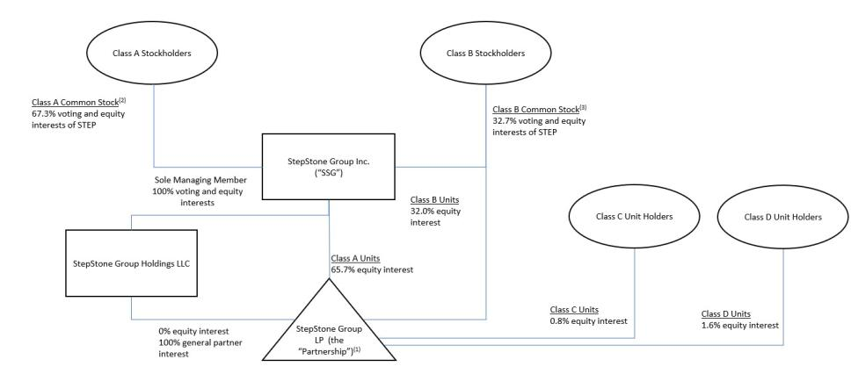

Amounts may not sum to 100% due to rounding.

- The partners of the Partnership other than StepStone Group Inc. are:

54

  - the General Partner, which holds a 100% general partner interest and no economic interests;

  - certain members of management, employee and former employee owners and outside investors, all of whom own Class B units and an equivalent number of shares of Class B common stock;
  - certain employee owners who own Class C units; and

  - certain employee owners who own Class D units.

- Each share of Class A common stock is entitled to one vote and votes together with the Class B common stock as a single class, except as set forth in SSG’s amended and restated certificate of incorporation or as required by law.
- Each share of Class B common stock is entitled to one vote and votes together with the Class A common stock as a single class, except as set forth in SSG’s amended and restated certificate of incorporation or as required by law. The economic rights of our Class B common stock are limited to the right to be redeemed at par value.

Prior to September 18, 2025, holders of our Class B common stock controlled a majority of the voting power of our outstanding common stock because (i) each share of our

Class B common stock entitled its holder to five votes on all matters to be voted on by stockholders generally, until the earliest to occur of certain ownership changes or September 18, 2025 as set forth in our then current Amended and Restated Certificate of Incorporation (the “Sunset”) and (ii) under our Amended and Restated Stockholders Agreement, dated as of September 20, 2021 (the “Stockholders Agreement”), certain Class A stockholders, Class B stockholders and Class C unitholders in the Partnership agreed to vote all of their shares of voting stock together and in accordance with the Class B Committee (as defined in the Stockholders Agreement). As a result, prior to the Sunset, we qualified as a “controlled company” within the meaning of the corporate governance rules of The Nasdaq Global Select Market LLC (“Nasdaq”). Under these rules, a listed company of which more than 50% of the voting power with respect to the election of directors is held by an individual, group or another company is a “controlled company” and may elect not to comply with certain corporate governance requirements. Consistent with this, until the occurrence of the Sunset, we elected not to comply with certain corporate governance requirements, including the requirements that (i) a majority of our board of directors consist of independent directors, (ii) director nominees be selected or recommended to the board entirely by independent directors and (iii) the compensation committee be composed entirely of independent directors.

However, since the occurrence of the Sunset and expiration of the Stockholders Agreement on September 18, 2025, each share of Class A common stock and Class B common stock is entitled to one vote, and we no longer qualify as a “controlled company” within the meaning of the Nasdaq rules. Under the Nasdaq rules, the Company may continue to rely on exemptions from certain corporate governance requirements during a one year “phase-in” period. The Company has taken all action necessary to comply with the Nasdaq rules that apply to non-controlled companies, including transitioning our board of directors to being composed of a majority of independent directors by September 18, 2026 (the end of the permitted “phase-in” period following loss of controlled company status under the Nasdaq rules). Additionally, as of September 18, 2025, the Compensation Committee and Nominating and Corporate Governance Committee of our board of directors each consist of a majority of independent directors. On or before September 18, 2026, we plan for these committees to be composed entirely of independent directors, and for a majority of our board of directors to consist of independent directors. Until the Company is fully subject to these requirements, stockholders may not have the same protections afforded to stockholders of companies that are subject to all of the corporate governance requirements under the Nasdaq rules.

Key Financial Measures

Our key financial measures are discussed below. Additional information regarding our significant accounting policies can be found in note 2 to our condensed consolidated financial statements included elsewhere in this quarterly report.

Revenues

We generate revenues primarily from management and advisory fees, incentive fees and allocations of carried interest.

55

Management and Advisory Fees, Net

Management and advisory fees, net, consist of fees received from managing SMAs and focused commingled funds, advisory and data services, and portfolio analytics and reporting. Management fees include income-based incentive fees, which are predictable and recurring in nature and paid quarterly based on net investment income of certain funds.

- Management fees from SMAs are generally based on a contractual rate applied to committed capital or net invested capital. These fees will vary over the life of the contract due to changes in the fee basis or contractual rate changes or thresholds, built-in declines in applicable contractual rates, and/or changes in net invested capital balances. The weighted-average management fee rate from SMAs was approximately 0.39% and 0.38% of average FEAUM for both the twelve months ended December 31, 2024 and 2025.

- Management fees from focused commingled funds are generally based on a specified fee rate applied against client capital commitments during a defined investment or commitment period. Thereafter, management fees are typically calculated based on a contractual rate applied against net invested capital, or a stepped-down fee rate applied against the initial commitment. The weighted-average management fee rate from focused commingled funds was approximately 1.03% and 1.01% of average FEAUM for the twelve months ended December 31, 2024 and 2025, respectively, and primarily reflected the timing of new funds and growth in our private wealth funds which earn higher fee rates.

- The weighted-average management fee rate across SMAs and focused commingled funds was approximately 0.64% and 0.63% of average FEAUM for the twelve months ended December 31, 2024 and 2025, respectively, and primarily reflected the timing of new funds, shifts in mix between SMAs and focused commingled funds and growth in our private wealth funds which earn higher fee rates.

- Fee revenues from advisory, StepStone Portfolio Analytics & Reporting (“SPAR”) and SPI Research are generally annual fixed fees, which vary based on the scope of services we provide. We also provide certain project-based or event-driven advisory services. The fees for these services are negotiated and typically paid upon successful delivery of services or on the execution of the event-driven service. Because advisory fees are negotiated and typically paid upon successful delivery of services or on the execution of the event-driven service, advisory fees do not necessarily correlate with the total size of our AUA.

- Management fees are reflected net of (i) certain professional and administrative services that we arrange to be performed by third parties on behalf of investment funds and (ii) certain distribution and servicing fees paid to third-party financial institutions. In both situations, we are acting as an agent because we do not control the services provided by the third parties before they are transferred to the customer.

Performance Fees

We earn two types of performance fee revenues: incentive fees and carried interest allocations, as described below. As of December 31, 2025, we had over $105 billion of performance fee-eligible capital (excluding certain legacy Greenspring funds) across over 225 programs.

56

Incentive fees comprise fees earned from certain client investment mandates for which we do not have a general partnership interest in a StepStone Fund. Incentive fees are generally calculated as a percentage of the profits (up to 15%) earned in respect of certain accounts, including certain permanent capital vehicles, for which we are the investment adviser, subject to the achievement of minimum return levels or performance benchmarks. Incentive fees are a form of variable consideration and represent contractual fee arrangements in our contracts with our customers. Incentive fees are typically subject to reversal until the end of a defined performance period, as these fees are affected by changes in the fair value of the assets under management or advisement over such performance period. Moreover, incentive fees that are received prior to the end of the defined performance period are typically subject to clawback, net of tax.

We recognize incentive fee revenue only when these amounts are realized and no longer subject to significant risk of reversal, which is typically at the end of a defined performance period and/or upon expiration of the associated clawback period (i.e., crystallization). However, clawback terms for incentive fees received prior to crystallization only require the return of amounts on a net of tax basis. Accordingly, the tax-related portion of incentive fees received in advance of crystallization is not subject to clawback and is therefore recognized as revenue immediately upon receipt. Incentive fees received in advance of crystallization that remain subject to clawback are recorded as deferred incentive fee revenue and included in accounts payable, accrued expenses and other liabilities in the condensed consolidated balance sheets.

Carried interest allocations include the allocation of performance-based fees, commonly referred to as carried interest, to us from limited partners in the StepStone Funds in which we hold an equity interest. We are entitled to a carried interest allocation (typically 5% to 20%) based on cumulative fund or account performance to date, irrespective of whether such amounts have been realized. These carried interest allocations are subject to the achievement of minimum return levels (typically 5% to 10%), in accordance with the terms set forth in the respective fund’s governing documents. We account for our investment balances in the StepStone Funds, including carried interest allocations, under the equity method of accounting because we are presumed to have significant influence as the general partner or managing member. Accordingly, carried interest allocations are not deemed to be within the scope of Accounting Standards Codification Topic 606 (“ASC 606”), Revenue from Contracts with Customers.

Legacy Greenspring carried interest allocations include the allocation of carried interest to legacy Greenspring general partner entities from limited partners in certain legacy Greenspring funds in which the legacy Greenspring general partner entities hold an equity interest. The legacy Greenspring general partner entities are entitled to a carried interest allocation (typically 5% to 20%) based on cumulative fund or account performance to date, irrespective of whether such amounts have been realized. We account for the

investment balances in the legacy Greenspring funds, including carried interest allocations, under the equity method of accounting because we are presumed to have significant influence as the general partner or managing member. Accordingly, legacy Greenspring carried interest allocations are not deemed to be within the scope of ASC 606. We do not have any direct economic interests in the legacy Greenspring general partner entities and thus are not entitled to any carried interest allocation from the legacy Greenspring funds.

All of the carried interest allocations in respect of such legacy Greenspring funds are payable to employees who are considered affiliates to us and are therefore reflected as legacy Greenspring performance fee-related compensation in the condensed consolidated statements of income (loss).

57

We recognize revenue attributable to carried interest allocations from a StepStone Fund based on the amount that would be due to us pursuant to the fund’s governing documents, assuming the fund was liquidated based on the current fair value of its underlying investments as of that date. Accordingly, the amount recognized as carried interest allocation revenue reflects our share of the gains and losses of the associated fund’s underlying investments measured at their then-fair values, relative to the fair values as of the end of the prior period. We record the amount of carried interest allocated to us as of each period end as accrued carried interest allocations, which is included as a component of investments in the condensed consolidated balance sheets. Our determination of fair value for investments in the underlying funds includes various valuation techniques. These techniques may include a market approach, recent transaction price, net asset value approach, or discounted cash flows, and may use one or more significant unobservable inputs such as EBITDA, revenue multiples, discount rates, weighted-average cost of capital, exit multiples, or terminal growth rates.

Carried interest is realized when an underlying investment is profitably disposed of and the fund’s cumulative returns are in excess of the specific hurdle rates, as defined in the applicable governing documents. Carried interest is subject to reversal to the extent that the amount received to date exceeds the amount due to us based on cumulative results. As such, a liability is accrued for the potential clawback obligations if amounts previously distributed to us would require repayment to a fund if such fund were to be liquidated based on the current fair value of their underlying investments as of the reporting date. Actual repayment obligations generally do not become realized until the end of a fund’s life. As of December 31, 2025 and March 31, 2025, no material amounts for potential clawback obligations had been accrued.

Expenses

Cash-based compensation primarily includes salaries, bonuses, employee benefits, cash-based incentive awards and employer-related payroll taxes.

Equity-based compensation represents grants of equity related awards or arrangements to certain employees and directors and expense associated with the employee stock purchase plan (“ESPP”).

Performance fee-related compensation represents the portion of carried interest allocation revenue and incentive fees that have been awarded to employees as a form of long-term incentive compensation. Performance fee-related compensation is generally tied to the investment performance of the StepStone Funds. Approximately 50% of carried interest allocation revenue is awarded to employees as part of our long-term incentive compensation plan, fostering alignment of interest with our clients and investors, and retaining key investment professionals. Carried interest-related compensation is accounted for as compensation expense in conjunction with the related carried interest allocation revenue and, until paid, is recorded as a component of accrued carried interest-related compensation in the condensed consolidated balance sheets. Amounts presented as realized indicate the amounts paid or payable to employees based on the receipt of carried interest allocation revenue from realized investment activity. Carried interest-related compensation expense may be subject to reversal to the extent that the related carried interest allocation revenue is reversed. Carried interest-related compensation paid to employees may be subject to clawback on an after-tax basis under certain scenarios. To date, no material amounts of realized carried interest-related compensation have been reversed. Incentive fee-related compensation is accrued as compensation expense when it is probable and estimable that payment will be made. On April 1, 2024, certain of our non-wholly owned subsidiaries underwent transactions to effect unitization of the outstanding limited partnership interests, including the class of interests relating to awards of carried interest allocations granted to employees, to combine into a single class of limited partnership interests and redesignated into units.

58

Legacy Greenspring performance fee-related compensation represents the legacy Greenspring carried interest allocations which are entirely payable to certain employees. Legacy Greenspring carried interest-related compensation is accounted for as compensation expense in conjunction with the related legacy Greenspring carried interest allocation revenue and, until paid, is recorded as a component of legacy Greenspring accrued carried interest-related compensation in the condensed consolidated balance sheets. Legacy Greenspring carried interest-related compensation expense may be subject to reversal to the extent that the related legacy Greenspring carried interest allocation revenue is reversed. However, none of the legacy Greenspring carried interest allocation revenue is attributable to the Company.

General, administrative and other includes occupancy, travel and related costs, insurance, legal and other professional fees, depreciation, amortization of intangible assets, system-related costs, and other general costs associated with operating our business. General, administrative and other includes costs associated with the Consolidated Funds. Expenses of the Consolidated Funds have no impact on net income or loss attributable to us to the extent such expenses are borne by third-party investors.

Other Income (Expense)

Investment income (loss) primarily represents our share of earnings (losses) from the investments we make in our SMAs and focused commingled funds. We, either directly or through our subsidiaries, generally have a general partner interest in the StepStone Funds, which invest in primary funds, secondary funds and co-investment funds, or a combination thereof. Investment income will increase or decrease based on the earnings of the StepStone Funds, which are primarily driven by net realized and unrealized gains (losses) on the underlying investments held by the funds. Our co-investment funds invest in underlying portfolio companies and therefore their valuation changes from period to period are more influenced by individual companies than our primary and secondary funds, which have exposures across multiple portfolio companies in underlying private markets funds. Our SMAs and focused commingled funds invest across various industries, strategies and geographies.

Consequently, our general partner investments do not include any significant concentrations in a specific sector or geography outside the United States. Investment income and legacy Greenspring investment income exclude carried interest allocations, which are presented as revenues as described above.

Legacy Greenspring investment income (loss) represents our share of earnings (losses) from the investments we make in certain legacy Greenspring funds through the legacy Greenspring general partner entities. We have no direct economic interests in the legacy Greenspring general partner entities. As a result, all such income is reflected as non-controlling interests in legacy Greenspring entities. Legacy Greenspring investment income will increase or decrease based on the earnings of such legacy Greenspring funds, which are primarily driven by net realized and unrealized gains (losses) on the underlying investments held by the funds.

Investment income (loss) of Consolidated Funds represents gains (losses) from the investments held by the Consolidated Funds.

Interest income consists of income earned on cash and cash equivalents, restricted cash, and amounts associated with the Consolidated Funds.

Interest expense primarily consists of the interest expense on the Revolver and the Notes, as well as the related amortization of deferred financing costs.

Other income (loss) includes foreign currency transaction gains and losses, non-operating activities, and amounts associated with the Consolidated Funds

59

Income Tax Expense

We are a corporation for U.S. federal income tax purposes and therefore are subject to U.S. federal and state income taxes on our share of taxable income generated by the Partnership. The Partnership is treated as a pass-through entity for U.S. federal and state income tax purposes. As such, income generated by the Partnership flows through to its limited partners, including us, and is generally not subject to U.S. federal or state income tax at the Partnership level. Our non-U.S. subsidiaries generally operate as corporate entities in non-U.S. jurisdictions, with certain of these entities subject to local or non-U.S. income taxes. Additionally, certain of our subsidiaries are subject to local jurisdiction income taxes at the entity level which are reflected within income tax expense in the condensed consolidated statements of income. As a result, the Partnership does not record U.S. federal and state income taxes on income generated by the Partnership or its subsidiaries, except for certain local and foreign income taxes discussed above.

Non-Controlling Interests

Non-controlling interests (“NCI”) reflect the portion of income or loss and the corresponding equity attributable to third-party equity holders and employees in certain consolidated subsidiaries that are not 100% owned by us. Non-controlling interests are presented as separate components in our condensed consolidated statements of income (loss) to clearly distinguish between our interests and the economic interests of third parties and employees in those entities. Net income (loss) attributable to SSG, as reported in the condensed consolidated statements of income (loss), is presented net of the portion of net income (loss) attributable to holders of non-controlling interests.

Non-controlling interests in subsidiaries represent the economic interests in the consolidated subsidiaries of the Partnership held by third parties and employees. Non-controlling interests in subsidiaries are allocated a share of income or loss in the respective consolidated subsidiary in proportion to their relative ownership interests, after consideration of contractual arrangements that govern allocations of income or loss.

Non-controlling interests in legacy Greenspring entities represent the economic interests in the legacy Greenspring general partner entities. We did not acquire any direct economic interests in the legacy Greenspring general partner entities. As a result, all of the net income (loss) attributable to the legacy Greenspring general partner entities is allocated to non-controlling interests in legacy Greenspring entities.

Non-controlling interests in the Partnership represent the economic interests in the Partnership held by the Class B, Class C and Class D unitholders of the Partnership. Non-controlling interests in the Partnership are allocated a share of income or loss in the Partnership in proportion to their relative ownership interests, after consideration of contractual arrangements that govern allocations of income or loss.

Redeemable non-controlling interests in Consolidated Funds represent the economic interests in the Consolidated Funds which are not held by us, but are held by the third-party investors in the funds. Redeemable non-controlling interests in Consolidated Funds are allocated a share of income or loss in the respective fund in proportion to their relative ownership interests, after consideration of contractual arrangements that govern allocations of income or loss.

Redeemable non-controlling interests in subsidiaries represent the redeemable economic interests in the consolidated subsidiaries of the Partnership held by third parties and employees in those entities that were established in connection with the Transaction Agreements. Redeemable non-controlling interests in subsidiaries are allocated a share of income or loss in the respective consolidated subsidiary in proportion to their relative ownership interests, after consideration of contractual arrangements that govern allocations of income or loss.

60

Key Operating Metrics

We monitor certain operating metrics that are either common to the asset management industry or that we believe provide important data regarding our business.

Assets Under Management

AUM primarily reflects the assets associated with our SMAs and focused commingled funds. We classify assets as AUM if we have full discretion over the investment decisions in an account or have responsibility or custody of assets. Although management fees are based on a variety of factors and are not linearly correlated with AUM, we believe AUM is a useful metric for assessing the relative size and scope of our asset management business.

Our AUM is calculated as the sum of (i) the net asset value (“NAV”) of client portfolio assets, including the StepStone Funds and (ii) the unfunded commitments of clients to the underlying investments and the StepStone Funds. Our AUM reflects the investment valuations in respect of the underlying investments of our funds and accounts on a three-month lag, adjusted for new client account activity through the period end. Our AUM does not include post-period investment valuation or cash activity. AUM as of December 31, 2025 reflects final data for the prior period (September 30, 2025), adjusted for net new client account activity through December 31, 2025. NAV data for underlying investments is as of September 30, 2025, as reported by underlying managers up to the business day occurring on or after 100 days following September 30, 2025. When NAV data is not available by the business day occurring on or after 100 days following September 30, 2025, such NAVs are adjusted for cash activity following the last available reported NAV.

Assets Under Advisement

AUA consists of client assets for which we do not have full discretion to make investment decisions but play a role in advising the client or monitoring their investments. We generally earn revenue for advisory-related services on a contractual fixed fee basis. Advisory-related services include asset allocation, strategic planning, development of investment policies and guidelines, screening and recommending investments, legal negotiations, monitoring and reporting on investments, and investment manager review and due diligence. Advisory fees vary by client based on the scope of services, investment activity and other factors. Most of our advisory fees are fixed, and therefore, increases or decreases in AUA do not necessarily lead to proportionate changes in revenue. We believe AUA is a useful metric for assessing the relative size of our advisory business.

Our AUA is calculated as the sum of (i) the NAV of client portfolio assets for which we do not have full discretion and (ii) the unfunded commitments of clients to the underlying investments. Our AUA reflects the investment valuations in respect of the underlying investments of our client accounts on a three-month lag, adjusted for new client account activity through the period end. Our AUA does not include post-period investment valuation or cash activity. AUA as of December 31, 2025 reflects final data for the prior period (September 30, 2025), adjusted for net new client account activity through December 31, 2025. NAV data for underlying investments is as of September 30, 2025, as reported by underlying managers up to the business day occurring on or after 100 days following September 30, 2025. When NAV data is not available by the business day occurring on or after 100 days following September 30, 2025, such NAVs are adjusted for cash activity following the last available reported NAV.

61

Fee-Earning AUM

FEAUM reflects the assets from which we earn management fee revenue (i.e., fee basis) and includes assets in our SMAs, focused commingled funds and assets held directly by our clients for which we have fiduciary oversight and are paid fees as the manager of the assets. Our SMAs and focused commingled funds typically pay management fees based on capital commitments, net invested capital and, in certain cases, NAV, depending on the fee terms. Management fees are only marginally affected by market appreciation or depreciation because substantially all of the StepStone Funds pay management fees based on capital commitments or net invested capital. As a result, management fees and FEAUM are not materially affected by changes in market value. We believe FEAUM is a useful metric in order to assess assets forming the basis of our management fee revenue.

Our calculation of FEAUM may differ from the calculations of other asset managers and, as a result, may not be comparable to similar measures presented by other asset managers.

Undeployed Fee-Earning Capital

Undeployed fee-earning capital represents the amount of capital commitments to StepStone Funds that has not yet been invested or considered active but will generate management fee revenue once this capital is invested or activated. We believe undeployed fee-earning capital is a useful metric for measuring the amount of capital that we can put to work in the future and thus earn management fee revenue thereon.

Consolidation of StepStone Funds

The activity of the Consolidated Funds is reflected within the condensed consolidated financial statement line items as indicated by reference thereto. The impact of the Consolidated Funds decrease revenues reported under GAAP to the extent these amounts are eliminated upon consolidation. The assets and liabilities of our Consolidated Funds are held within separate legal entities and, as a result, the liabilities of our Consolidated Funds are typically non-recourse to us. The net economic ownership interests of our Consolidated Funds held by third parties are reflected as redeemable non-controlling interests in Consolidated Funds in our condensed consolidated financial statements. We generally deconsolidate funds when we are no longer deemed to have a controlling financial interest in the entity. The performance of our Consolidated Funds is not necessarily consistent with, or representative of, the combined performance trends of all of our funds.

Consolidated Results of Operations

We consolidate funds and entities where we are deemed to hold a controlling financial interest. The Consolidated Funds are not necessarily the same entities in each year presented due to changes in ownership, changes in limited partners’ or investor rights, and the creation and termination of funds and entities. The following is a discussion of our unaudited consolidated results of operations for the periods presented. The information is derived from our accompanying condensed consolidated financial statements prepared in accordance with GAAP.

During the three months ended December 31, 2025, we deconsolidated an investment fund that was previously consolidated in our results as it was determined that we no longer held a controlling financial interest.

62

 |  | Three Months Ended December 31, |  |  |  |  |  | Nine Months Ended December 31,
(in thousands) |  | 2025 |  |  | 2024 |  |  | 2025 |  |  | 2024
Revenues
Management and advisory fees, net | $ | 239,932 |  | $ | 190,840 |  | $ | 666,594 |  | $ | 553,613
Performance fees:
Incentive fees |  | 207,954 |  |  | 22,369 |  |  | 213,046 |  |  | 26,365
Carried interest allocations:
Realized |  | 46,703 |  |  | 24,282 |  |  | 129,985 |  |  | 83,718
Unrealized |  | 101,985 |  |  | 93,325 |  |  | 338,681 |  |  | 120,370
Total carried interest allocations |  | 148,688 |  |  | 117,607 |  |  | 468,666 |  |  | 204,088
Legacy Greenspring carried interest allocations⁽¹⁾ |  | (10,063) |  |  | 8,207 |  |  | 56,717 |  |  | 13,035
Total performance fees |  | 346,579 |  |  | 148,183 |  |  | 738,429 |  |  | 243,488
Total revenues |  | 586,511 |  |  | 339,023 |  |  | 1,405,023 |  |  | 797,101
Expenses
Compensation and benefits:
Cash-based compensation |  | 107,114 |  |  | 85,203 |  |  | 303,447 |  |  | 246,298
Equity-based compensation |  | 468,808 |  |  | 486,418 |  |  | 1,541,996 |  |  | 542,929
Performance fee-related compensation:
Realized |  | 122,215 |  |  | 25,477 |  |  | 164,915 |  |  | 55,092
Unrealized |  | 69,050 |  |  | 49,670 |  |  | 202,134 |  |  | 66,495
Total performance fee-related compensation |  | 191,265 |  |  | 75,147 |  |  | 367,049 |  |  | 121,587
Legacy Greenspring performance fee-related compensation⁽¹⁾ |  | (10,063) |  |  | 8,207 |  |  | 56,717 |  |  | 13,035
Total compensation and benefits |  | 757,124 |  |  | 654,975 |  |  | 2,269,209 |  |  | 923,849
General, administrative and other |  | 50,640 |  |  | 43,130 |  |  | 138,846 |  |  | 134,202
Total expenses |  | 807,764 |  |  | 698,105 |  |  | 2,408,055 |  |  | 1,058,051
Other income (expense)
Investment income |  | 9,829 |  |  | 1,064 |  |  | 19,131 |  |  | 5,710
Legacy Greenspring investment income (loss)⁽¹⁾ |  | (527) |  |  | 1,167 |  |  | 4,168 |  |  | (4,119)
Investment income of Consolidated Funds |  | 21,282 |  |  | 15,037 |  |  | 88,997 |  |  | 30,878
Interest income |  | 2,455 |  |  | 2,559 |  |  | 8,175 |  |  | 7,632
Interest expense |  | (5,123) |  |  | (3,008) |  |  | (14,082) |  |  | (9,510)
Other income (loss) |  | (1,312) |  |  | (2,452) |  |  | 5,818 |  |  | (1,626)
Total other income |  | 26,604 |  |  | 14,367 |  |  | 112,207 |  |  | 28,965
Loss before income tax |  | (194,649) |  |  | (344,715) |  |  | (890,825) |  |  | (231,985)
Income tax benefit |  | (32,214) |  |  | (57,552) |  |  | (140,889) |  |  | (46,005)
Net loss |  | (162,435) |  |  | (287,163) |  |  | (749,936) |  |  | (185,980)
Less: Net income attributable to non-controlling interests in subsidiaries |  | 24,562 |  |  | 27,226 |  |  | 62,421 |  |  | 62,966
Less: Net income (loss) attributable to non-controlling interests in legacy Greenspring entities⁽¹⁾ |  | (527) |  |  | 1,167 |  |  | 4,168 |  |  | (4,119)
Less: Net loss attributable to non-controlling interests in the Partnership |  | (82,207) |  |  | (134,760) |  |  | (369,275) |  |  | (107,856)
Less: Net income attributable to redeemable non-controlling interests in Consolidated Funds |  | 18,564 |  |  | 10,905 |  |  | 79,180 |  |  | 23,101
Less: Net income attributable to redeemable non-controlling interests in subsidiaries |  | 624 |  |  | 314 |  |  | 1,587 |  |  | 983
Net loss attributable to StepStone Group Inc. | $ | (123,451) |  | $ | (192,015) |  | $ | (528,017) |  | $ | (161,055)

_______________________________

- Reflects amounts attributable to consolidated VIEs for which we did not acquire any direct economic interests. See notes 2, 3 and 5 to our condensed consolidated financial statements included elsewhere in this quarterly report.

63

Revenues

Three Months Ended December 31, 2025 Compared to Three Months Ended December 31, 2024

Total revenues increased $247.5 million, or 73%, to $586.5 million for the three months ended December 31, 2025 as compared to the three months ended December 31, 2024. The overall increase was driven by higher incentive fees, higher management and advisory fees, net, and higher carried interest allocations, partially offset by a reversal of legacy Greenspring carried interest allocations in the current period as compared to positive legacy Greenspring carried interest allocations in the prior year period, in each case, as described below.

Management and advisory fees, net increased $49.1 million, or 26%, to $239.9 million for the three months ended December 31, 2025 as compared to the three months ended December 31, 2024. The increase was driven by new client activity, 24% growth in average FEAUM across the platform and higher income-based incentive fees. The three months ended December 31, 2025 included retroactive fees of $1.1 million from the closings of StepStone’s infrastructure secondaries and multi-strategy global venture capital funds. The three months ended December 31, 2024 included retroactive fees of $9.7 million from the closings of StepStone’s Real Estate Partners V, Tactical Growth Fund IV and Infrastructure Co-Investment Partners 2022 funds.

Incentive fees increased $185.6 million, or 830%, to $208.0 million for the three months ended December 31, 2025 as compared to the three months ended December 31, 2024, largely due to higher incentive fees generated by StepStone’s Private Venture and Growth Fund (“SPRING”).

Realized carried interest allocation revenues increased $22.4 million, or 92%, to $46.7 million for the three months ended December 31, 2025 as compared to the three months ended December 31, 2024, reflecting higher realization activity within our private equity funds. Unrealized carried interest allocation revenues include the reversal of realized carried interest allocation revenues. Excluding the reversal of $46.7 million, unrealized carried interest allocation revenues increased $31.1 million, or 26%, to $148.7 million for the three months ended December 31, 2025 as compared to the three months ended December 31, 2024. The increase in unrealized carried interest allocations for the three months ended December 31, 2025 primarily reflected a higher net increase in the cumulative allocation of gains associated with the underlying portfolios within our private equity and infrastructure funds.

Legacy Greenspring carried interest allocation revenues decreased $18.3 million to $(10.1) million for the three months ended December 31, 2025 as compared to the three months ended December 31, 2024 as a result of net unrealized depreciation in the fair value of certain underlying fund investments in the current year period as compared to net unrealized appreciation in the prior year period. The three months ended December 31, 2025 reflect gross realized carried interest allocations of $0.3 million and unrealized carried interest allocations, net of the reversal of realized carried interest allocations, of $(10.3) million. The three months ended December 31, 2024 reflect gross realized carried interest allocations of $38.3 million and unrealized carried interest allocations, net of the reversal of realized carried interest allocations, of $(30.1) million.

Nine Months Ended December 31, 2025 Compared to Nine Months Ended December 31, 2024

Total revenues increased $607.9 million, or 76%, to $1,405.0 million for the nine months ended December 31, 2025 as compared to the nine months ended December 31, 2024. The overall increase was driven by higher carried interest allocations, higher incentive fees, higher management and advisory fees, net, and higher legacy Greenspring carried interest allocations, in each case, as described below.

64

Management and advisory fees, net increased $113.0 million, or 20%, to $666.6 million for the nine months ended December 31, 2025 as compared to the nine months ended December 31, 2024. The increase was driven by new client activity, 26% growth in average FEAUM across the platform and higher income-based incentive fees. The nine months ended December 31, 2025 included retroactive fees of $3.5 million from the closings of StepStone’s Real Estate Partners V, infrastructure secondaries and multi-strategy global venture capital funds. The nine months ended December 31, 2024 included retroactive fees of $36.8 million from the closings of StepStone’s Secondary Opportunities V, Real Estate Partners V, Infrastructure Co-Investment Partners 2022, Tactical Growth Fund IV and VC Global Partners XI funds.

Incentive fees increased $186.7 million, or 708%, to $213.0 million for the nine months ended December 31, 2025 as compared to the nine months ended December 31, 2024, largely due to higher incentive fees generated by SPRING.

Realized carried interest allocation revenues increased $46.3 million, or 55%, to $130.0 million for the nine months ended December 31, 2025 as compared to the nine months ended December 31, 2024, reflecting higher realization activity within our private equity funds. Unrealized carried interest allocation revenues include the reversal of realized carried interest allocation revenues. Excluding the reversal of $130.0 million, unrealized carried interest allocation revenues increased $264.6 million, or 130%, to $468.7 million for the nine months ended December 31, 2025 as compared to the nine months ended December 31, 2024. The increase in unrealized carried interest allocations for the nine months ended December 31, 2025 primarily reflected a higher net increase in the cumulative allocation of gains associated with the underlying portfolios within our private equity funds.

Legacy Greenspring carried interest allocation revenues increased $43.7 million, or 335%, to $56.7 million for the nine months ended December 31, 2025 as compared to the nine months ended December 31, 2024 as a result of higher net unrealized appreciation in the fair value of certain underlying fund investments in the current year period as compared to the prior year period. The nine months ended December 31, 2025 reflect gross realized carried interest allocations of $18.4 million and unrealized carried interest allocations, net of the reversal of realized carried interest allocations, of $38.3 million. The nine months ended December 31, 2024 reflect gross realized carried interest allocations of $56.8 million and unrealized carried interest allocations, net of the reversal of realized carried interest allocations, of $(43.8) million.

Expenses

Three Months Ended December 31, 2025 Compared to Three Months Ended December 31, 2024

Total expenses increased $109.7 million, or 16%, to $807.8 million for the three months ended December 31, 2025 as compared to the three months ended December 31, 2024. The overall increase resulted from increases in performance fee-related compensation, cash-based compensation, and general, administrative and other expenses, partially offset by decreases in legacy Greenspring performance fee-related compensation and equity-based compensation, in each case, as described below.

Cash-based compensation increased $21.9 million, or 26%, to $107.1 million for the three months ended December 31, 2025 as compared to the three months ended December 31, 2024, due to 18% higher average headcount, increased compensation levels from merit increases and higher income-based incentive fee compensation in the current year period as compared to the prior year period.

65

Equity-based compensation decreased $17.6 million, or 4%, to $468.8 million for the three months ended December 31, 2025 as compared to the three months ended December 31, 2024. The decrease was primarily attributable to a $19.8 million decrease in expenses for liability classified awards related to the profits interest issued in SPW in the current year period as compared to the prior year period, partially offset by increases in expenses for restricted stock units (“RSUs”) and performance-based RSUs (“PRSUs”) granted in the current year period with no comparable expense for these grants in the prior year period. We expect that there may be additional significant increases in equity-based compensation in future periods due to further increases in the fair value of liability classified awards, which is driven by the performance of SPW. SPW generated profitability in fiscal 2025 and in fiscal 2026 to date, and we expect that there will be an increase in the profitability generated by SPW in the future which would increase the fair value of the associated liability for the profits interest issued in SPW. As of December 31, 2025 and March 31, 2025, we had recognized $2,165.6 million and $663.9 million, respectively, for liability classified awards within accrued compensation and benefits in the condensed consolidated balance sheets.

Total performance fee-related compensation expense increased $116.1 million, or 155%, to $191.3 million for the three months ended December 31, 2025 as compared to the three months ended December 31, 2024, primarily reflecting the increase in carried interest allocation and incentive fee revenues. Realized performance fee-related compensation increased $96.7 million, or 380%, to $122.2 million for the three months ended December 31, 2025 as compared to the three months ended December 31, 2024, primarily reflecting higher realization activity and higher incentive fees from SPRING.

Legacy Greenspring performance fee-related compensation expense decreased $18.3 million to $(10.1) million for the three months ended December 31, 2025 as compared to the three months ended December 31, 2024. The three months ended December 31, 2025 reflect gross realized performance fee-related compensation expense of $0.3 million and unrealized performance fee-related compensation expense, net of the reversal of realized performance fee-related compensation expense, of $(10.3) million. The three months ended December 31, 2024 reflect gross realized performance fee-related compensation expense of $38.3 million and unrealized performance fee-related compensation expense, net of the reversal of realized performance fee-related compensation expense, of $(30.1) million.

General, administrative and other expenses increased $7.5 million, or 17%, to $50.6 million for the three months ended December 31, 2025 as compared to the three months ended December 31, 2024. The overall increase primarily reflected $2.4 million in travel and associated costs for investment evaluation and client service, $2.0 million in marketing and conference expenses, $1.8 million in information and technology expense, $1.2 million in professional fees, $1.0 million in platform fees, $1.0 million in human resources and recruiting expenses and other general operating expenses, partially offset by a $2.4 million lower expense for change in fair value for contingent consideration obligation as compared to the prior period.

Nine Months Ended December 31, 2025 Compared to Nine Months Ended December 31, 2024

Total expenses increased $1,350.0 million, or 128%, to $2,408.1 million for the nine months ended December 31, 2025 as compared to the nine months ended December 31, 2024. The overall increase resulted from increases in equity-based compensation, performance fee-related compensation, cash-based compensation, legacy Greenspring performance fee-related compensation, and general, administrative and other expenses, in each case, as described below.

Cash-based compensation increased $57.1 million, or 23%, to $303.4 million for the nine months ended December 31, 2025 as compared to the nine months ended December 31, 2024, due to 16% higher average headcount, increased compensation levels from merit increases and higher income-based incentive fee compensation in the current year period as compared to the prior year period.

66

Equity-based compensation increased $999.1 million, or 184%, to $1,542.0 million for the nine months ended December 31, 2025 as compared to the nine months ended December 31, 2024. The increase was primarily attributable to a $998.4 million increase in expenses for liability classified awards related to the profits interest issued in SPW in the current year period as compared to the prior year period, and RSUs and PRSUs granted in the current year period with no comparable expense for these grants in the prior year period. These increases were partially offset by a decrease of $5.0 million in expense due to the final vesting of RSUs issued in connection with our IPO.

Total performance fee-related compensation expense increased $245.5 million, or 202%, to $367.0 million for the nine months ended December 31, 2025 as compared to the nine months ended December 31, 2024, primarily reflecting the increase in carried interest allocation and incentive fee revenues. Realized performance fee-related compensation increased $109.8 million, or 199%, to $164.9 million for the nine months ended December 31, 2025 as compared to the nine months ended December 31, 2024, primarily reflecting higher realization activity and higher incentive fees from SPRING.

Legacy Greenspring performance fee-related compensation expense increased $43.7 million, or 335%, to $56.7 million for the nine months ended December 31, 2025 as compared to the nine months ended December 31, 2024. The nine months ended December 31, 2025 reflect gross realized performance fee-related compensation expense of $18.4 million and unrealized performance fee-related compensation expense, net of the reversal of realized performance fee-related compensation expense, of $38.3 million. The nine months ended December 31, 2024 reflect gross realized performance fee-related compensation expense of $56.8 million and unrealized performance fee-related compensation expense, net of the reversal of realized performance fee-related compensation expense, of $(43.8) million.

General, administrative and other expenses increased $4.6 million, or 3%, to $138.8 million for the nine months ended December 31, 2025 as compared to the nine months ended December 31, 2024. The overall increase primarily reflected $4.2 million in professional fees, $4.0 million in travel and associated costs for investment evaluation and client service, $3.3 million in marketing and conference expenses, $2.6 million in information and technology expense, $2.1 million in platform fees, $1.3 million in occupancy costs and other general operating expenses, partially offset by a $16.1 million lower expense for change in fair value for contingent consideration obligation as compared to the prior period.

Other Income (Expense)

Three Months Ended December 31, 2025 Compared to Three Months Ended December 31, 2024

Investment income increased $8.8 million, or 824%, to $9.8 million for the three months ended December 31, 2025 as compared to the three months ended December 31, 2024, primarily reflecting overall changes in the valuations of the underlying investments in StepStone Funds.

Legacy Greenspring investment income decreased $1.7 million to loss of $0.5 million for the three months ended December 31, 2025 as compared to the three months ended December 31, 2024. The three months ended December 31, 2025 reflect gross realized investment income of $38 thousand and unrealized investment loss, net of the reversal of realized investment income, of $0.6 million. The three months ended December 31, 2024 reflect gross realized investment income of $3.9 million and unrealized investment loss, net of the reversal of realized investment income, of $2.8 million.

Investment income of Consolidated Funds increased $6.2 million, or 42%, to $21.3 million for the three months ended December 31, 2025 as compared to the three months ended December 31, 2024, primarily reflecting overall changes in the valuations of the underlying investments of the Consolidated Funds.

67

Interest income decreased $0.1 million, or 4%, to $2.5 million for the three months ended December 31, 2025 as compared to the three months ended December 31, 2024, primarily due to the impact of deconsolidation of one of the Consolidated Funds during the current year period, partially offset by higher average cash and cash equivalent balances during the current year period as compared with the prior year period. Interest income attributable to Consolidated Funds was $4 thousand in the current year period as compared to $0.9 million in the prior year period.

Interest expense increased $2.1 million, or 70%, to $5.1 million for the three months ended December 31, 2025 as compared to the three months ended December 31, 2024. The increase was due to higher average outstanding debt balances during the current year period as compared with the prior year period, partially offset by the lower interest rate on the Notes for the current year period.

Other loss decreased $1.1 million, or 46%, to $1.3 million for the three months ended December 31, 2025 as compared to the three months ended December 31, 2024, primarily reflecting lower net foreign currency transaction losses in the current year period as compared with the prior year period.

Nine Months Ended December 31, 2025 Compared to Nine Months Ended December 31, 2024

Investment income increased $13.4 million, or 235%, to $19.1 million for the nine months ended December 31, 2025 as compared to the nine months ended December 31, 2024, primarily reflecting overall changes in the valuations of the underlying investments in StepStone Funds.

Legacy Greenspring investment loss decreased $8.3 million to income of $4.2 million for the nine months ended December 31, 2025 as compared to the nine months ended December 31, 2024. The nine months ended December 31, 2025 reflect gross realized investment income of $2.6 million and unrealized investment income, net of the reversal of realized investment income, of $1.6 million. The nine months ended December 31, 2024 reflected gross realized investment income of $6.8 million and unrealized investment loss, net of the reversal of realized investment income, of $10.9 million.

Investment income of Consolidated Funds increased $58.1 million, or 188%, to $89.0 million for the nine months ended December 31, 2025 as compared to the nine months ended December 31, 2024, primarily reflecting overall changes in the valuations of the underlying investments of the Consolidated Funds.

Interest income increased $0.5 million, or 7%, to $8.2 million for the nine months ended December 31, 2025 as compared to the nine months ended December 31, 2024, primarily due to higher average cash and cash equivalent balances during the current year period as compared with the prior year period, partially offset by the impact of deconsolidation of one of the Consolidated Funds during the current year period. Interest income attributable to Consolidated Funds was $2.3 million in the current year period as compared to $3.2 million in the prior year period.

Interest expense increased $4.6 million, or 48%, to $14.1 million for the nine months ended December 31, 2025 as compared to the nine months ended December 31, 2024. The increase was due to higher average outstanding debt balances during the current year period as compared with the prior year period, partially offset by the lower interest rate on the Notes for the current year period.

Other income (loss) increased $7.4 million to income of $5.8 million for the nine months ended December 31, 2025 as compared to the nine months ended December 31, 2024, primarily reflecting net foreign currency transaction gains in the current year period as compared with net foreign currency transaction losses in the prior year period as well as the inclusion of gains of $1.3 million related to adjustments for the Tax Receivable Agreements during the current year period.

68

Income Tax Expense

Income tax expense primarily reflects U.S. federal and state income taxes on our share of taxable income generated by the Partnership, as well as local and foreign income taxes of certain of the Partnership’s subsidiaries.

Our effective income tax rate was 16.5% and 16.7% for the three months ended December 31, 2025 and 2024, respectively, and 15.8% and 19.8% for the nine months ended December 31, 2025 and 2024, respectively. The overall effective tax rate in each of the periods described above is less than the statutory rate. For the three and nine months ended December 31, 2025 and 2024, this is primarily due to a portion of net loss allocated to non-controlling interests and the related tax benefit being borne by the holders of non-controlling interests. The decrease in the effective tax rate for the nine months ended December 31, 2025 as compared to the prior year period was mainly driven by an increase in the tax expense associated with net loss allocated to non-controlling interests in a period of increased pre-tax net loss.

Three Months Ended December 31, 2025 Compared to Three Months Ended December 31, 2024

Income tax benefit decreased $25.3 million, or 44%, to $32.2 million for the three months ended December 31, 2025 as compared to the three months ended December 31, 2024. The decrease in income tax benefit was primarily driven by the decrease in pre-tax net loss for the three months ended December 31, 2025 as compared to the three months ended December 31, 2024.

Nine Months Ended December 31, 2025 Compared to Nine Months Ended December 31, 2024

Income tax benefit increased $94.9 million, or 206%, to $140.9 million for the nine months ended December 31, 2025 as compared to the nine months ended December 31, 2024. The increase in income tax benefit was primarily driven by the increase in pre-tax net loss for the nine months ended December 31, 2025 as compared to the nine months ended December 31, 2024.

Net Income Attributable to Non-Controlling Interests in Subsidiaries

Net income attributable to non-controlling interests in subsidiaries decreased $2.7 million, or 10%, to $24.6 million for the three months ended December 31, 2025 as compared to the three months ended December 31, 2024. The decrease was primarily attributable to a decrease in income generated by our consolidated subsidiaries not wholly-owned by us due to significant retroactive fees in the prior year period that did not reoccur in the current year period and an increase in our economic interests in the Asset Class Entities as a result of the Transaction Agreements resulting in a lower rate of allocation of net income to non-controlling interests in subsidiaries.

Net income attributable to non-controlling interests in subsidiaries decreased $0.5 million, or 1%, to $62.4 million for the nine months ended December 31, 2025 as compared to the nine months ended December 31, 2024. The decrease was primarily attributable to an increase in our economic interests in the Asset Class Entities as a result of the Transaction Agreements resulting in a lower rate of allocation of net income to non-controlling interests in subsidiaries, partially offset by an increase in income generated by our consolidated subsidiaries not wholly-owned by us.

69

Net Income (Loss) Attributable to Non-Controlling Interests in Legacy Greenspring Entities

Net income (loss) attributable to non-controlling interests in legacy Greenspring entities represents the net income or loss attributable to the interests held by the legacy Greenspring general partner entities. We did not acquire any direct economic interests in the legacy Greenspring general partner entities. As a result, all of the net income or loss related to the legacy Greenspring general partner entities is allocated to non-controlling interests in legacy Greenspring entities. Net income (loss) attributable to non-controlling interests in legacy Greenspring entities was $(0.5) million and $1.2 million for the three months ended December 31, 2025 and 2024, respectively, and $4.2 million and $(4.1) million for the nine months ended December 31, 2025 and 2024, respectively.

Net Loss Attributable to Non-Controlling Interests in the Partnership

Net loss attributable to non-controlling interests in the Partnership represents the portion of net income or loss attributable to the interests held by the Class B, Class C and Class D unitholders of the Partnership. Net loss attributable to non-controlling interests in the Partnership was $82.2 million and $134.8 million for the three months ended December 31, 2025 and 2024, respectively, and $369.3 million and $107.9 million for the nine months ended December 31, 2025 and 2024, respectively.

Net Income Attributable to Redeemable Non-Controlling Interests in Consolidated Funds

Net income attributable to redeemable non-controlling interests in Consolidated Funds represents income of the Consolidated Funds attributable to third-party investors. Net income attributable to redeemable non-controlling interests in Consolidated Funds was $18.6 million and $10.9 million for the three months ended December 31, 2025 and 2024, respectively, and $79.2 million and $23.1 million for the nine months ended December 31, 2025 and 2024, respectively.

Net Income Attributable to Redeemable Non-Controlling Interests in Subsidiaries

Net income attributable to redeemable non-controlling interests in subsidiaries was $0.6 million and $0.3 million for the three months ended December 31, 2025 and 2024, respectively, and $1.6 million and $1.0 million for the nine months ended December 31, 2025 and 2024, respectively.

Key Operating Metrics

Assets Under Management

AUM was $220 billion as of December 31, 2025, $189 billion as of March 31, 2025 and $179 billion as of December 31, 2024.

Assets Under Advisement

Assets related to our advisory accounts were $591 billion as of December 31, 2025, $520 billion as of March 31, 2025 and $519 billion as of December 31, 2024.

Fee-Earning AUM

Three Months Ended December 31, 2025

FEAUM increased approximately $5.8 billion to $138.6 billion as of December 31, 2025 as compared to September 30, 2025. During the period, FEAUM from SMAs increased approximately $2.1 billion and FEAUM from commingled funds increased approximately $3.6 billion.

70

Nine Months Ended December 31, 2025

FEAUM increased approximately $17.2 billion to $138.6 billion as of December 31, 2025 as compared to March 31, 2025. During the period, FEAUM from SMAs increased approximately $7.2 billion and FEAUM from commingled funds increased approximately $10.0 billion.

 |  | Three Months Ended December 31, 2025 |  |  |  |  |  |  |  |  | Nine Months Ended December 31, 2025
(in millions) |  | SMAs |  |  | Focused |  |  | Total |  |  | SMAs |  |  | Focused |  |  | Total
(in millions) |  |  |  | Commingled Funds |  |  |  |  |  |  |  |  | Commingled Funds |  |  |  | Total
Beginning balance | $ | 78,207 |  | $ | 54,584 |  | $ | 132,791 |  | $ | 73,174 |  | $ | 48,216 |  | $ | 121,390
Contributions⁽¹⁾ |  | 2,627 |  |  | 3,245 |  |  | 5,872 |  |  | 8,199 |  |  | 8,814 |  |  | 17,013
Distributions⁽²⁾ |  | (1,117) |  |  | (547) |  |  | (1,664) |  |  | (2,852) |  |  | (1,519) |  |  | (4,371)
Market value, FX and other⁽³⁾ |  | 611 |  |  | 941 |  |  | 1,552 |  |  | 1,807 |  |  | 2,712 |  |  | 4,519
Ending balance | $ | 80,328 |  | $ | 58,223 |  | $ | 138,551 |  | $ | 80,328 |  | $ | 58,223 |  | $ | 138,551

_______________________________

- Contributions consist of new capital commitments that earn fees on committed capital and capital contributions to funds and accounts that earn fees on net invested capital or NAV.

- Distributions consist of returns of capital from funds and accounts that pay fees on net invested capital or NAV and reductions in fee-earning AUM from funds that moved from a committed capital to net invested capital fee basis or from funds and accounts that no longer pay fees.
- Market value, FX and other primarily consist of changes in market value appreciation (depreciation) for funds that pay on NAV and the effect of foreign exchange rate changes on non-U.S. dollar denominated commitments.

The following tables set forth FEAUM by asset class and selected weighted-average management fee rate data:

 |  |  |  |  | As of
(in millions) |  | December 31, 2025 |  |  | March 31, 2025 |  |  | December 31, 2024
FEAUM
Private equity | $ | 73,193 |  | $ | 65,007 |  | $ | 62,811
Infrastructure |  | 27,897 |  |  | 23,830 |  |  | 23,411
Private debt |  | 23,882 |  |  | 19,517 |  |  | 17,882
Real estate |  | 13,579 |  |  | 13,036 |  |  | 10,062
Total | $ | 138,551 |  | $ | 121,390 |  | $ | 114,166

 |  |  | As of
 | December 31, 2025 |  | March 31, 2025 |  | December 31, 2024
Weighted-average fee rate⁽¹⁾
Private equity⁽²⁾ | 0.72 % |  | 0.77 % |  | 0.77 %
Real estate, infrastructure and private debt asset classes⁽³⁾ | 0.53 % |  | 0.51 % |  | 0.47 %
Total | 0.63 % |  | 0.65 % |  | 0.64 %

_______________________________

- Weighted-average fee rates reflect the applicable management fees for the last 12 months ended on each period presented, and is inclusive of any retroactive fees for such period.

- The change in weighted-average fee rates primarily reflected the timing of new funds, shifts in mix between SMAs and focused commingled funds and growth in our private wealth funds which earn higher fee rates.

71

- The change in weighted-average fee rates primarily reflected the timing of new funds, shifts in asset class mix, shifts in mix between SMAs and focused commingled funds and growth in our private wealth funds which earn higher fee rates.

Undeployed Fee-Earning Capital

As of December 31, 2025, we had $32.7 billion of undeployed fee-earning capital, which will generate management fee revenue once invested or activated.

Non-GAAP Financial Measures

Below is a description of our non-GAAP financial measures. These measures are presented on a basis other than GAAP and should be considered in addition to, and not as a substitute for or superior to, financial measures calculated in accordance with GAAP.

Adjusted Net Income

Adjusted net income (“ANI”) is a non-GAAP performance measure that we present before the consolidation of StepStone Funds on a pre-tax and after-tax basis used to evaluate profitability. ANI represents the after-tax net realized income attributable to us. ANI does not reflect legacy Greenspring carried interest allocation revenues, legacy Greenspring carried interest-related compensation and legacy Greenspring investment income (loss) as none of the economics are attributable to us. The components of revenues used in the determination of ANI (“adjusted revenues”) comprise fee revenues, adjusted incentive fees and realized carried interest allocations. In addition, ANI excludes: (a) unrealized carried interest allocation revenues and related compensation, (b) unrealized investment income (loss), (c) equity-based compensation for awards granted prior to and in connection with our IPO, profits interests issued by our non-wholly owned subsidiaries, and unrealized mark-to-market changes in the fair value of the profits interests issued in SPW, (d) amortization of intangibles, (e) net income (loss) attributable to non-controlling interests in our subsidiaries and realized gains attributable to the profits interests issued in SPW, (f) charges associated with acquisitions and corporate transactions, and (g) certain other items that we believe are not indicative of our core operating performance (as listed in the below table). ANI is fully taxed at our blended statutory rate. We believe ANI and adjusted revenues are useful to investors because they enable investors to evaluate the performance of our business across reporting periods.

Adjusted Revenues

Adjusted revenues represents the components of revenues used in the determination of ANI and comprise fee revenues, adjusted incentive fees and realized carried interest allocations. We believe adjusted revenues is useful to investors because it presents a measure of realized revenues.

Fee-Related Earnings

Fee-related earnings (“FRE”) is a non-GAAP performance measure used to monitor our baseline earnings from recurring management and advisory fees. FRE is a component of ANI and comprises fee revenues, less adjusted expenses which are operating expenses other than (a) performance fee-related compensation, (b) equity-based compensation for awards granted prior to and in connection with our IPO, profits interests issued by our non-wholly owned subsidiaries, and unrealized mark-to-market changes in the fair value of the profits interests issued in SPW, (c) amortization of intangibles, (d) charges associated with acquisitions and corporate transactions, and (e) certain other items that we believe are not indicative of our core operating performance (as listed in the below table). FRE is presented before income taxes. We believe FRE is useful to investors because it provides additional insight into the operating profitability of our business and our ability to cover direct base compensation and operating expenses from total fee revenues.

72

Fee Revenues

Fee revenues represents management and advisory fees, net, including amounts earned from the Consolidated Funds which are eliminated in consolidation. We believe fee revenues is useful to investors because it presents the net amount of management and advisory fee revenues attributable to us.

Adjusted Weighted-Average Shares and Adjusted Net Income Per Share

ANI per share measures our per-share earnings assuming all Class B units, Class C units and Class D units in the Partnership were exchanged for Class A common stock in SSG, including the dilutive impact of outstanding equity-based awards. ANI per share is calculated as ANI divided by adjusted weighted-average shares outstanding. We believe adjusted weighted-average shares and ANI per share are useful to investors because they enable investors to better evaluate per-share operating performance across reporting periods.

Fee-Related Earnings

Three Months Ended December 31, 2025 Compared to Three Months Ended December 31, 2024

FRE increased $15.1 million, or 20%, to $89.2 million for the three months ended December 31, 2025 as compared to the three months ended December 31, 2024, primarily reflecting higher fee revenues, partially offset by higher adjusted cash-based compensation, adjusted general, administrative and other expenses, and adjusted equity-based compensation.

Nine Months Ended December 31, 2025 Compared to Nine Months Ended December 31, 2024

FRE increased $31.0 million, or 14%, to $249.1 million for the nine months ended December 31, 2025 as compared to the nine months ended December 31, 2024, primarily reflecting higher fee revenues, partially offset by higher adjusted cash-based compensation, adjusted general, administrative and other expenses, and adjusted equity-based compensation.

Adjusted Revenues and Adjusted Net Income

Three Months Ended December 31, 2025 Compared to Three Months Ended December 31, 2024

Adjusted revenues increased $250.6 million, or 103%, to $494.5 million for the three months ended December 31, 2025 as compared to the three months ended December 31, 2024, primarily reflecting increases in adjusted incentive fees, fee revenues and realized carried interest allocation revenues.

ANI increased $27.2 million, or 52%, to $79.9 million for the three months ended December 31, 2025 as compared to the three months ended December 31, 2024, primarily due to the increase in FRE as discussed above, higher performance fee-related earnings (adjusted incentive fees, plus realized carried interest allocation revenues, less realized performance fee-related compensation) and higher interest income. The overall increase was partially offset by a higher allocation of income to non-controlling interests and higher interest expense.

Nine Months Ended December 31, 2025 Compared to Nine Months Ended December 31, 2024

Adjusted revenues increased $340.5 million, or 51%, to $1,014.3 million for the nine months ended December 31, 2025 as compared to the nine months ended December 31, 2024, primarily reflecting increases in adjusted incentive fees, fee revenues and realized carried interest allocations.

73

ANI increased $31.6 million, or 19%, to $195.1 million for the nine months ended December 31, 2025 as compared to the nine months ended December 31, 2024, primarily due to the increase in FRE as discussed above, higher performance fee-related earnings, higher interest income and higher realized investment income. The overall increase was partially offset by a higher allocation of income to non-controlling interests and higher interest expense.

Adjusted Weighted-Average Shares and Adjusted Net Income Per Share

The following table shows a reconciliation of diluted weighted-average shares of Class A common stock outstanding to adjusted weighted-average shares outstanding used in the computation of ANI per share for the three and nine months ended December 31, 2025 and 2024.

 |  | Three Months Ended December 31, |  |  |  |  |  | Nine Months Ended December 31,
 |  | 2025 |  |  | 2024 |  |  | 2025 |  |  | 2024
(in thousands, except share and per share amounts)
ANI | $ | 79,858 |  | $ | 52,659 |  | $ | 195,101 |  | $ | 163,469
Weighted-average shares of Class A common stock outstanding –
Basic |  | 79,465,039 |  |  | 73,687,289 |  |  | 78,627,273 |  |  | 69,561,254
Assumed vesting of RSUs |  | 590,042 |  |  | 491,014 |  |  | 482,776 |  |  | 695,423
Assumed vesting and exchange of Class B2 units⁽¹⁾ |  | — |  |  | — |  |  | — |  |  | 573,185
Assumed purchase under ESPP |  | — |  |  | — |  |  | — |  |  | 702
Exchange of Class B units in the Partnership⁽²⁾ |  | 39,094,629 |  |  | 41,729,937 |  |  | 39,400,266 |  |  | 44,251,143
Exchange of Class C units in the Partnership⁽²⁾ |  | 931,103 |  |  | 1,016,737 |  |  | 946,186 |  |  | 1,496,518
Exchange of Class D units in the Partnership⁽²⁾ |  | 2,509,417 |  |  | 2,010,202 |  |  | 2,992,654 |  |  | 2,162,580
Adjusted weighted-average shares |  | 122,590,230 |  |  | 118,935,179 |  |  | 122,449,155 |  |  | 118,740,805
ANI per share | $ | 0.65 |  | $ | 0.44 |  | $ | 1.59 |  | $ | 1.38
_______________________________
- The Class B2 units fully vested in June 2024.

- Assumes the full exchange of Class B units, Class C units or Class D units in the Partnership for Class A common stock of SSG pursuant to the Class B Exchange Agreement, Class C Exchange Agreement or Class D Exchange Agreement, respectively.

74

Reconciliation of GAAP to Non-GAAP Financial Measures

The table below shows a reconciliation of revenues to adjusted revenues.

 | Three Months Ended December 31, |  |  |  |  |  |  | Nine Months Ended December 31,
(in thousands) | 2025 |  |  | 2024 |  |  |  | 2025 |  |  | 2024
Total revenues | $ | 586,511 |  | $ | 339,023 |  | $ | 1,405,023 |  | $ | 797,101
Unrealized carried interest allocations |  | (101,985) |  |  | (93,325) |  |  | (338,681) |  |  | (120,370)
Deferred incentive fees |  | (1,544) |  |  | — |  |  | (873) |  |  | 2,451
Legacy Greenspring carried interest allocations |  | 10,063 |  |  | (8,207) |  |  | (56,717) |  |  | (13,035)
Management and advisory fee revenues for the Consolidated
Funds⁽¹⁾ |  | 1,201 |  |  | 992 |  |  | 4,740 |  |  | 2,214
Incentive fees for the Consolidated Funds⁽²⁾ |  | 254 |  |  | 5,422 |  |  | 817 |  |  | 5,497
Adjusted revenues | $ | 494,500 |  | $ | 243,905 |  | $ | 1,014,309 |  | $ | 673,858

______________________________

- Reflects the add back of management and advisory fee revenues for the Consolidated Funds, which have been eliminated in consolidation.

- Reflects the add back of incentive fee revenues for the Consolidated Funds, which have been eliminated in consolidation.

75

The table below shows a reconciliation of GAAP measures to additional non-GAAP measures. We use the non-GAAP measures presented below as components when calculating FRE and ANI. We believe these additional non-GAAP measures are useful to investors in evaluating both the baseline earnings from recurring management and advisory fees, which provide additional insight into the operating profitability of our business, and the after-tax net realized income attributable to us, allowing investors to evaluate the performance of our business. These additional non-GAAP measures remove the impact of Consolidated Funds that we are required to consolidate under GAAP, and certain other items that we believe are not indicative of our core operating performance.

 |  | Three Months Ended December 31, |  |  |  |  |  | Nine Months Ended December 31,
(in thousands) |  | 2025 |  |  | 2024 |  |  | 2025 |  |  | 2024
GAAP management and advisory fees, net | $ | 239,932 |  | $ | 190,840 |  | $ | 666,594 |  | $ | 553,613
Management and advisory fee revenues for the Consolidated
Funds⁽¹⁾ |  | 1,201 |  |  | 992 |  |  | 4,740 |  |  | 2,214
Fee revenues | $ | 241,133 |  | $ | 191,832 |  | $ | 671,334 |  | $ | 555,827
GAAP incentive fees | $ | 207,954 |  | $ | 22,369 |  | $ | 213,046 |  | $ | 26,365
Adjustments⁽²⁾ |  | (1,290) |  |  | 5,422 |  |  | (56) |  |  | 7,948
Adjusted incentive fees | $ | 206,664 |  | $ | 27,791 |  | $ | 212,990 |  | $ | 34,313
GAAP interest income | $ | 2,455 |  | $ | 2,559 |  | $ | 8,175 |  | $ | 7,632
Interest income earned by the Consolidated Funds⁽³⁾ |  | (4) |  |  | (887) |  |  | (2,275) |  |  | (3,157)
Adjusted interest income | $ | 2,451 |  | $ | 1,672 |  | $ | 5,900 |  | $ | 4,475
GAAP other income (loss) | $ | (1,312) |  | $ | (2,452) |  | $ | 5,818 |  | $ | (1,626)
Adjustments⁽⁴⁾ |  | 660 |  |  | 1,883 |  |  | (4,572) |  |  | 729
Adjusted other income (loss) | $ | (652) |  | $ | (569) |  | $ | 1,246 |  | $ | (897)

______________________________

- Reflects the add-back of management and advisory fee revenues for the Consolidated Funds, which have been eliminated in consolidation.

- Reflects the add-back of incentive fee revenues for the Consolidated Funds, which have been eliminated in consolidation, and deferred incentive fees that are not included in GAAP revenues.
- Reflects the removal of interest income earned by the Consolidated Funds.

- Reflects the removal of amounts for Tax Receivable Agreements adjustments recognized as other income (loss) and the impact of consolidation of the Consolidated Funds.

76

The table below shows a reconciliation of loss before income tax to ANI and FRE.

 | Three Months Ended December 31, |  |  |  |  |  |  | Nine Months Ended December 31,
(in thousands) | 2025 |  |  | 2024 |  |  |  | 2025 |  |  | 2024
Loss before income tax | $ | (194,649) |  | $ | (344,715) |  | $ | (890,825) |  | $ | (231,985)
Net income attributable to non-controlling interests in
subsidiaries⁽¹⁾ |  | (115,887) |  |  | (32,765) |  |  | (174,257) |  |  | (69,528)
Net (income) loss attributable to non-controlling interests in
legacy Greenspring entities |  | 527 |  |  | (1,167) |  |  | (4,168) |  |  | 4,119
Unrealized carried interest allocations |  | (101,985) |  |  | (93,325) |  |  | (338,681) |  |  | (120,370)
Unrealized performance fee-related compensation |  | 69,050 |  |  | 49,670 |  |  | 202,134 |  |  | 66,495
Unrealized investment (income) loss |  | (8,268) |  |  | 656 |  |  | (14,114) |  |  | (954)
Impact of Consolidated Funds |  | (18,944) |  |  | (6,892) |  |  | (87,215) |  |  | (23,890)
Deferred incentive fees |  | (1,544) |  |  | — |  |  | (873) |  |  | 2,451
Equity-based compensation⁽²⁾ |  | 464,124 |  |  | 483,958 |  |  | 1,528,787 |  |  | 535,690
Amortization of intangibles |  | 10,207 |  |  | 10,250 |  |  | 30,621 |  |  | 30,750
Tax Receivable Agreements adjustments through earnings |  | — |  |  | — |  |  | (1,302) |  |  | —
Non-core items⁽³⁾ |  | 106 |  |  | 2,094 |  |  | 891 |  |  | 17,580
Pre-tax ANI |  | 102,737 |  |  | 67,764 |  |  | 250,998 |  |  | 210,358
Income taxes⁽⁴⁾ |  | (22,879) |  |  | (15,105) |  |  | (55,897) |  |  | (46,889)
ANI |  | 79,858 |  |  | 52,659 |  |  | 195,101 |  |  | 163,469
Income taxes⁽⁴⁾ |  | 22,879 |  |  | 15,105 |  |  | 55,897 |  |  | 46,889
Realized carried interest allocations |  | (46,703) |  |  | (24,282) |  |  | (129,985) |  |  | (83,718)
Realized performance fee-related compensation |  | 122,215 |  |  | 25,477 |  |  | 164,915 |  |  | 55,092
Realized investment income |  | (1,560) |  |  | (1,720) |  |  | (5,016) |  |  | (4,756)
Adjusted incentive fees⁽⁵⁾ |  | (206,664) |  |  | (27,791) |  |  | (212,990) |  |  | (34,313)
Adjusted interest income⁽⁶⁾ |  | (2,451) |  |  | (1,672) |  |  | (5,900) |  |  | (4,475)
Interest expense |  | 5,123 |  |  | 3,008 |  |  | 14,082 |  |  | 9,510
Adjusted other (income) loss⁽⁷⁾ |  | 652 |  |  | 569 |  |  | (1,246) |  |  | 897
Net income attributable to non-controlling interests in
subsidiaries⁽¹⁾ |  | 115,887 |  |  | 32,765 |  |  | 174,257 |  |  | 69,528
FRE | $ | 89,236 |  | $ | 74,118 |  | $ | 249,115 |  | $ | 218,123

_______________________________

- Reflects the portion of pre-tax ANI attributable to non-controlling interests in our subsidiaries and realized gains attributable to the profits interests issued in the private wealth subsidiary. Amounts attributable to the profits interests issued in the private wealth subsidiary were $97.5 million and $14.1 million for the three months ended December 31, 2025 and 2024, respectively, and $116.1 million and $17.0 million for the nine months ended December 31, 2025 and 2024, respectively. Amounts specifically attributable to non-controlling interests in subsidiaries not attributable to the private wealth subsidiary were $18.4 million and $18.7 million for the three months ended December 31, 2025 and 2024, respectively, and $58.1 million and $52.6 million for the nine months ended December 31, 2025 and 2024, respectively.
- Reflects equity-based compensation for awards granted prior to and in connection with the IPO, profits interests issued by our non-wholly owned subsidiaries, and unrealized mark-to-market changes in the fair value of the profits interests issued in the private wealth subsidiary.
- Includes (income) expense related to transaction costs ($47 thousand and $12 thousand for the three months ended

77

December 31, 2025 and 2024, respectively, and $0.7 million and $0.8 million for the nine months ended December 31, 2025 and 2024, respectively), unrealized amounts associated with cash-based incentive awards tracked to investment funds ($34 thousand for the nine months ended December 31, 2025), loss on change in fair value for contingent consideration obligation ($0.1 million and $2.5 million for the three months ended December 31, 2025 and 2024, respectively, and $0.2 million and $16.3 million for the nine months ended December 31, 2025 and 2024, respectively), compensation paid to certain employees as part of an acquisition earn-out ($(0.4) million and $0.4 million for the three and nine months ended December 31, 2024, respectively) and other non-core operating income and expenses.

- Represents corporate income taxes at a blended statutory rate of 22.3% applied to pre-tax ANI for the three and nine months ended December 31, 2025 and 2024, which is based on a federal statutory rate of 21.0% and a combined state, local and foreign rate net of federal benefits of 1.3%.
- Reflects the add-back of incentive fee revenues for the Consolidated Funds, which have been eliminated in consolidation, and deferred incentive fees that are not included in GAAP revenues.
- Reflects the removal of interest income earned by the Consolidated Funds.

- Reflects the removal of the impact of consolidation of the Consolidated Funds and amounts for Tax Receivable Agreements adjustments recognized as other income (loss) ($1.3 million for the nine months ended December 31, 2025).

Investment Performance

The following table presents information relating to the performance of all the investments that StepStone has recommended and subsequently tracked across asset classes and investment strategies, except as set forth in greater detail below. The data for these investments are generally presented from the inception date of each strategy and asset class through September 30, 2025 and have not been adjusted to reflect acquisitions or disposals of investments subsequent to that date.

The historical results of our investments are not indicative of future results to be expected of existing or new investment funds, and are not a proxy for the performance of our Class A common stock, including because:

- market conditions and investment opportunities may differ from those in the past;

- the performance of our funds is largely based on the NAV (as defined below) of the funds’ investments, including unrealized gains, which may never be realized;

- newly-established funds may generate lower investment returns during the period that they initially deploy their capital;

- changes in the global tax and regulatory environment may impact both the investment preferences of our clients and the financing strategies employed by businesses in which particular funds invest, which may reduce the overall capital available for investment and the availability of suitable investments, thereby reducing investment returns in the future;

- competition for investment opportunities, resulting from the increasing amount of capital invested in private markets alternatives, may increase the cost and reduce the availability of suitable investments, thereby reducing investment returns in the future; and

- the industries and businesses in which particular funds invest will vary.

Historical and future returns of investments included in our track record are not directly correlated to potential returns on our Class A common stock.

78

For the purposes of the following table:

- “Invested capital” refers to the total amount of all investments made by a fund, including commitment-reducing and non-commitment-reducing capital calls;

- “NAV” refers to the estimated fair value of unrealized investments plus any net assets or liabilities associated with the investment as of September 30, 2025;

- “IRR” refers to the annualized internal rate of return for all investments within the relevant investment strategy on an inception-to-date basis as of September 30, 2025 (except as noted otherwise below), based on contributions, distributions and unrealized value;

- “Net IRR” refers to IRR net of fees and expenses charged by both the underlying fund managers and StepStone; and

- “Net TVM” refers to the total value to paid-in capital or invested capital expressed as a multiple, and is calculated as distributions plus unrealized valuations divided by invested capital (including all capitalized costs).

StepStone Performance Summary by Asset Class

PRIVATE EQUITY |  |  |  | REAL ESTATE |  |  |  | INFRASTRUCTURE |  |  | PRIVATE DEBT
INVESTMENT STRATEGY(1,2,4) | NET IRR(3) | NET TVM(3) |  | INVESTMENT STRATEGY(1,4,5) | NET IRR(3) | NET TVM(3) |  | INVESTMENT STRATEGY(1,4,6) | NET IRR(3) |  | INVESTMENT STRATEGY(1,4,8) | NET IRR(3)
Primaries | 13.8% | 1.5x |  | Core/Core+ fund investments | 6.9% | 1.4x |  | Core/debt - all strategies | 7.0% |  | Primaries | 7.7%
Secondaries | 14.4% | 1.4x |  | Value-add/opportunistic fund | 8.0% | 1.3x |  | Core+/value-add - primary fund | 10.4% |  | Direct lending | 7.0%
 |  |  |  | investments | 8.0% | 1.3x |  | investments | 10.4% |  | Direct lending | 7.0%
Co-investments(7) | 15.0% | 1.5x |  | Real estate debt fund investments | 5.1% | 1.1x |  | Core+/value-add - secondary fund | 8.2% |  | Opportunistic | 8.3%
 |  |  |  |  |  |  |  | investments | 8.2% |  | Opportunistic | 8.3%
 |  |  |  | Value-add/opportunistic secondaries & | 8.6% | 1.2x |  | Core+/value-add - co-investments | 11.4% |  | Co-investments/secondaries | 9.5%
 |  |  |  | co-investments |  |  |  |  |  |  | Co-investments/secondaries | 9.5%
 |  |  |  |  |  |  |  |  |  |  | Direct lending | 8.1%
 |  |  |  |  |  |  |  |  |  |  | Opportunistic | 11.5%
 |  |  |  |  |  |  |  |  |  |  | Customized Managed Accounts | (*)

_______________________________

- Investment returns reflect NAV data for underlying investments as of September 30, 2025, as reported by underlying managers up to the business day occurring on or after 100 days following September 30, 2025. For investment returns where NAV data is not available by the business day occurring on or after 100 days following September 30, 2025, such NAVs are adjusted for cash activity following the last available reported NAV. Investment returns are calculated on a constant currency adjusted reporting basis converting non-USD investment cash flows and NAVs to USD using the foreign currency exchange rate corresponding to each client’s first cash flow date.
- Private equity includes 3,216 investments totaling $228.0 billion of capital commitments and excludes (i) two advisory co-investments, totaling $100.0 million of capital commitments, (ii) 240 client-directed private equity investments, totaling $33.3 billion of capital commitments, and (iii) investments that do not have client data monitored in SPI Reporting. Private equity includes buyout, venture capital, growth equity, fund-of-funds, and energy focused strategies. StepStone’s venture capital and growth equity strategy is composed of a) venture capital and growth equity focused commingled funds and separately managed accounts (the “StepStone VC Platform”) and b) underlying venture capital and growth equity investments within StepStone’s broader private equity accounts (“StepStone PE Accounts”).

79

- Net IRR and Net TVM are presented solely for illustrative purposes and do not represent actual returns received by any investor in any of the StepStone Funds represented above and are net of fees and expenses charged by both the underlying investment and hypothetical StepStone fees. The aggregate returns are not indicative of the returns an individual investor would receive from these investments. No individual investor received the aggregate returns described herein as the investments were made across multiple mandates over multiple years. StepStone fees and expenses are based on the following assumptions (management fees and expenses represent an annual rate, charged quarterly):

  - Primaries management fee: 25 basis points of net invested capital for private equity, real estate and infrastructure; 25 basis points of net asset value for private debt; 75 basis points of committed capital for the StepStone VC Platform.
  - Secondaries management fee: 125 basis points, 125 basis points and 95 basis points of capital commitments for private equity, real estate and infrastructure, respectively, in years 1 through 4 for management fees, charged quarterly. In year 5, management fees step down to 90% of the previous year’s fee; 65 basis points of net asset value for private debt; 75 basis points of committed capital for the StepStone VC Platform.
  - Co-investments management fee: 100 basis points of net committed capital for private equity and real estate; 90 and 50 basis points of net committed capital for infrastructure co-investments and direct asset management investments, respectively; 65 basis points of net asset value for private debt; 200 basis points of net invested capital for the StepStone VC Platform.
  - All investments assess 5 basis points of capital commitments for fund expenses, charged quarterly, and 1 basis point of capital commitments drawn down in the first cash flow quarter for organizational costs.
  - Private equity secondaries and co-investments include 12.5% and 10.0% of paid and unrealized carry, respectively, with an 8.0% preferred return hurdle; infrastructure secondaries and co-investments include 10.0% of paid and unrealized carry, respectively, with an 8.0% preferred return hurdle; real estate secondaries and co-investments include 15.0% of paid and unrealized carry, with an 8.0% preferred return hurdle; private debt secondaries and co-investments include 10.0% of paid and unrealized carry, with a 5.0% preferred return hurdle; and the StepStone VC Platform primaries, secondaries and co-investments/directs include 5.0%, 5.0% and 20.0%, respectively, of paid and unrealized carry with no preferred return hurdle.
Net IRR and Net TVM for certain investments may have been impacted by StepStone’s, or the underlying fund manager’s, use of subscription backed credit facilities by such vehicles.

Reinvested/recycled amounts increase contributed capital.

- Investments of former clients are included in performance summary past the client termination date until such time as StepStone stops receiving current investment data (quarterly valuations and cash flows) for the investment. At that point, StepStone will then ‘liquidate’ the fund by entering a distribution amount equal to the last reported NAV, thus ending its contribution to the track record as of that date. Historical performance contribution will be maintained up until the ‘liquidation’ date.
- Real estate includes 509 investments totaling $91.2 billion of capital commitments and excludes (i) 100 client-directed real estate investments, totaling $16.8 billion of capital commitments, (ii) 19 secondary/co-investment core/core+ or credit investments, totaling $1.1 billion of capital commitments, (iii) four advisory fund investments totaling $463.6 million of capital commitments, and (iv) investments that do not have client data monitored in SPI Reporting.
- Infrastructure includes 332 investments totaling $69.9 billion of capital commitments and excludes (i) eight infrastructure investments made by the Partnership prior to the formation of the infrastructure subsidiary in 2013 or made prior to StepStone’s acquisition of Courtland Partners, Ltd. on April 1, 2018 (the “Courtland acquisition”), totaling $501.9 million of capital commitments, (ii) 46 client-directed infrastructure investments, totaling $11.0 billion of capital commitments, and (iii) investments that do not have client data monitored in SPI Reporting.
- Co-investments include venture capital and growth equity direct investments for private equity.

- Private debt includes 1,764 investments totaling $66.8 billion of capital commitments and excludes (i) 48 client-directed debt investments, totaling $4.3 billion of capital commitments, (ii)

50 real estate credit investments that were recommended by Courtland Partners, Ltd. prior to the Courtland acquisition, totaling $5.1 billion of capital commitments, and (iii) investments that do not have client data monitored in SPI Reporting. *Net IRRs are not aggregated and shown for customized managed accounts (which include capacity-negotiated GP co-investment accounts and GP primary managed accounts) totaling $35.1 billion of committed capital, as the investment objective of those investments are customized to the respective client’s investment target on multiple-on-committed-capital (“MOCC”) and can differ significantly.

80

Liquidity and Capital Resources

Sources and Uses of Liquidity

We generate cash primarily from management and advisory fees and performance fees. We have historically managed our liquidity and capital resource needs through (a) cash generated from our operating activities, (b) realizations from investment activities, (c) borrowings, interest payments and repayments under credit agreements, senior note issuances and other borrowing arrangements, (d) funding capital commitments to our funds, and (e) funding our growth initiatives, including capital expenditures for property, equipment, and acquisitions to expand into new businesses.

As of December 31, 2025, we had $266.6 million of cash, cash equivalents and restricted cash ($378.0 million including Consolidated Funds) and $2,128.9 million of investments in StepStone Funds, including $1,835.9 million of accrued carried interest allocations, against $270.2 million in debt obligations, net of debt issuance costs, and $960.5 million in accrued carried interest-related compensation payable.

Ongoing sources of cash include (a) management and advisory fees, which are collected monthly or quarterly, (b) performance fees, which are volatile and largely unpredictable as to amount and timing; and (c) distributions from our investments in the StepStone Funds. We use cash flow from operations and distributions from our investments in the StepStone Funds to pay compensation and related expenses, general and administrative expenses, income taxes, debt service, capital expenditures, dividends to our stockholders and distributions to holders of Partnership units, and to make investments in the StepStone Funds. We believe we will have sufficient ability to meet our liquidity and capital resources requirements for the next 12 months through cash flows from operating activities, existing cash and cash equivalents, and our ability to obtain future financing.

Cash Flows

The accompanying condensed consolidated cash flows include the Consolidated Funds, which activities primarily consist of raising capital from third-party investors, purchasing investments, making payment for the operating costs of the fund, generating cash flows from realized income allocations of investments and sales of investments, and making distributions to investors. The Consolidated Funds are accounted for as investment companies and therefore the cash flows from investing activities are included in cash flows from operations.

The following table summarizes our cash flows attributable to operating, investing and financing activities:

 |  | Nine Months Ended December 31,
(in thousands) |  | 2025 |  |  | 2024
Net cash provided by operating activities | $ | 89,681 |  | $ | 131,451
Net cash used in investing activities |  | (88,840) |  |  | (36,671)
Net cash provided by financing activities |  | 95,199 |  |  | 2,580
Effect of exchange rate changes |  | (7,828) |  |  | (168)
Net increase in cash, cash equivalents and restricted cash | $ | 88,212 |  | $ | 97,192

Operating Activities

Operating activities provided $89.7 million and $131.5 million of cash for the nine months ended December 31, 2025 and 2024, respectively. For the nine months ended

December 31, 2025 and 2024, respectively, these amounts primarily consisted of the following:

81

- net income, after adjustments for non-cash items (including unrealized mark-to-market changes in the fair value of the profits interests issued in the private wealth subsidiary, unrealized carried interest allocations, unrealized performance fee-related compensation, unrealized investment (income) loss and fair value adjustment for acquisition-related contingent consideration), of $388.1 million and $293.0 million;

- net change in operating assets and liabilities of $9.8 million and $27.3 million;

- adjustments for unrealized investment income from Consolidated Funds of $87.5 million and $28.1 million;

- net purchases of investments of Consolidated Funds of $225.9 million and $160.5 million; and

- net change in operating assets and liabilities of Consolidated Funds of $5.2 million and $(0.2) million.

Investing activities used $88.8 million and $36.7 million of cash for the nine months ended December 31, 2025 and 2024, respectively, and primarily consisted of the following amounts:

- net contributions to investments of $35.5 million and $37.8 million;

- net distributions from investments in legacy Greenspring entities of $0.9 million and $3.6 million;

- net cash derecognized from deconsolidation of fund of $52.4 million and $0 million; and

- purchases of fixed assets of $1.9 million and $2.4 million.

Financing activities provided $95.2 million and $2.6 million of cash for the nine months ended December 31, 2025 and 2024, respectively, and primarily consisted of the following:

- net repayments on revolving credit facility of $0 million and $150.0 million;

- proceeds from issuance of notes payable of $0 million and $175.0 million;

- deferred financing costs of $0 million and $5.4 million;

- proceeds from capital contributions from non-controlling interests of $2.2 million and $7.1 million;

- distributions to non-controlling interests of $125.4 million and $96.9 million;

- purchase of non-controlling interests of $10.3 million and $5.4 million;

- redemption of redeemable non-controlling interests of $0 million and $13.0 million;

- proceeds from capital contributions to legacy Greenspring entities of $1.1 million and $19.2 million;

- distributions to non-controlling interests in legacy Greenspring entities of $4.7 million and $29.6 million;

82

- dividends paid to common stockholders of $94.4 million and $57.6 million;

- payments for taxes related to the net settlement of RSUs of $0 million and $1.1 million;

- proceeds from issuance of Class A common stock under ESPP of $1.7 million and $1.1 million;

- payments to related parties under the Tax Receivable Agreements of $12.6 million and $9.8 million;

- net borrowings on fund credit facility of $0 million and $7.9 million;

- contributions from redeemable non-controlling interests in Consolidated Funds of $391.3 million and $169.9 million; and

- redemptions of redeemable non-controlling interests in Consolidated Funds of $53.8 million and $8.8 million.

Debt Obligations

Revolving Credit Facility

We are party to a credit agreement, as amended and restated in May 2024 (the “Credit Agreement”), which, among other things, increased the aggregate principal amount of the commitments thereunder to $300.0 million from $225.0 million and extended the maturity date of the revolving facility to May 2029. The Credit Agreement was arranged by JPMorgan Chase Bank, N.A., as administrative agent and collateral agent, and certain other lenders party thereto and provides for a $300.0 million multicurrency Revolver.

Borrowings under the Revolver bear interest at a variable rate per annum. We may designate each borrowing as (i) in the case of any borrowing in U.S. dollars, a base rate loan or a Term Secured Overnight Financing Rate (“SOFR”) rate loan, (ii) in the case of any borrowing denominated in Euros, a EURIBOR rate loan, (iii) in the case of any borrowing denominated in British Pounds Sterling, a Sterling Overnight Index Average (“SONIA”) loan, (iv) in the case of any borrowing denominated in Swiss Francs, a Swiss Average Rate Overnight (“SARON”) loan, and (v) in the case of any borrowing denominated in Australian dollars, an AUD rate loan. Borrowings bear interest equal to (i) in the case of base rate loans, 1.00% plus the greatest of (a) the Prime Rate, (b) the New York Federal Reserve Bank Rate plus 0.50% and (c) the 1 month Term SOFR, plus 1.10%, (ii) in the case of a Term SOFR rate loan, the Term SOFR rate plus 2.10%, (iii) in the case of a EURIBOR rate loan, the EURIBOR rate multiplied by the Statutory Reserve Rate (as defined in the Credit Agreement) plus 2.00%, (iv) in the case of a SONIA loan, the Sterling Overnight Index Average plus 2.03%, (v) in the case of a SARON loan, the Swiss Average Rate Overnight plus 2.00%, and (vi) in the case of an AUD rate loan, the AUD Screen Rate (as defined in the Credit Agreement) multiplied by the Statutory Reserve Rate plus 2.20%, in certain cases subject to applicable interest rate floors. The weighted-average interest rate in effect for the Revolver as of December 31, 2025 was 6.02%.

Borrowings under the Revolver may be repaid at any time during the term of the Credit Agreement and, subject to certain terms and conditions, may be reborrowed prior to the maturity date. Any outstanding principal amounts, together with any accrued interest thereon, shall be due and payable on the maturity date. The maturity date for the Revolver is May 16, 2029.

The Revolver bears a fee on undrawn commitments equal to 0.25% per annum if total utilization of revolving commitments is equal to or greater than 50% and 0.35% per annum if total utilization of revolving commitments is less than 50%.

83

We can use available funding capacity under the Revolver to satisfy letters of credit in amounts up to $10.0 million. Amounts used to satisfy the letters of credit reduce the available capacity under the Revolver. As of December 31, 2025, we had outstanding letters of credit totaling $10.1 million.

Senior Notes

On October 22, 2024, we issued $175.0 million aggregate principal amount of our 5.52% Series A senior notes due October 22, 2029, pursuant to the Note Purchase Agreement, dated as of October 22, 2024, in a private placement exempt from registration under the Securities Act.

Interest on the Notes is payable semi-annually in arrears on April 22 and October 22 of each year. Interest on the Notes accrues from and including October 22, 2024. The Notes will mature on October 22, 2029. We may, at our option, prepay at any time all, or from time to time any part of, the Notes, in an amount not less than 5% of the aggregate principal amount of the Notes then outstanding at a redemption price equal to 100% of the principal amount thereof plus any applicable “make-whole amount” and accrued and unpaid interest to the redemption date. So long as no default or event of default shall have occurred and be continuing under the Note Purchase Agreement, no make-whole amount will be due if the Notes are paid on or after April 22, 2029.

Debt Obligations of Consolidated Funds

Certain Consolidated Funds may maintain revolving credit facilities that are secured by fund assets to fund investments on a short-term basis. The debt obligations of the Consolidated Funds are non-recourse to us.

In December 2024, one of our consolidated investment funds entered into a credit agreement with Northern Trust Global Service SE (the “Fund Credit Facility”). The Fund Credit Facility provides for a multi-currency revolving credit facility of up to $125.0 million. Amounts drawn under the facility must be repaid within 180 days. As of December 31, 2025, there were no outstanding borrowings under the Fund Credit Facility.

Borrowings under the Fund Credit Facility bear interest at a variable rate per annum. Borrowings in USD will bear interest at the applicable federal funds target rate (upper range) plus a margin of 250 basis points. Borrowings in GBP will bear interest at the Bank of England base rate plus a margin of 250 basis points. Borrowings in EUR will bear interest at the European Central Bank main refinancing rate plus a margin of 250 basis points.

Debt Covenants

Under the terms of the Credit Agreement, certain of our assets serve as pledged collateral. In addition, the Credit Agreement contains covenants that, among other things: limit our ability to incur indebtedness; create, incur or allow liens; transfer or dispose of assets; merge with other companies; make certain investments; pay dividends or make distributions in certain circumstances; engage in new or different lines of business; and engage in certain transactions with affiliates. The Credit Agreement also contains financial covenants requiring us to maintain a total net leverage ratio, and a minimum total of fee-earning assets under management.

The Note Purchase Agreement contains certain covenants, including those requiring us to (a) maintain a total net leverage ratio, (b) maintain a minimum total of fee-earning assets under management, (c) cause at least 80% of all management fees payable by material subsidiaries to us to be collected each period without deferral, waiver or reduction, (d) limit the amount of secured indebtedness to be incurred by us, and (e) other customary covenants. The Note Purchase Agreement also provides for customary events of default, which, if any occur and is continuing, could permit or require the entire unpaid principal amount of any or all Notes, plus all accrued and unpaid interest thereon and any applicable “make-whole amount” to become or to be declared due and payable immediately.

84

Under the terms of the Fund Credit Facility, certain of the assets of the Consolidated Funds serve as pledged collateral. In addition, the Fund Credit Facility contains covenants that, among other things: limit the ability of the fund to incur indebtedness; create, incur or allow liens; and other customary covenants. The Fund Credit Facility also provides for customary events of default, which, if any occur and are continuing, could permit or require the entire unpaid principal amount of any or all loans under the Fund Credit Facility, plus all accrued and unpaid interest thereon to become or to be declared due and payable immediately.

As of December 31, 2025, we were in compliance with the covenants under our various debt agreements.

Equity Transactions

In June 2025, we issued 152,768 shares of Class A common stock to certain limited partners of the Partnership in exchange for 152,768 Class B units of the Partnership in accordance with the elective exchange notices submitted pursuant to the Class B Exchange Agreement. A corresponding number of shares of Class B common stock were automatically redeemed at par value and canceled in connection with such exchange and a corresponding number of Class A units of the Partnership were issued to us. We also issued 18,000 shares of Class A common stock to certain limited partners of the Partnership in exchange for 18,000 Class C units of the Partnership in accordance with the elective exchange notices submitted pursuant to the Class C Exchange Agreement, and a corresponding number of Class A units of the Partnership were issued to us. We also issued 864,640 shares of Class A common stock to certain limited partners of the Partnership in exchange for 864,640 Class D units of the Partnership in accordance with the elective exchange notices submitted pursuant to the Class D Exchange Agreement, and a corresponding number of Class A units of the Partnership were issued to us.

In September 2025, we issued 370,470 shares of Class A common stock to certain limited partners of the Partnership in exchange for 370,470 Class B units of the Partnership in accordance with the elective exchange notices submitted pursuant to the Class B Exchange Agreement. A corresponding number of shares of Class B common stock were automatically redeemed at par value and canceled in connection with such exchange and a corresponding number of Class A units of the Partnership were issued to us. We also issued 16,658 shares of Class A common stock to certain limited partners of the Partnership in exchange for 16,658 Class C units of the Partnership in accordance with the elective exchange notices submitted pursuant to the Class C Exchange Agreement, and a corresponding number of Class A units of the Partnership were issued to us. We also issued 135,697 shares of Class A common stock to certain limited partners of the Partnership in exchange for 135,697 Class D units of the Partnership in accordance with the elective exchange notices submitted pursuant to the Class D Exchange Agreement, and a corresponding number of Class A units of the Partnership were issued to us.

In December 2025, we issued 116,000 shares of Class A common stock to certain limited partners of the Partnership in exchange for 116,000 Class B units of the Partnership in accordance with the elective exchange notices submitted pursuant to the Class B Exchange Agreement. A corresponding number of shares of Class B common stock were automatically redeemed at par value and canceled in connection with such exchange and a corresponding number of Class A units of the Partnership were issued to us. We also issued 892,169 shares of Class A common stock to certain limited partners of the Partnership in exchange for 892,169 Class D units of the Partnership in accordance with the elective exchange notices submitted pursuant to the Class D Exchange Agreement, and a corresponding number of Class A units of the Partnership were issued to us.

Future Sources and Uses of Liquidity

In the future, we may issue additional equity or debt with the objective of increasing our available capital. We believe that we will be able to continue to meet our current and long-term liquidity and capital requirements through our cash flows from operating activities, existing cash and cash equivalents, and our ability to obtain future financing.

85

Dividend and Distribution Policy

On February 5, 2026, we announced a dividend of $0.28 per share of Class A common stock, payable on March 13, 2026 to holders of record at the close of business on February 27, 2026.

The following table presents information regarding cash quarterly dividends on Class A common shares for the periods indicated:

Quarterly Fiscal Period¹ |  | Dividend Payment Date |  |  | Dividend Per Share of Class A Common Stock
First quarter |  | June 28, 2024 |  | $ | 0.21
Supplemental² |  | June 28, 2024 |  |  | 0.15
Second quarter |  | September 13, 2024 |  |  | 0.24
Third quarter |  | December 13, 2024 |  |  | 0.24
Fourth quarter |  | March 15, 2025 |  |  | 0.24
Total dividends paid in FY2025 |  |  |  | $ | 1.08
First quarter |  | June 30, 2025 |  | $ | 0.24
Supplemental² |  | June 30, 2025 |  |  | 0.40
Second quarter |  | September 15, 2025 |  |  | 0.28
Third quarter |  | December 15, 2025 |  |  | 0.28
Total dividends paid in FY2026 |  |  |  | $ | 1.20

_______________________________

- Dividends paid, as reported in this table, relate to the preceding quarterly period in which they were earned.

- The supplemental cash dividend relates to earnings in respect of our full fiscal years 2024 and 2025, respectively.

We may pay additional dividends to holders of our Class A common stock in the future. The declaration and payment by us of any future dividends to Class A stockholders is at the sole discretion of our board of directors. Subject to funds being legally available, we will cause the Partnership to make pro rata distributions to its limited partners, including us, in amounts sufficient to make payment of applicable income and other taxes, to make payments under the Tax Receivable Agreements, and to make payment for corporate and other general expenses. Because our board of directors may determine to pay or not pay dividends to our Class A stockholders, our Class A stockholders may not necessarily receive dividend distributions relating to our excess distributions, even if the Partnership makes excess distributions to us.

Tax Receivable Agreements

We have entered into an Exchanges Tax Receivable Agreement with the Class B limited partners, Class C limited partners, and Class D limited partners and a Reorganization Tax Receivable Agreement with certain pre-IPO institutional investors (collectively, the “Tax Receivable Agreements”). The Tax Receivable Agreements provide for payment by SSG to these partners and pre-IPO institutional investors of the Partnership of 85% of the amount of the net cash tax savings, if any, that SSG realizes (or, under certain circumstances, is deemed to realize) as a result of increases in tax basis (and utilization of certain other tax benefits) resulting from (i) SSG’s acquisition of such partner’s and institutional investor’s Partnership units and (ii) in the case of the Exchanges Tax Receivable Agreement, any payments SSG makes under the Exchanges Tax Receivable Agreement (including tax benefits related to imputed interest). SSG will retain the benefit of the remaining 15% of these net cash tax savings under the Tax Receivable Agreements.

86

Option Agreement Payment

In November 2022, we entered into arrangements with the SPW management team (the “Private Wealth Transaction”) under which certain members of the SPW team received a profits interest in SPW and concurrently entered into an option agreement which provides that (i) we have the right to acquire the profits interest at the end of any fiscal quarter after June 30, 2027 in exchange for payment of a call price and (ii) the SPW management team, through an entity named CH Equity Partners, LLC, has the right to put the profits interest to us on June 30, 2026 or at the end of any fiscal quarter thereafter, in exchange for payment of a put price. The applicable call or put price is, in certain circumstances, subject to an earn-out or earn-down. The call or put price will be payable in cash unless we elect to pay up to 75% of the consideration in units of the Partnership, each to be exchangeable into shares of our Class A common stock, and, in either case, rights under one or more tax receivable agreements. As of December 31, 2025, based on the fair value of the liability classified awards, the estimated minimum and maximum amount of cash that would be potentially payable to settle the liability under the Private Wealth Transaction was $521.0 million and $2,084.1 million, respectively. We believe that we will be able to meet the cash requirements for settlement of the liability through our ability to obtain future financing. See note 9 to our condensed consolidated financial statements included elsewhere in this quarterly report for more information. Certain assumptions used in determining the fair value are inherently subjective; therefore, the ultimate settlement amount for the liability classified awards may differ materially from the current estimate.

Off-Balance Sheet Arrangements

We do not have any off-balance sheet arrangements that would expose us to any liability or require us to fund losses or guarantee target returns to clients in our funds that are not reflected in our condensed consolidated financial statements. See notes 4 and 14, respectively, to our condensed consolidated financial statements included elsewhere in this quarterly report for information on variable interest entities and commitments and contingencies.

Critical Accounting Estimates

We prepare our condensed consolidated financial statements in accordance with GAAP. In applying many of these accounting principles, we need to make assumptions, estimates and judgments that affect the reported amounts of assets, liabilities, revenues and expenses in our condensed consolidated financial statements. We base our estimates and judgments on historical experience and other assumptions that we believe are reasonable under the circumstances. These assumptions, estimates and judgments, however, are both subjective and subject to change, and actual amounts may differ from our assumptions and estimates. If actual amounts are ultimately different from our estimates, the revisions are included in our results of operations for the period in which the actual amounts become known.

See note 2 to our condensed consolidated financial statements included elsewhere in this quarterly report, and note 2 to our audited consolidated financial statements in our Form 10-K for the year ended March 31, 2025 for a summary of our significant accounting policies.

Recent Accounting Developments

Information regarding recent accounting developments and their effects to us can be found in note 2 to our condensed consolidated financial statements included elsewhere in this quarterly report.

87

Item 3. Quantitative and Qualitative Disclosures About Market Risk

In the normal course of business, we are exposed to a broad range of risks inherent in the financial markets in which we participate, including price risk, interest-rate risk, access to and cost of financing risk, liquidity risk, counterparty risk and foreign exchange-rate risk. Potentially negative effects of these risks may be mitigated to a certain extent by those aspects of our investment approach, investment strategies, fundraising practices or other business activities that are designed to benefit, either in relative or absolute terms, from periods of economic weakness, tighter credit markets or financial market dislocations.

Market Risk

Our predominant exposure to market risk is related to our role as general partner or investment manager for our focused commingled funds and SMAs and the sensitivities to movements in the fair value of their investments, which may adversely affect our performance fee revenues and investment income.

Our management fee and advisory fee revenues have historically been only marginally affected by changes in investment values because our management fees are generally based on commitments or net invested capital and our advisory fees are fixed. For the last twelve months ended December 31, 2025 and March 31, 2025, NAV-based management fees represented approximately 21% and 14%, respectively, of total net management and advisory fees. The increase in the proportion of NAV-based management fees relative to total net management and advisory fees is due, in large part, to growth of our private wealth funds, which have higher average contractual fee rates that are based on NAV. We estimate that a 10% decline in market values of the investments held in our funds as of December 31, 2025 and March 31, 2025, would result in an approximate decrease to annual management fees of $18.0 million and $11.2 million, respectively.

The fair value of the financial assets and liabilities of our focused commingled funds and SMAs may fluctuate in response to changes in the fair value of a fund’s underlying investments, foreign currency exchange rates, commodity prices and interest rates. The effect of these risks is as follows:

- Incentive fees from our funds are not materially affected by changes in the fair value of unrealized investments because they are based on realized gains and subject to achievement of performance criteria rather than on the fair value of the fund’s assets prior to realization. As of December 31, 2025 and March 31, 2025, we had $21.4 million and $22.3 million of deferred incentive fee revenue recorded in accounts payable, accrued expenses and other liabilities in the condensed consolidated balance sheets.

88

- We earn carried interest allocation revenue from certain of the StepStone Funds based on cumulative fund performance to date, subject to specified performance criteria. Our carried interest allocation is affected by changes in market factors. However, the degree of impact will vary depending on several factors, including but not limited to (i) the performance criteria for each individual fund in relation to how that fund’s results of operations are affected by changes in market factors; (ii) whether such performance criteria are annual or over the life of the fund; (iii) to the extent applicable, the previous performance of each fund in relation to its performance criteria; and (iv) whether each funds’ performance related distributions are subject to contingent repayment. As a result, the impact of changes in market factors on carried interest allocation revenue will vary widely from fund to fund. An overall decrease of 10% in the general equity markets would not necessarily drive the same impact on our funds’ valuations, as many of our investments in our funds are illiquid and do not trade on any exchange. Additionally, as a large percentage of our carried interest allocation revenues is paid to employees as carried interest-related compensation, the overall net impact to our income would be mitigated by lower compensation payments. As of December 31, 2025, and March 31, 2025, the maximum amount of carried interest allocations (excluding legacy Greenspring carried interest allocations) subject to contingent repayment, net of tax, was an estimated $419.6 million and $355.0 million, respectively, assuming the fair value of all investments was zero, a possibility that we view as remote. The primary driver for the change in the contingent repayment between periods is due to additional carried interest allocation realizations in fiscal 2026 that are potentially subject to clawback.

- Investment income changes in relation to realized and unrealized gains and losses of the underlying investments in our funds in which we have a general partner commitment. Based on investments (excluding legacy Greenspring investments in funds and investments of Consolidated Funds) held as of December 31, 2025 and March 31, 2025, we estimate that a 10% decline in fair value of the investments in funds would result in a decrease in investment income of $29.3 million and $18.4 million, respectively.

Exchange Rate Risk

Our business is affected by movements in the exchange rate between the U.S. dollar and non-U.S. dollar currencies in respect of revenues and expenses of our foreign offices that are denominated in non-U.S. dollar currencies and cash and other balances we hold in non-functional currencies. The amount of revenues and expenses attributable to our foreign offices is not material in relation to our U.S. offices. Therefore, changes in exchange rates are not expected to materially affect our condensed consolidated financial statements.

Certain of our focused commingled funds and SMAs hold investments denominated in non-U.S. dollar currencies that may be affected by movements in the exchange rate between the U.S. dollar and foreign currencies, which could affect investment performance. The currency exposure related to investments in foreign currency assets is limited to our general partner interest, which is typically no more than 1% of total capital commitments. Changes in exchange rates are not expected to materially affect our condensed consolidated financial statements.

Interest Rate Risk

As of December 31, 2025 and March 31, 2025, we had $175.0 million outstanding under our Notes and $100.0 million in borrowings outstanding under our Revolver. The Revolver accrues interest at a variable rate and the Notes accrue interest at a fixed rate of 5.52%. As of December 31, 2025 and March 31, 2025, we estimate that interest expense would increase by $2.8 million on an annualized basis as a result of a 100 basis point increase in interest rates. Based on the $266.6 million and $245.3 million of cash, cash equivalents and restricted cash (excluding Consolidated Funds) as of December 31, 2025 and March 31, 2025, we estimate that interest income would increase by $2.7 million and $2.5 million, respectively, on an annualized basis as a result of a 100 basis point increase in interest rates.

89

Credit Risk

We are party to agreements providing for various financial services and transactions that contain an element of risk in the event that the counterparties are unable to meet the terms of such agreements. In such agreements, we depend on the respective counterparty to make payment or otherwise perform. We generally endeavor to minimize our risk of exposure by limiting the counterparties with which we enter into financial transactions to reputable financial institutions. In other circumstances, availability of financing from financial institutions may be uncertain due to market events, and we may not be able to access these financing markets.

Item 4. Controls and Procedures.

Disclosure Controls and Procedures

We maintain disclosure controls and procedures, as such term is defined in Rules 13a-15(e) and 15d-15(e) under the Securities Exchange Act of 1934, as amended (the “Exchange Act”), that are designed to ensure that information required to be disclosed by us in reports that we file or submit under the Exchange Act is recorded, processed, summarized and reported within the time periods specified in Securities and Exchange Commission rules and forms, and that such information is accumulated and communicated to our management, including our Chief Executive Officer and Chief Financial Officer, as appropriate, to allow timely decisions regarding required disclosure. In designing disclosure controls and procedures, our management necessarily was required to apply its judgment in evaluating the cost-benefit relationship of possible disclosure controls and procedures. The design of any disclosure controls and procedures also is based in part upon certain assumptions about the likelihood of future events, and there can be no assurance that any design will succeed in achieving its stated goals under all potential future conditions. Any controls and procedures, no matter how well designed and operated, can provide only reasonable assurance of achieving the desired objectives.

Our management, under the supervision and with the participation of our Chief Executive Officer and Chief Financial Officer, evaluated the effectiveness of our disclosure controls and procedures pursuant to Rule 13a-15 under the Exchange Act as of the end of the period covered by this report. Based on that evaluation, our Chief Executive Officer and Chief Financial Officer have concluded that, as of the end of the period covered by this report, our disclosure controls and procedures (as defined in Rule 13a-15(e) under the Exchange Act) are effective to provide reasonable assurance that information that we are required to disclose in reports that we file or submit under the Exchange Act is recorded, processed, summarized and reported within the time periods specified in Securities and Exchange Commission rules and forms, and that such information is accumulated and communicated to our management, including our Chief Executive Officer and Chief Financial Officer, as appropriate, to allow timely decisions regarding required disclosure.

Changes in Internal Control over Financial Reporting

There have been no changes in our internal control over financial reporting (as such term is defined in Rules 13a-15(f) and 15d-15(f) under the Exchange Act) during our most recent quarter ended December 31, 2025, that have materially affected, or are reasonably likely to materially affect, our internal control over financial reporting.

PART II—OTHER INFORMATION

Item 1. Legal Proceedings.

The information required with respect to this item can be found under the heading “Litigation” in note 14, Commitments and Contingencies, to our condensed consolidated financial statements included elsewhere in this quarterly report, and such information is incorporated by reference into this Part II, Item 1.

90

Item 1A. Risk Factors.

There have been no material changes from the risk factors previously disclosed in Part I, Item 1A of our annual report on Form 10-K for the fiscal year ended March 31,

2025.

Item 2. Unregistered Sales of Equity Securities and Use of Proceeds.

None.

Item 3. Defaults Upon Senior Securities.

None.

Item 4. Mine Safety Disclosures.

Not applicable.

Item 5. Other Information.

(c) Trading Arrangements.

During the quarter ended December 31, 2025, none of our directors or officers (as defined in Exchange Act Rule 16a-1(f)) adopted or terminated a “Rule 10b5-1 trading arrangement” or “non-Rule 10b5-1 trading arrangement,” as each term is defined in Item 408 of Regulation S-K.

91

Item 6. Exhibits.

 |  |  |  |  |  |  |  |  |  |  |  |  |  |  |  |  | Filed or
 |  |  |  |  |  |  |  |  |  |  |  |  |  | Incorporated By Reference |  |  | Furnished
 |  |  |  |  |  |  |  |  |  |  |  |  |  |  |  |  | Herewith
Exhibit No. |  |  | Description of Exhibit |  |  |  |  |  |  |  |  |  | Form | Exhibit | Filing Date | File No.
3.1 |  |  | Restated Certificate of Incorporation of StepStone Group Inc. |  |  |  |  |  |  |  |  |  | 8-K | 3.2 | 9/19/2025 | 001-39510
3.2 |  |  | Amended and Restated Bylaws of StepStone Group Inc. |  |  |  |  |  |  |  |  |  | 10-Q | 3.2 | 2/09/2023 | 001-39510
10.1† |  |  | StepStone Group Inc. Deferred Compensation Plan |  |  |  |  |  |  |  |  |  |  |  |  |  | X
31.1 |  |  | Certification of Chief Executive Officer pursuant to Rule 13a-14(a) and Rule 15d- |  |  |  |  |  |  |  |  |  |  |  |  |  | X
 |  |  | 14(a) of the Securities Exchange Act, as amended |  |  |  |  |  |  |  |  |  |  |  |  |  | X
31.2 |  |  | Certification of Chief Financial Officer pursuant to Rule 13a-14(a) and Rule 15d- |  |  |  |  |  |  |  |  |  |  |  |  |  | X
 |  |  | 14(a) of the Securities Exchange Act, as amended |  |  |  |  |  |  |  |  |  |  |  |  |  | X
32.1 |  |  | Certification of Chief Executive Officer pursuant to Section 906 of the Sarbanes- |  |  |  |  |  |  |  |  |  |  |  |  |  | X
 |  |  | Oxley Act of 2002 |  |  |  |  |  |  |  |  |  |  |  |  |  | X
32.2 |  |  | Certification of Chief Financial Officer pursuant to Section 906 of the Sarbanes- |  |  |  |  |  |  |  |  |  |  |  |  |  | X
 |  |  | Oxley Act of 2002 |  |  |  |  |  |  |  |  |  |  |  |  |  | X

- The following financial information from our quarterly report on Form 10-Q for the quarter ended December 31, 2025 formatted in Inline XBRL (Extensible Business Reporting Language): (i) the Condensed Consolidated Balance Sheets; (ii) the Condensed Consolidated Statements of Loss; (iii) the Condensed Consolidated Statements of Comprehensive Loss; (iv) the Condensed Consolidated Statements of Stockholders’ Equity; (v) the Condensed Consolidated Statements of Cash Flows; (vi) Notes to Condensed Consolidated Financial Statements; and (vii) Part II, Item 5(c).

- Cover Page Interactive Data File (formatted as Inline XBRL and contained in Exhibit 101)

- Indicates a management contract or compensatory plan or arrangement.

X

X

92

SIGNATURES

Pursuant to the requirements of the Securities Exchange Act of 1934, the Registrant has duly caused this report to be signed on its behalf by the undersigned, thereunto duly authorized, on February 5, 2026.

STEPSTONE GROUP INC.

By: /s/ David Y. Park

David Y. Park

Chief Financial Officer

(Principal Financial Officer and Authorized Signatory)

93



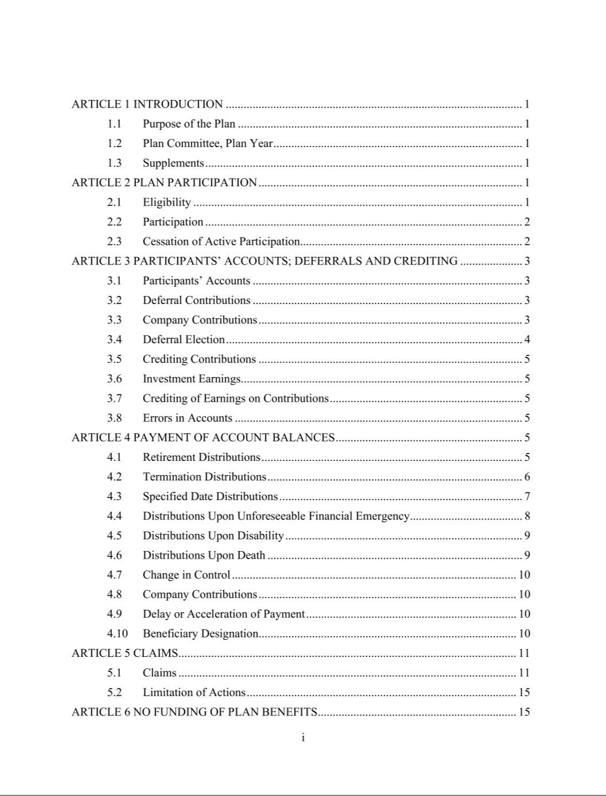

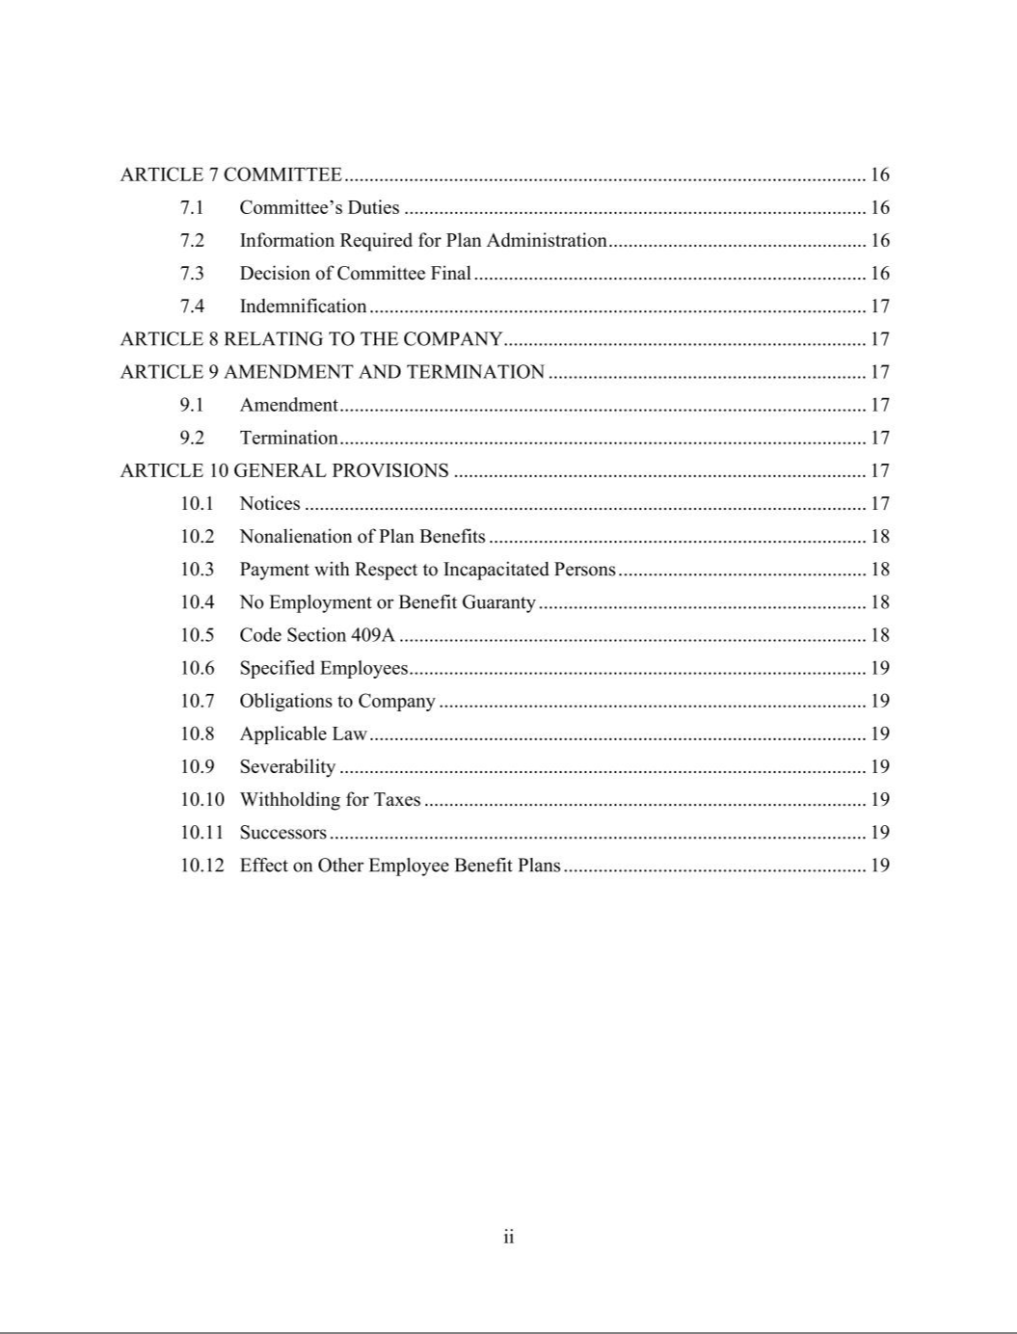

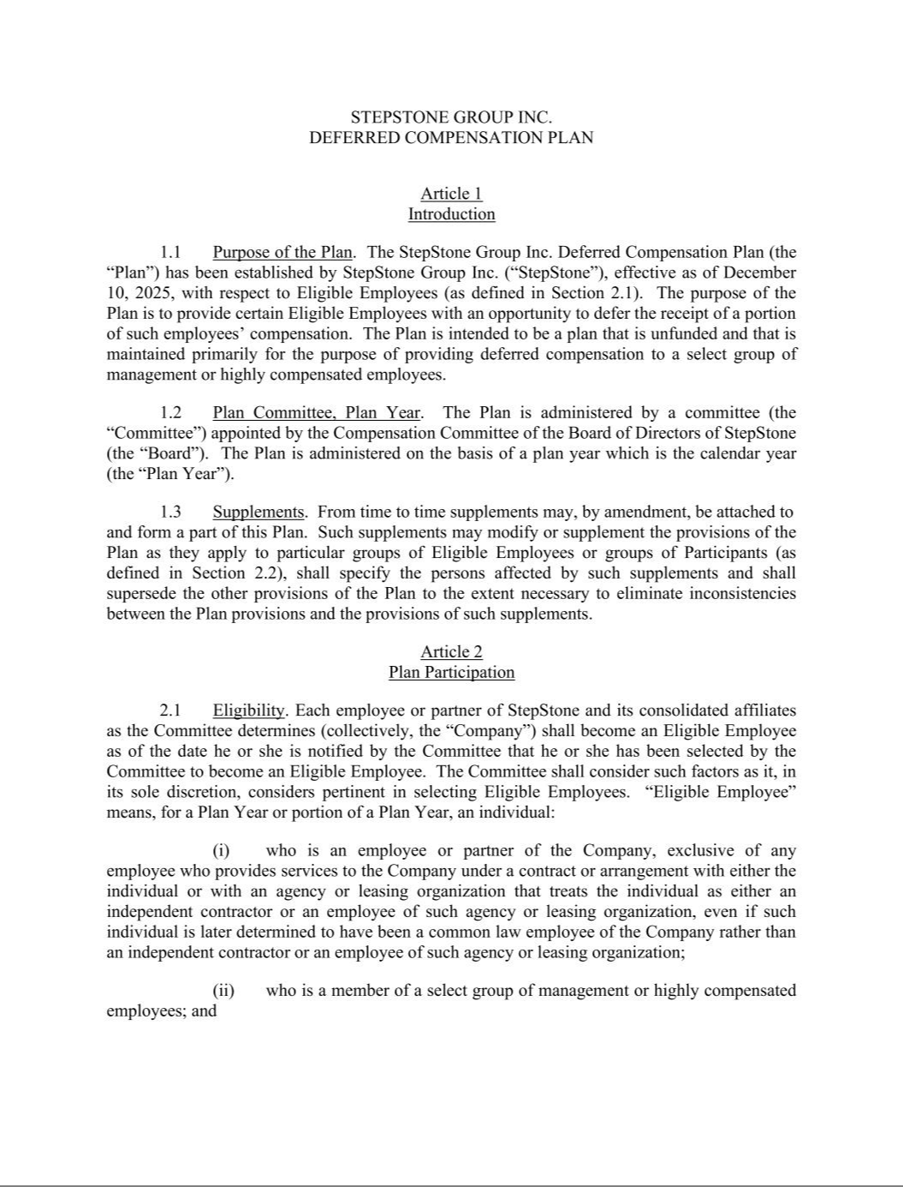

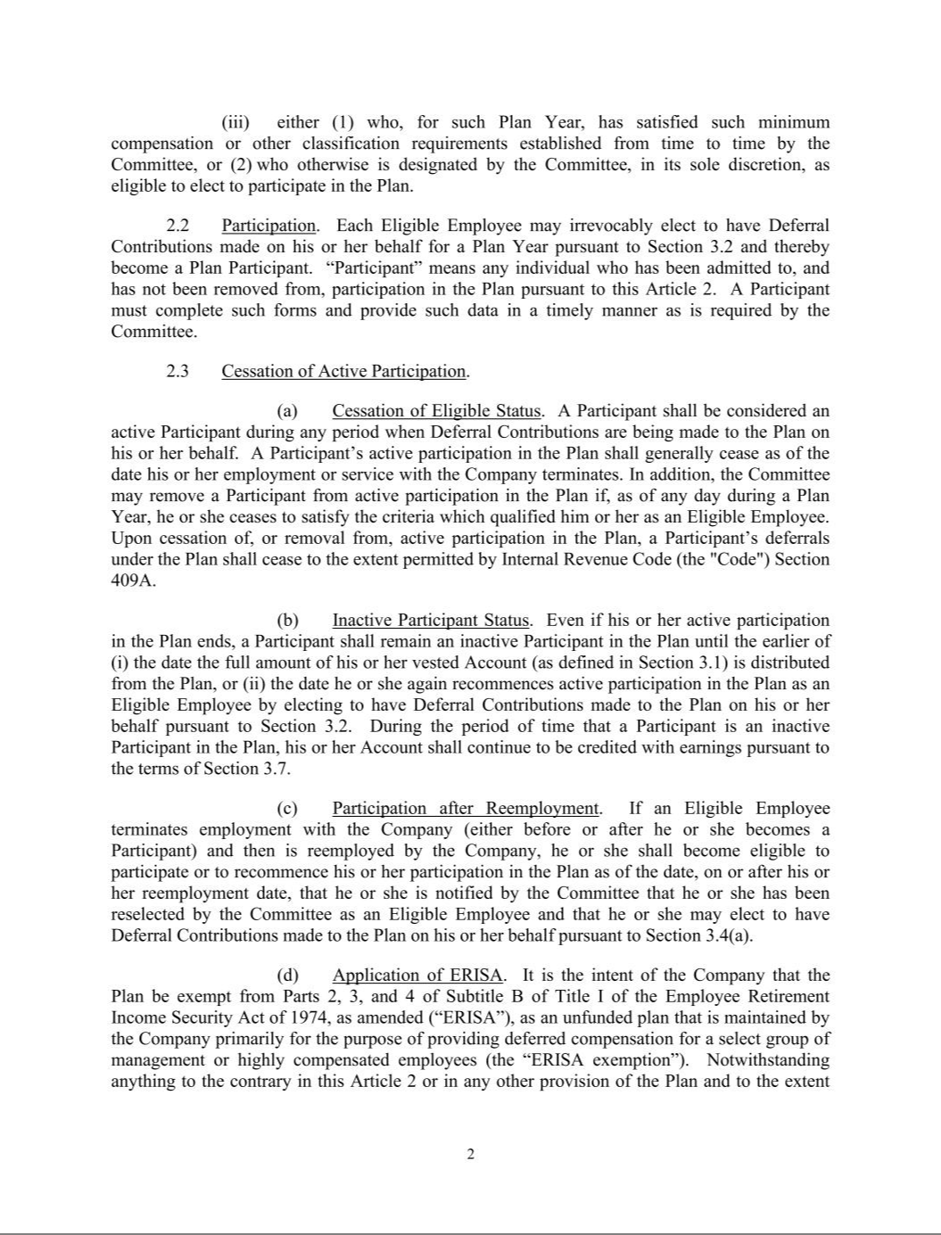

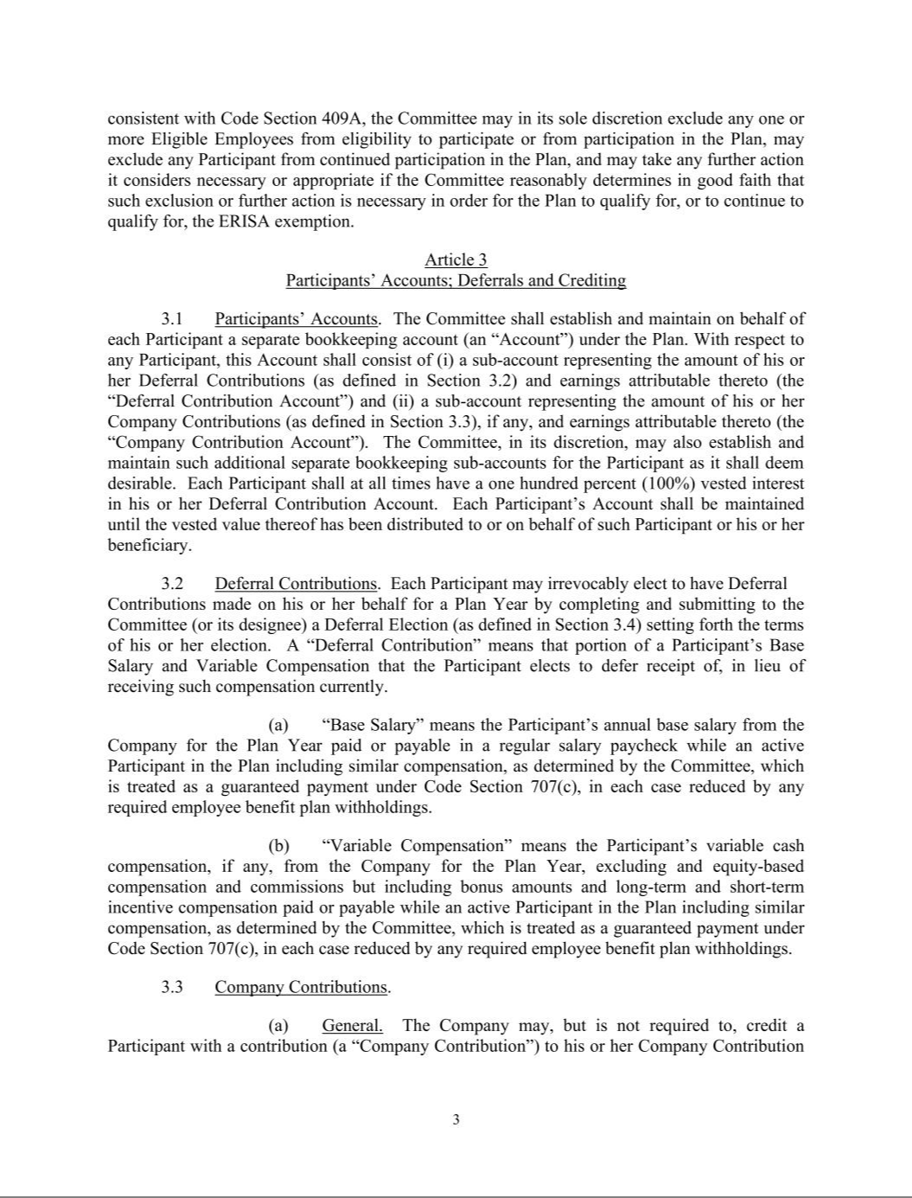

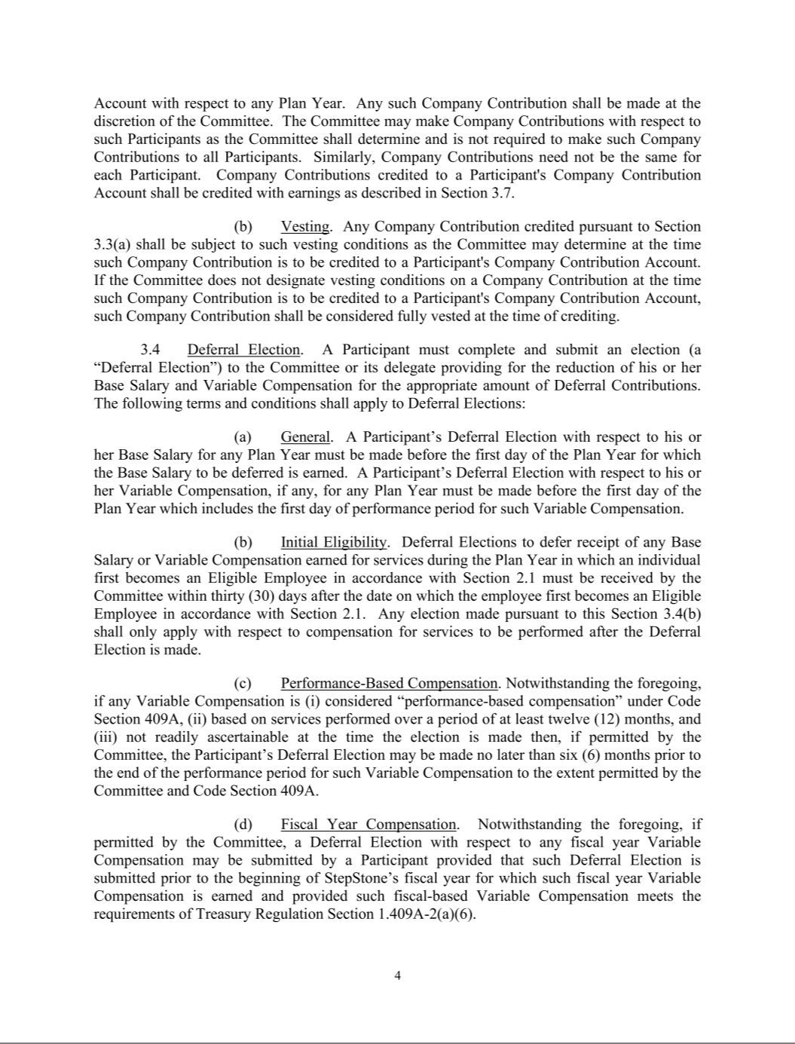

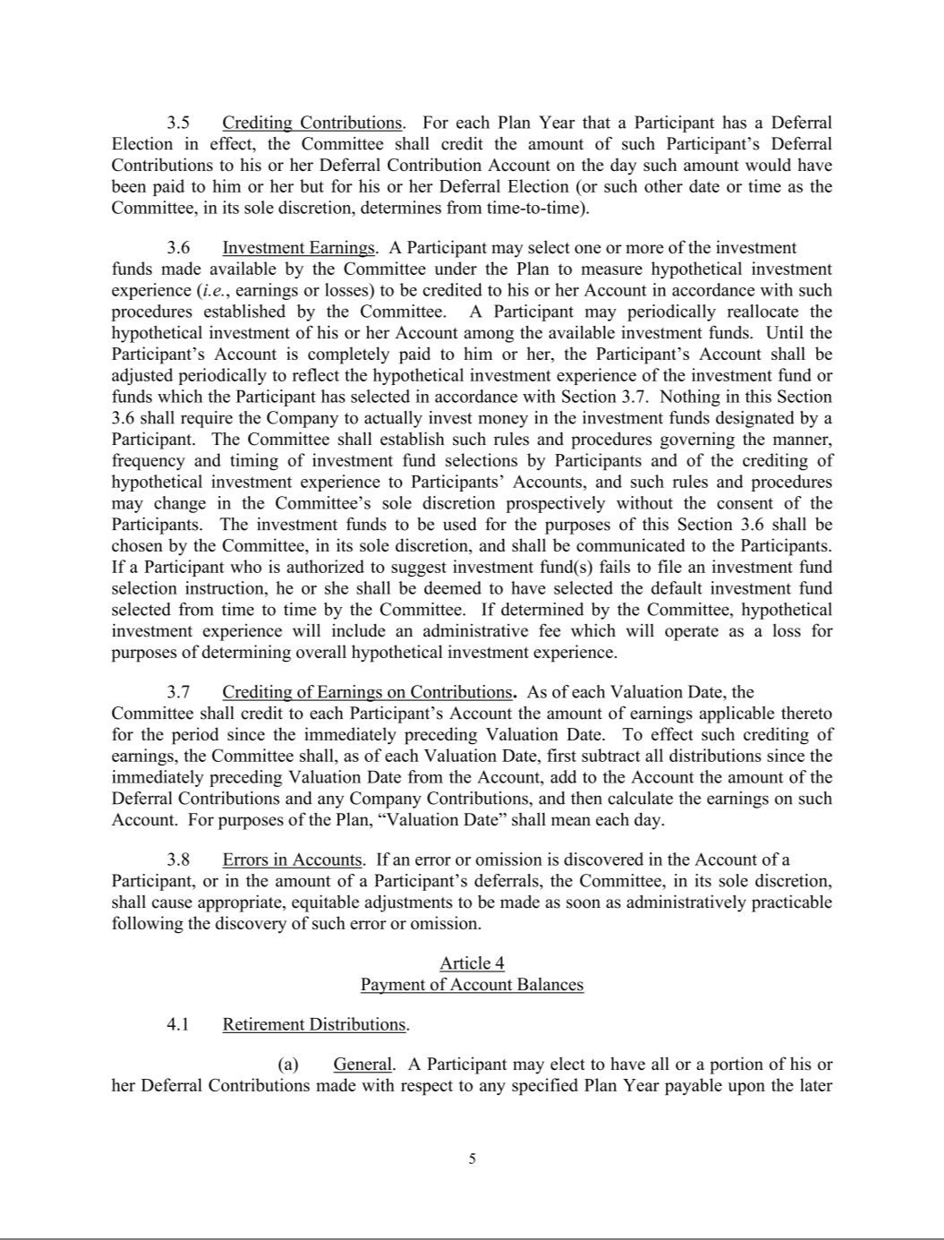

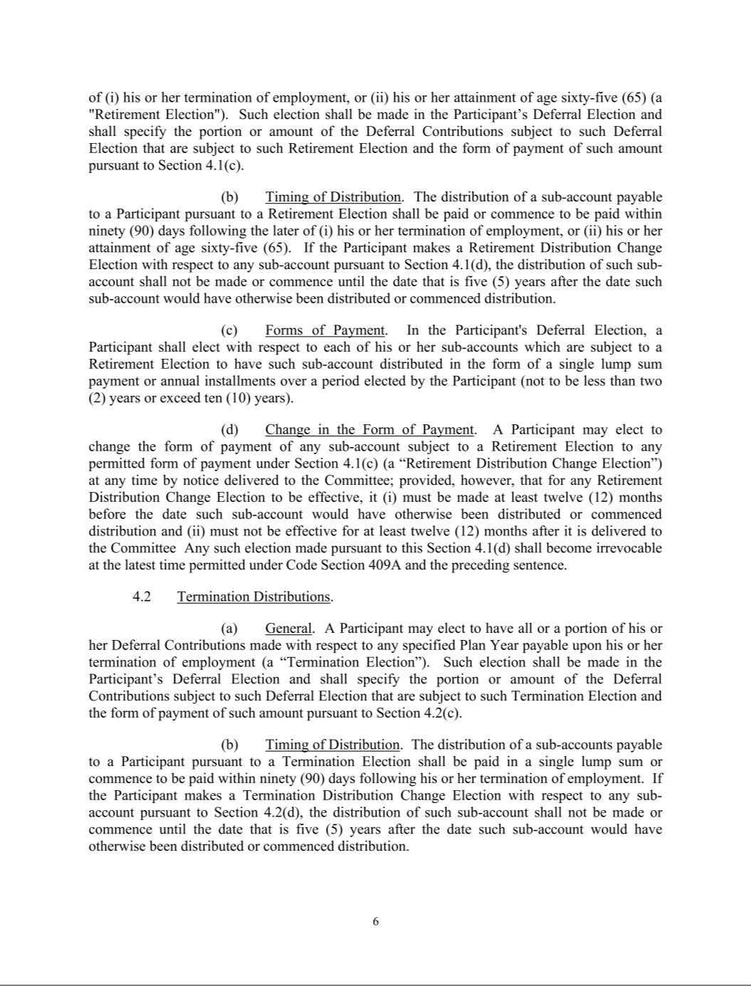

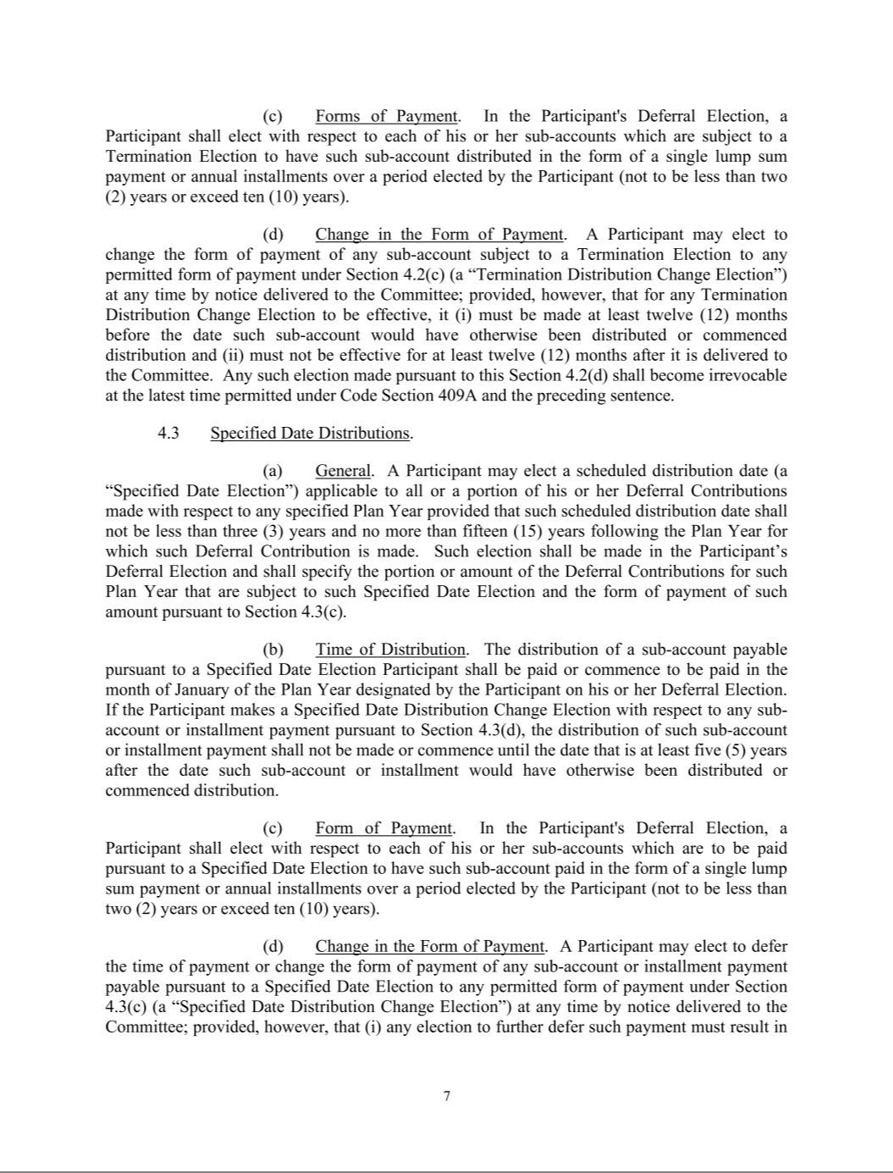

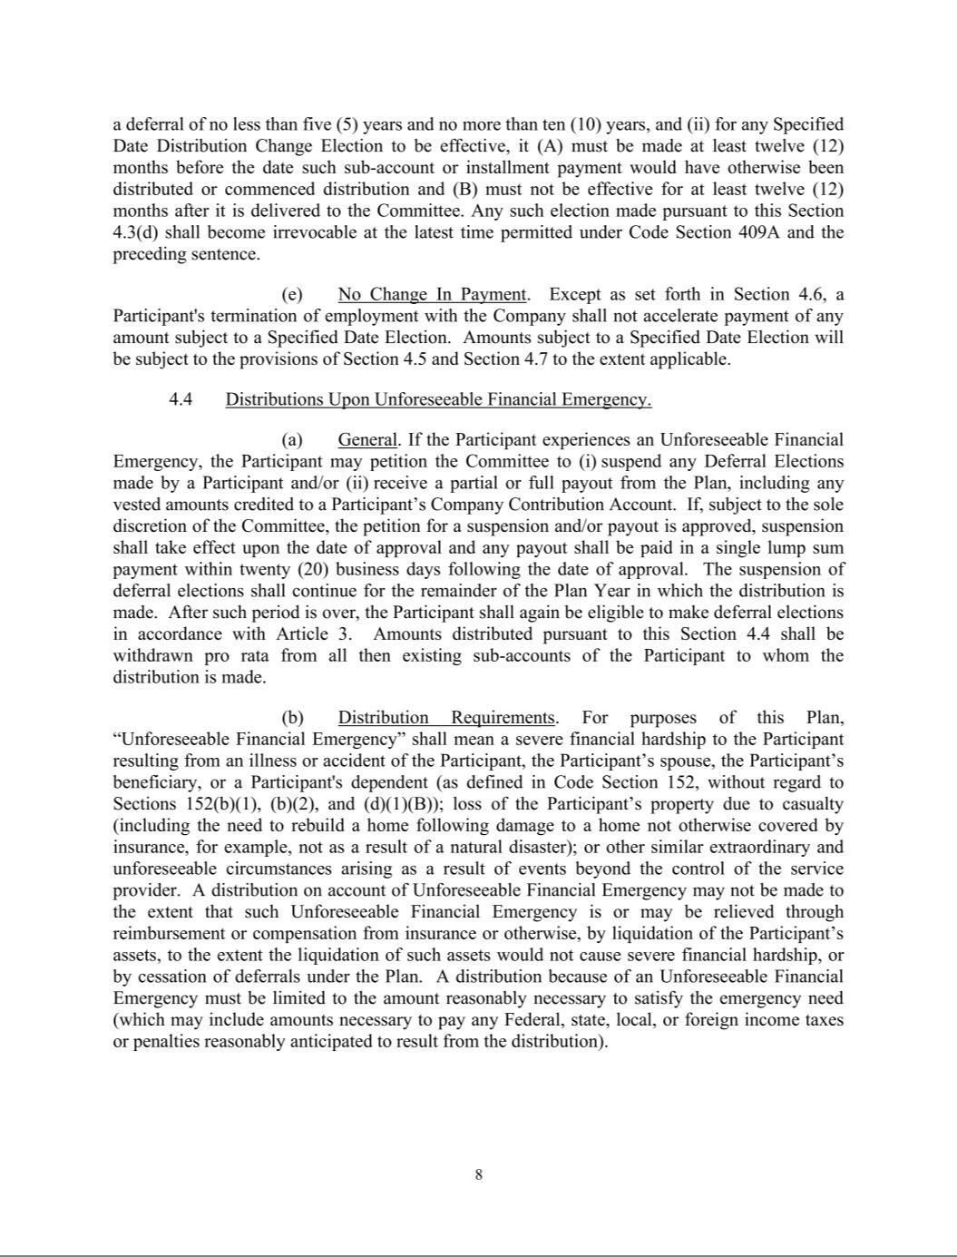

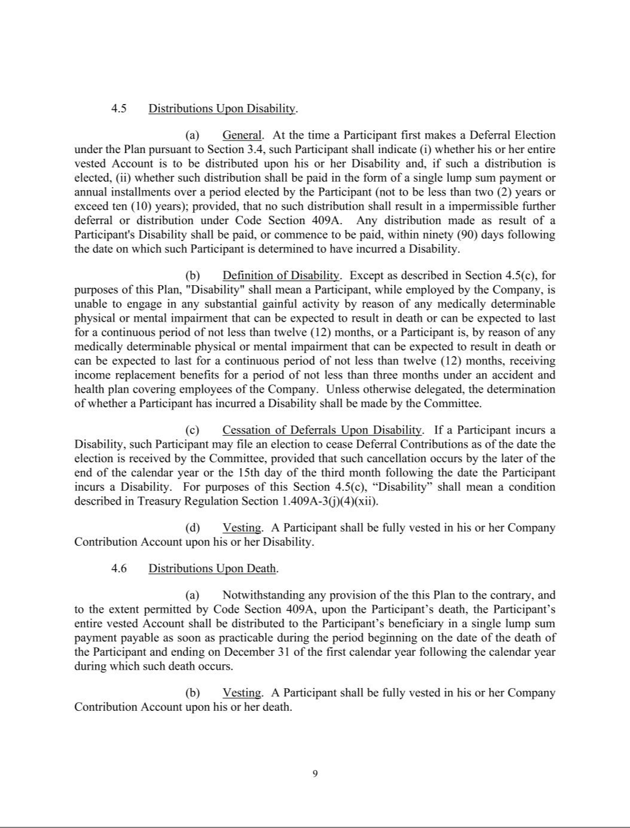

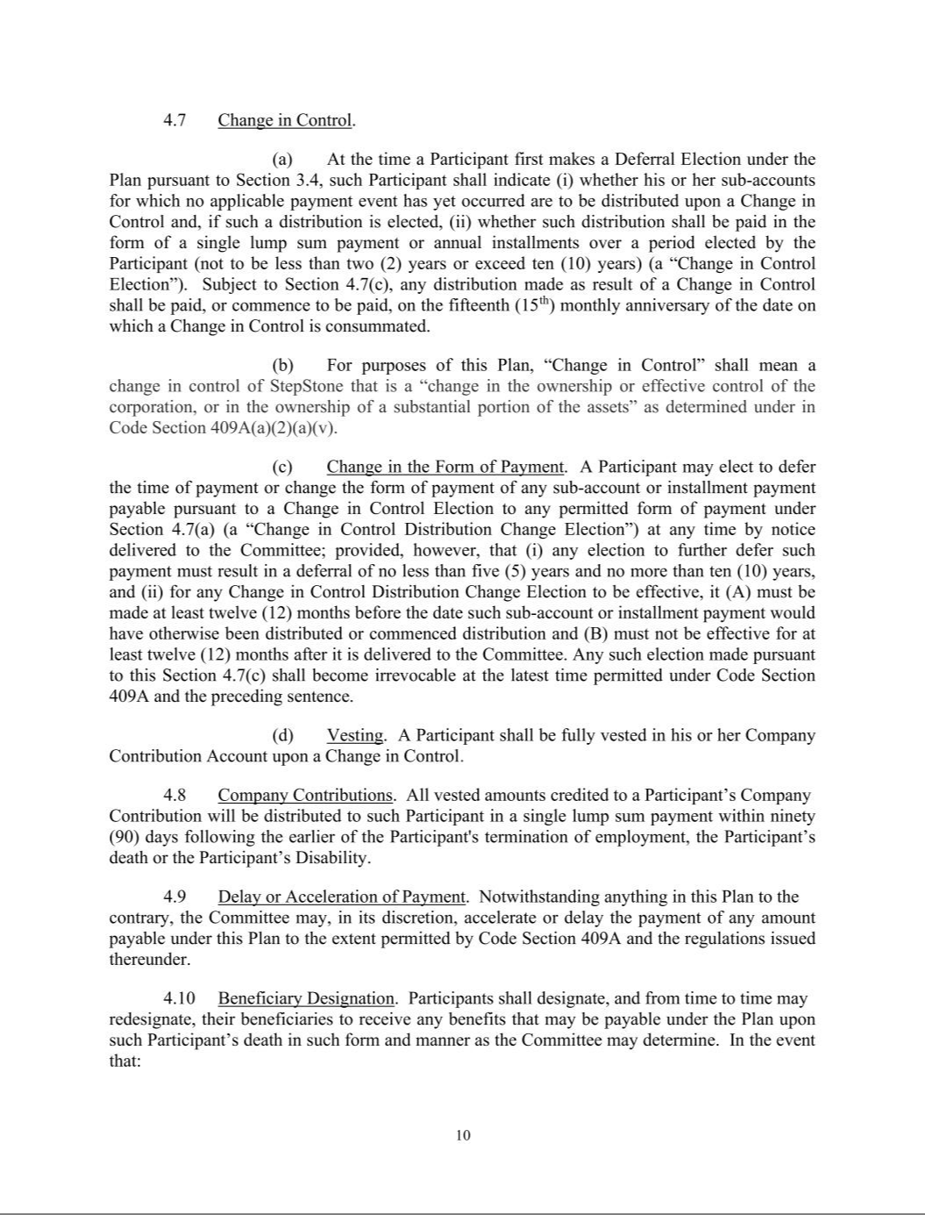

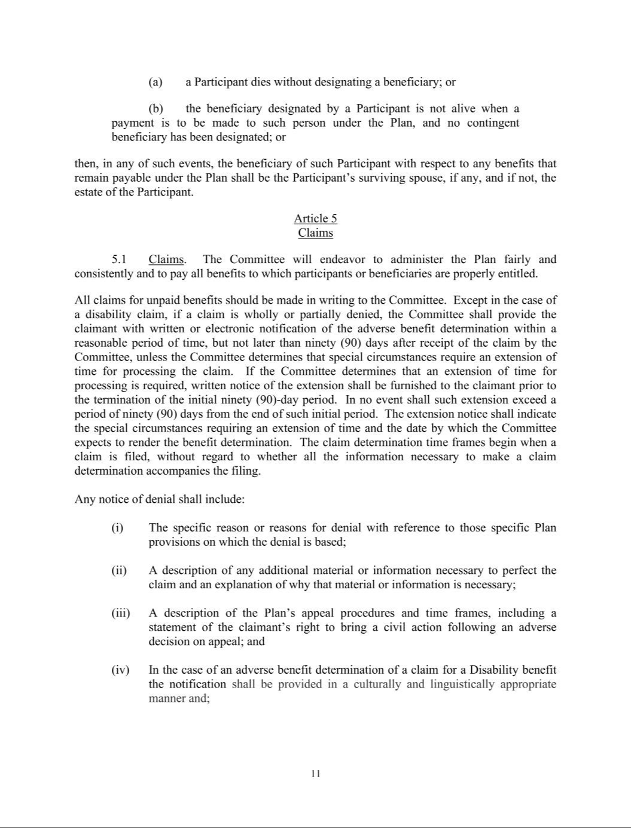

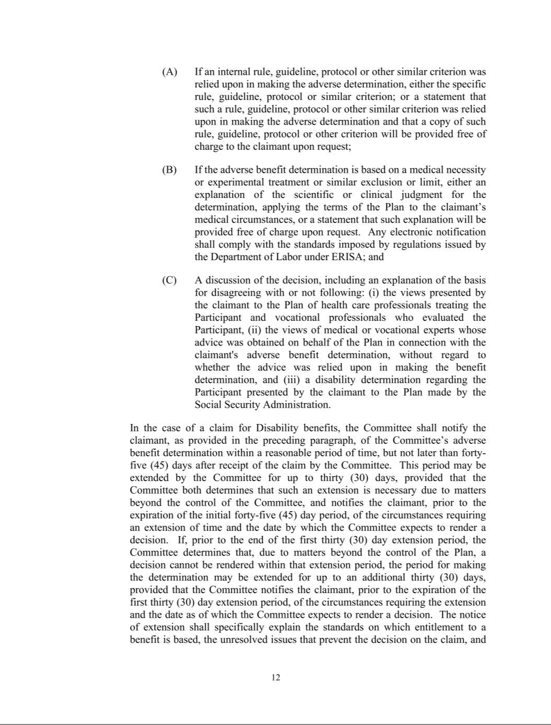

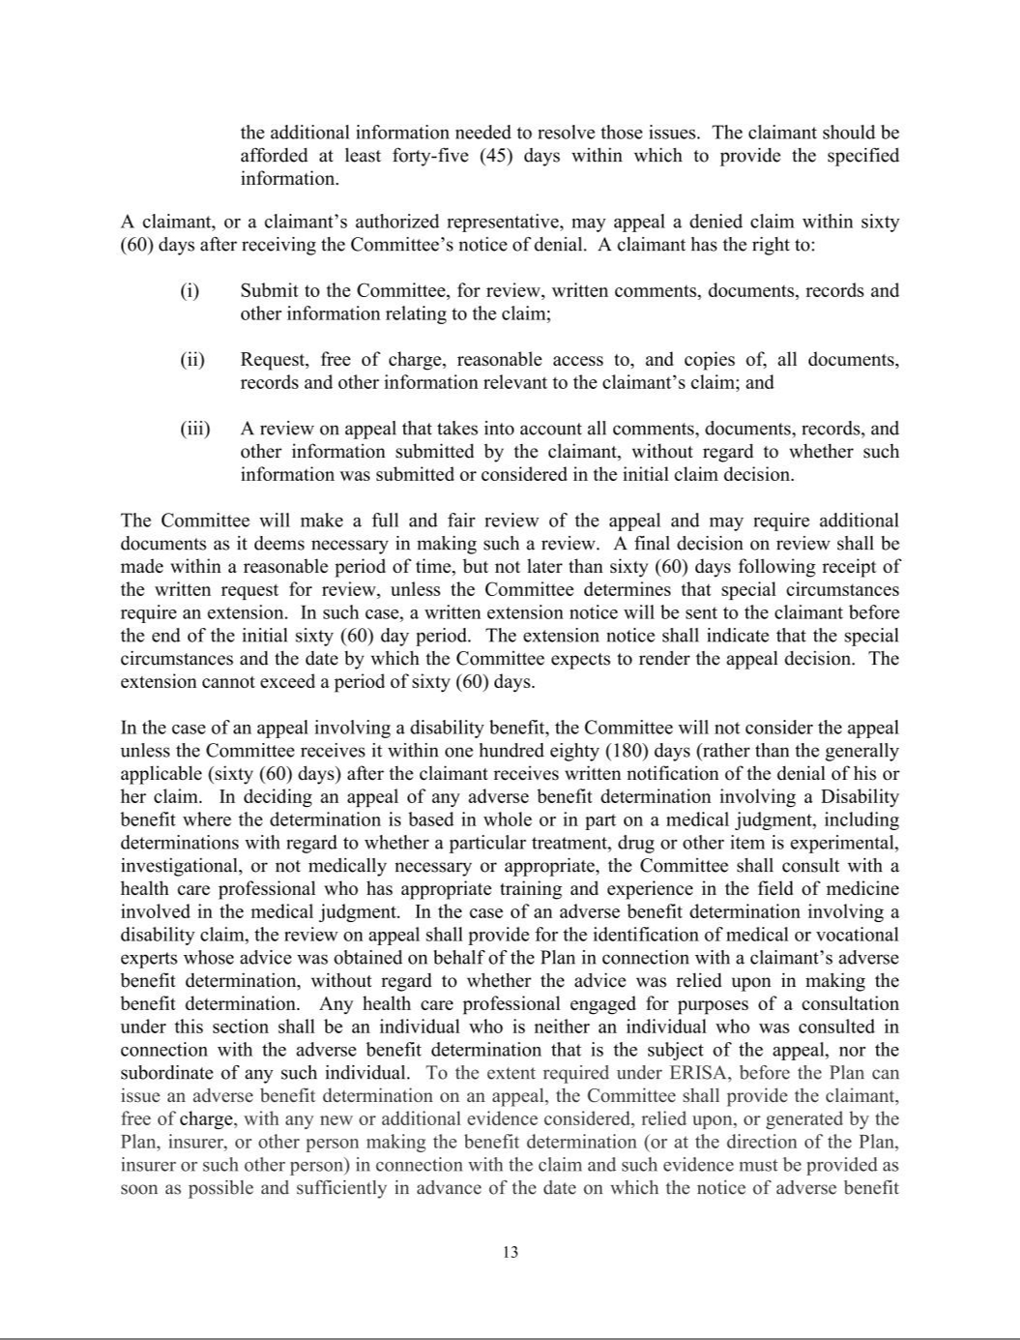

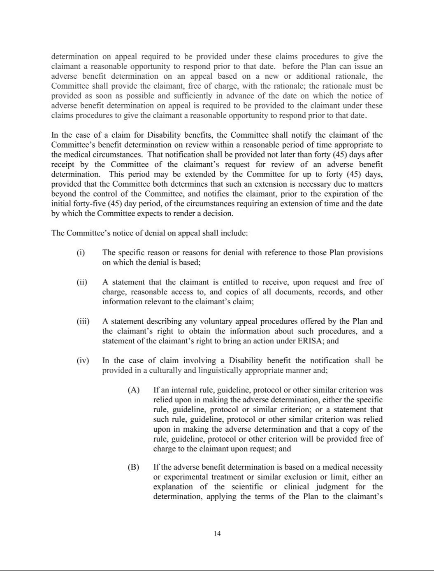

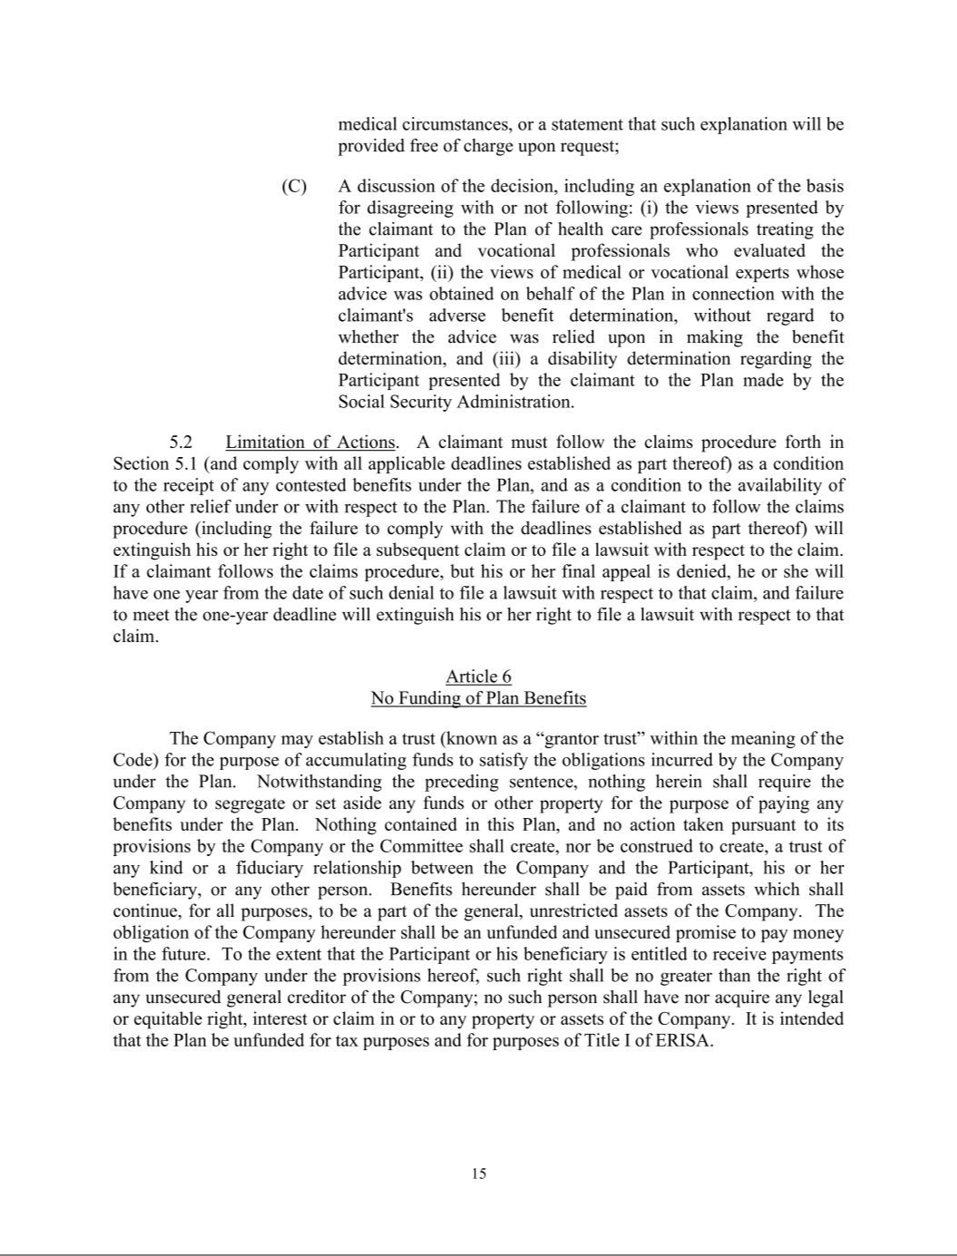

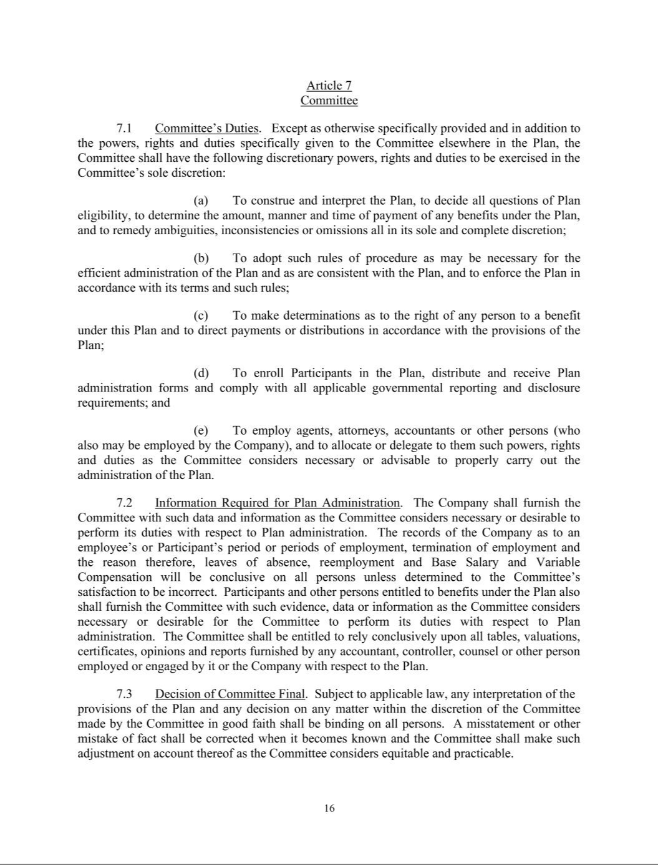

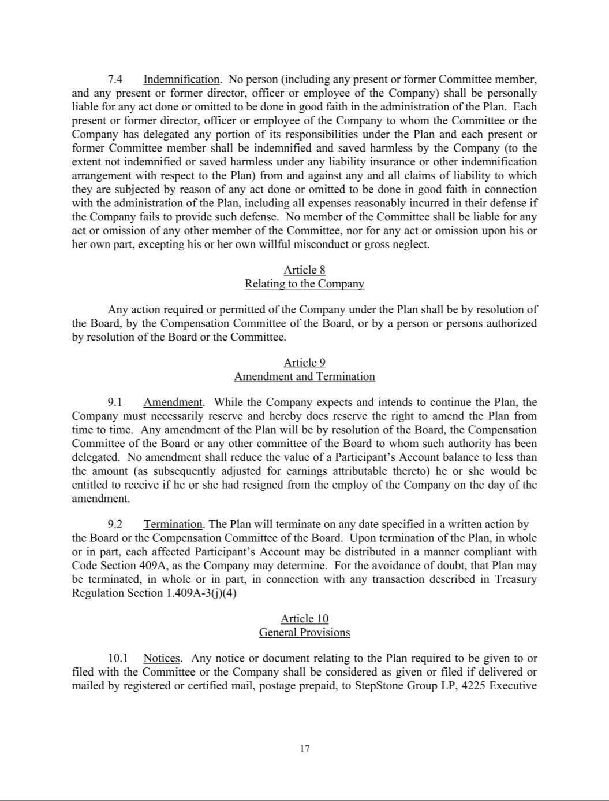

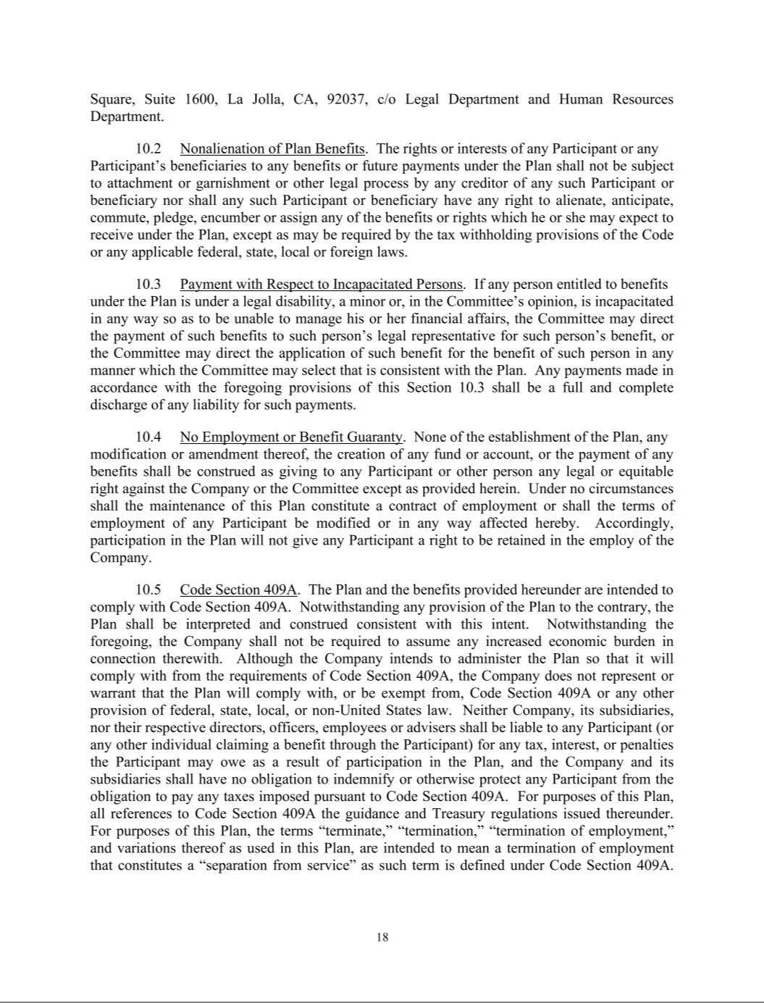

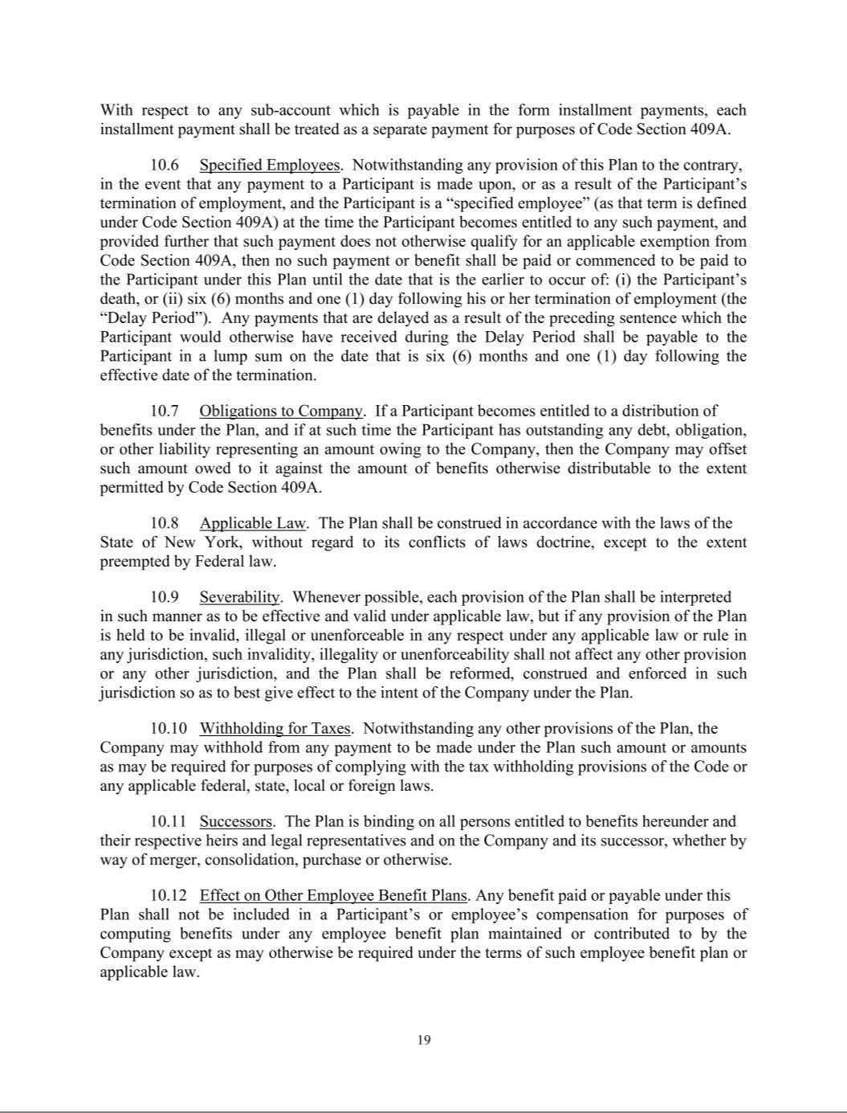

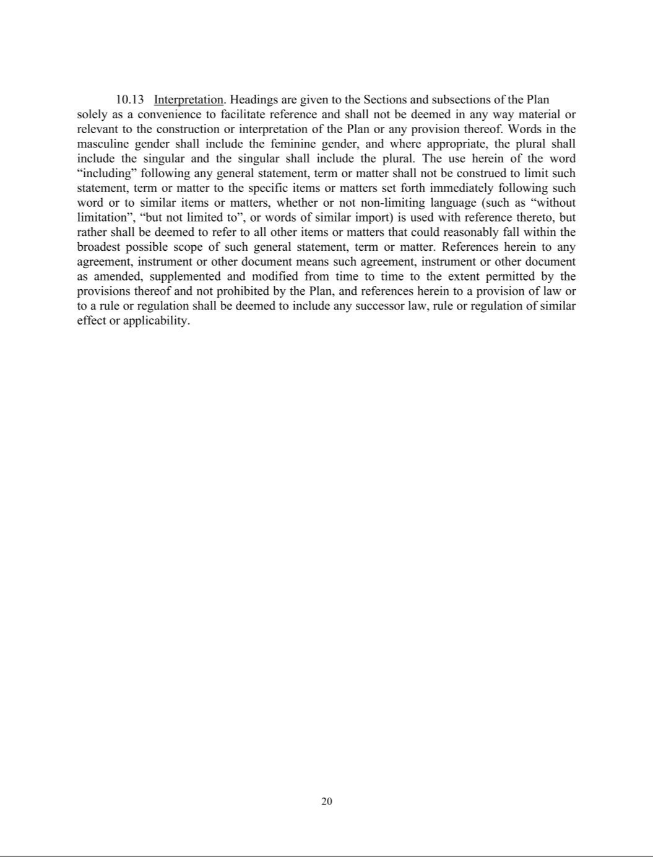

EXHIBIT 31.1

CERTIFICATION BY THE CHIEF EXECUTIVE OFFICER PURSUANT TO SECTION 302 OF THE SARBANES-OXLEY ACT OF 2002

I, Scott W. Hart, certify that:

- I have reviewed this quarterly report on Form 10-Q of StepStone Group Inc.;

- Based on my knowledge, this report does not contain any untrue statement of a material fact or omit to state a material fact necessary to make the statements made, in light of the circumstances under which such statements were made, not misleading with respect to the period covered by this report;

- Based on my knowledge, the financial statements, and other financial information included in this report, fairly present in all material respects the financial condition, results of operations and cash flows of the registrant as of, and for, the periods presented in this report;

- The registrant’s other certifying officer(s) and I are responsible for establishing and maintaining disclosure controls and procedures (as defined in Exchange Act Rules 13a-15(e) and 15d-15(e)) and internal control over financial reporting (as defined in Exchange Act Rules 13a-15(f) and 15d-15(f)) for the registrant and have:

  - Designed such disclosure controls and procedures, or caused such disclosure controls and procedures to be designed under our supervision, to ensure that material information relating to the registrant, including its consolidated subsidiaries, is made known to us by others within those entities, particularly during the period in which this report is being prepared;

  - Designed such internal control over financial reporting, or caused such internal control over financial reporting to be designed under our supervision, to provide reasonable assurance regarding the reliability of financial reporting and the preparation of financial statements for external purposes in accordance with generally accepted accounting principles;

  - Evaluated the effectiveness of the registrant’s disclosure controls and procedures and presented in this report our conclusions about the effectiveness of the disclosure controls and procedures, as of the end of the period covered by this report based on such evaluation; and

  - Disclosed in this report any change in the registrant’s internal control over financial reporting that occurred during the registrant’s most recent fiscal quarter (the registrant’s fourth fiscal quarter in

the case of an annual report) that has materially affected, or is reasonably likely to materially affect, the registrant’s internal control over financial reporting; and

- The registrant’s other certifying officer(s) and I have disclosed, based on our most recent evaluation of internal control over financial reporting, to the registrant’s auditors and the audit committee of the registrant’s board of directors (or persons performing the equivalent functions):

  - All significant deficiencies and material weaknesses in the design or operation of internal control over financial reporting which are reasonably likely to adversely affect the registrant’s ability to record, process, summarize and report financial information; and

  - Any fraud, whether or not material, that involves management or other employees who have a significant role in the registrant’s internal control over financial reporting.

Date: February 5, 2026 | By: /s/ Scott W. Hart
 |  | Scott W. Hart
 |  | Chief Executive Officer
 |  | (Principal Executive Officer)

EXHIBIT 31.2

CERTIFICATION BY THE CHIEF FINANCIAL OFFICER PURSUANT TO SECTION 302 OF THE SARBANES-OXLEY ACT OF 2002

I, David Y. Park, certify that:

- I have reviewed this quarterly report on Form 10-Q of StepStone Group Inc.;

- Based on my knowledge, this report does not contain any untrue statement of a material fact or omit to state a material fact necessary to make the statements made, in light of the circumstances under which such statements were made, not misleading with respect to the period covered by this report;

- Based on my knowledge, the financial statements, and other financial information included in this report, fairly present in all material respects the financial condition, results of operations and cash flows of the registrant as of, and for, the periods presented in this report;

- The registrant’s other certifying officer(s) and I are responsible for establishing and maintaining disclosure controls and procedures (as defined in Exchange Act Rules 13a-15(e) and 15d-15(e)) and internal control over financial reporting (as defined in Exchange Act Rules 13a-15(f) and 15d-15(f)) for the registrant and have:

  - Designed such disclosure controls and procedures, or caused such disclosure controls and procedures to be designed under our supervision, to ensure that material information relating to the registrant, including its consolidated subsidiaries, is made known to us by others within those entities, particularly during the period in which this report is being prepared;

  - Designed such internal control over financial reporting, or caused such internal control over financial reporting to be designed under our supervision, to provide reasonable assurance regarding the reliability of financial reporting and the preparation of financial statements for external purposes in accordance with generally accepted accounting principles;

  - Evaluated the effectiveness of the registrant’s disclosure controls and procedures and presented in this report our conclusions about the effectiveness of the disclosure controls and procedures, as of the end of the period covered by this report based on such evaluation; and

  - Disclosed in this report any change in the registrant’s internal control over financial reporting that occurred during the registrant’s most recent fiscal quarter (the registrant’s fourth fiscal quarter in the case of an annual report) that has materially affected, or is reasonably likely to materially affect, the registrant’s internal control over financial reporting; and

- The registrant’s other certifying officer(s) and I have disclosed, based on our most recent evaluation of internal control over financial reporting, to the registrant’s auditors and the audit committee of the registrant’s board of directors (or persons performing the equivalent functions):

  - All significant deficiencies and material weaknesses in the design or operation of internal control over financial reporting which are reasonably likely to adversely affect the registrant’s ability to record, process, summarize and report financial information; and

  - Any fraud, whether or not material, that involves management or other employees who have a significant role in the registrant’s internal control over financial reporting.

Date: February 5, 2026 | By: /s/ David Y. Park
 |  | David Y. Park
 |  | Chief Financial Officer
 |  | (Principal Financial Officer)

EXHIBIT 32.1

CERTIFICATION PURSUANT TO 18 U.S.C. SECTION 1350 AS ADOPTED PURSUANT TO SECTION 906 OF THE SARBANES-OXLEY ACT OF 2002

In connection with the Quarterly Report of StepStone Group Inc. (the “Company”) on Form 10-Q for the three months ended December 31, 2025, as filed with the Securities and Exchange Commission (the “SEC”) on or about the date hereof (the “Report”), I, Scott W. Hart, Chief Executive Officer of the Company certify, pursuant to 18 U.S.C. Section 1350, as adopted pursuant to Section 906 of the Sarbanes-Oxley Act of 2002, that to my knowledge:

- The Report fully complies with the requirements of Section 13(a) or 15(d) of the Securities Exchange Act of 1934, as amended; and

- The information contained in the Report fairly presents, in all material respects, the financial condition and results of operations of the Company. Date: February 5, 2026
By: /s/ Scott W. Hart

Scott W. Hart

Chief Executive Officer

(Principal Executive Officer)

A signed original of this written statement required by Section 906 has been provided to the Company and will be retained by the Company and furnished to the SEC or its staff on request.

EXHIBIT 32.2

CERTIFICATION PURSUANT TO 18 U.S.C. SECTION 1350 AS ADOPTED PURSUANT TO SECTION 906 OF THE SARBANES-OXLEY ACT OF 2002

In connection with the Quarterly Report of StepStone Group Inc. (the “Company”) on Form 10-Q for the three months ended December 31, 2025, as filed with the Securities and Exchange Commission (the “SEC”) on or about the date hereof (the “Report”), I, David Y. Park, Chief Financial Officer of the Company certify, pursuant to 18 U.S.C. Section 1350, as adopted pursuant to Section 906 of the Sarbanes-Oxley Act of 2002, that to my knowledge:

- The Report fully complies with the requirements of Section 13(a) or 15(d) of the Securities Exchange Act of 1934, as amended; and

- The information contained in the Report fairly presents, in all material respects, the financial condition and results of operations of the Company. Date: February 5, 2026
By: /s/ David Y. Park

David Y. Park

Chief Financial Officer

(Principal Financial Officer)

A signed original of this written statement required by Section 906 has been provided to the Company and will be retained by the Company and furnished to the SEC or its staff on request.

